*nflation Report*

# Summary

The *Inflation Report* contains the Bank of England's analysis of recent changes in inflation and the prospects for the future. It contains six sections covering: (i) recent price developments;

(ii) monetary and fiscal policy; (iii) demand and output; (iv) price dynamics; (v) prospects for inflation; and (vi) conclusions.

Compared with three months ago, it is now somewhat easier to see how last autumn's depreciation is affecting domestic prices. Retail prices of a number of products, including some food items and consumer durables, have risen more rapidly since the autumn.

And the latest three-month inflation rate has increased a l ittle since the last *Report* and now stands somewhat further above the

twelve-month rate than was the case three months ago. Nevertheless, underlying inflation, at 3.5%, is still in line with our expectations in February.

Inflation, as measured by RPIX, has remained within the target range throughout the period since the February *Report.* During that period new information about the likely course of future

inflation has been of three main kinds. First, levels of real activity are rising more rapidly than had been anticipated three months

ago. Most of the indicators relating to the real economy, including output, retail sales and employment, point to increasing levels of activity. Second, the exchange rate, as measured by the sterling effective exchange rate index on 7 May, is some 5% above the level at the time of the February *Report.* Third, in the March

B udget the Chancellor announced i ncreases in indirect taxes, to take effect both this year and next, which will raise the measured rate of underlying inflation. The rise in the exchange rate is not independent of the news about activity, indeed in large part it

fol lows from it. This increase in the exchange rate has lowered somewhat the risk of breaching the top of the target range towards the end of this year and the early part of next.

The projections for the next three months show inflation declining in April, but then rising to 3.5% by June. The initial fall largely reflects the impact of the change from the Community Charge to the Council Tax. The subsequent rise is expected to be broadly based, and associated with the direct pass-through of higher import prices into domestic retail prices.

149

On balance, the changes since the last *Inflation Report* have lowered slightly both the expected inflation rate and the probability of breaching the 4% limit during the course of this year. The i mpact next year of the B udget measures, together with the uncertainties surrounding the rate at which the output gap is l ikely to narrow, suggest that the probability of breaching the target next year may be a li ttle greater than previously envisaged, but the B ank's central expectation still is that the target will be met. Any further increase (decrease) in the exchange rate would lower (raise) the probability of breaching the target.

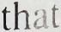

Expectations of inflation in the future are not yet consistent with the target range for inflation of 1 %-4%. Both direct surveys of expectations and also the indirect evidence from implied forward market interest rates suggest that many economic agents have yet to be convinced that the target will be met in the long run. But the longer underlying inflation remains within the target range the more credibility will grow over time.

Looking to the end of 1 994 and beyond, the principal uncertainty concerns the response of domestic factor costs wages and profits-to the loss of purchasing power resulting from depreciation of the currency. If total profits and wages rise because of a *volume* effect, rather than an increase in profit margins per unit of output or earnings per head, then the increase in nominal demand consistent with the monetary stance will lead to rising real activity and continuing low inflation. A continuing determination on the part of the authorities to meet the inflation target will help to ensure increases in wages and profits are real i ncreases, reflecting higher output and productivity, rather than nominal increases reflecting only higher unit costs. It is vital in this context that the inflation target be seen as a framework for policy over a long period, and that monetary and fiscal policy should be consis tent with achieving the target on a sustained basis.

150

# Recent price developments

'hart 1.1 ntlation

Increase in prices on a year earlier

- 12

- 10

- 8

- 6

- 4

- 2

o

Inflation is a rise in the *general* level of prices. When there are significant changes in *relative* prices, the various measures of i nflation may give different e�timates of ' the' rate of inflation. This is particularly relevant following a depreciation of the currency-the effective sterling exchange rate fell by more than 13% between the first quarter of 1 992 and the first quarter of this year-when retail prices will rise to reflect the one-off adjustment of domestic prices to the higher costs of imports. In principle the GDP deflator, which measures the rise in the price of domestically produced output, offers a better guide to underlying inflation. But, because there are time

lags between changes in the exchange rate and the response of prices in the home market to increases in i mport prices, the GDP deflator is itself a misleading guide to underlying inflation at exactly the time when it might be thought to provide a more accurate signal. Indeed, the GDP deflator (measured at factor cost) fell by almost 1 % in the fourth quarter of last

year,. when import prices rose but were not

immediately reflected in higher prices at home. And the deflator is l ikely to rise during 1 993 to compensate for this fall. These arguments strengthen the case for defining the official inflation target in terms of the increase in the Retail Prices Index

excluding mortgage interest payments. Measured in

1990 91 92 93

this way the outturn for i nflation is available promptly and is easily understood, thus enhancing accountability. It is, however, affected by changes in indirect taxes which, fol lowing the March Budget, will lead to higher measured inflation than would otherwise have been the case. For these reasons Section 1 discusses recent changes in different measures of inflation in the United Kingdom.

## Retail

The headline rate of inflation, as measured by the twelve-month change in the Retail Prices Index (RPI), was 1 . 9% in March compared with 2.6% in December. The rate fell sharply between December and January, to a twenty-five year low of 1 .7%, but rose slightly in both February and March (see

Chart 1.1 ) . This fall was partly the result of

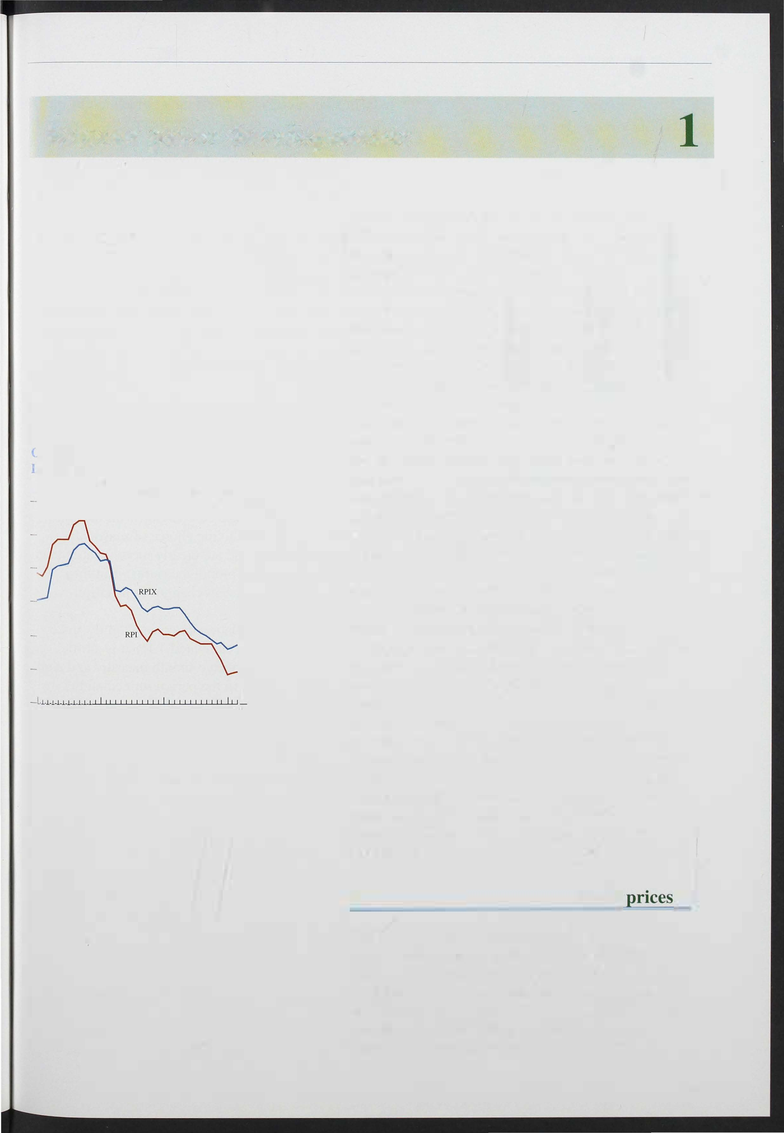

151

Chart 1.2

Conventional measures of inflation

reductions in mortgage interest rates, which fell by an average of one percentage point between December and

All ilelll� Excluding MIPs

Mar. 1992

Table LA

Goods Services

Increase in prices on a year earlier

_ 12

_ 10

_ 2

o

Sep'- 1992 Mar. 1993

March. But the underlying rate of inflation-the increase in the RPI excluding mortgage interest payments (RPIX)-also fell from 3.7% in December to 3.5% in March.

As Chart 1 . 1 shows, inflation fell most rapidly between mid- 1 990 and m id- 1 991. Thereafter the headline rate fell only very slowly until the latter part of last year.

The underlying rate, by contrast, showed a steady reduction from April of last year which only came to an end with the i ncreases in February and March this year. As Chart 1 . 2 shows, the decline in the underlying rate was broadly based, and held in both services and goods.

Very recent price developments are captured rather poorly, however, by conventional measures which record the change in prices over the previous twelve months.

Table 1 . A shows price changes recorded over

Short-run measures of in flation

tfercentage changes (a)

2.8

|  |  |  |  |  |
| --- | --- | --- | --- | --- |
|  | RPI | RPIX | Goods | Services |
| March 1 992 | 3.5 |  | 3.6 | 7.3 |
| June 1992 | 3.2 |  | 0.5 |  |
| September 1992 | 2.6 | 3. 1 | 1 .6 |  |
| December 1992 | 0.8 | 3.9 |  |  |
| March 1993 | 1.0 |  | 3.9 |  |

1. The change in the IaleSt month on three months earlier, seasonally adjusted and annualised.

4.9

*5. 1*

4.1

The natural logarilhms of the price series were seasonally adjusted using a Kalman filter to decompose the series into trend, cyclical. irregular and seasonal components. The series for goods and services do not exhaust the RPIX series because the laner comprises also the Community Charge, personal articles and dwellings insurance.

Chart 1.3

Recent retail price developments

Percentage changes on a year earlier (a)

-

14

- 12

- 10

_ 8

- 6

- 4

- 2

+

three-month periods for each of the series shown in Chart 1 . 2. The figures have been seasonally adjusted and then annualised to ease comparison with the chart.

The figures are sensitive to the choice of seasonal adjustment technique, and are clearly more volatile than the conventional twelve-month measures. But they provide an insight into recent changes in inflation.

Short-run underlying inflation has risen slightly since three months ago. At an estimated 4. 1 % it is a little above the conventional twelve-month measure and well above the short-run rate in the period immediately before sterling's withdrawal from the exchange rate mechanism. The short-run rate of increase of goods prices also reached a trough during this period and has picked up quite sharply since then. The impact of devaluation would be expected to show up earlier in the prices of goods than of services because imports constitute a greater proportion of final expenditure on goods than of services. Nevertheless, short-run changes in the price of services have also increased recently. The effects of devaluation were first visible in petrol prices but, as can be seen in Chart 1 . 3, there has also been some acceleration in food prices and the prices of consumer durables since the autumn.

Consumer durables (b)

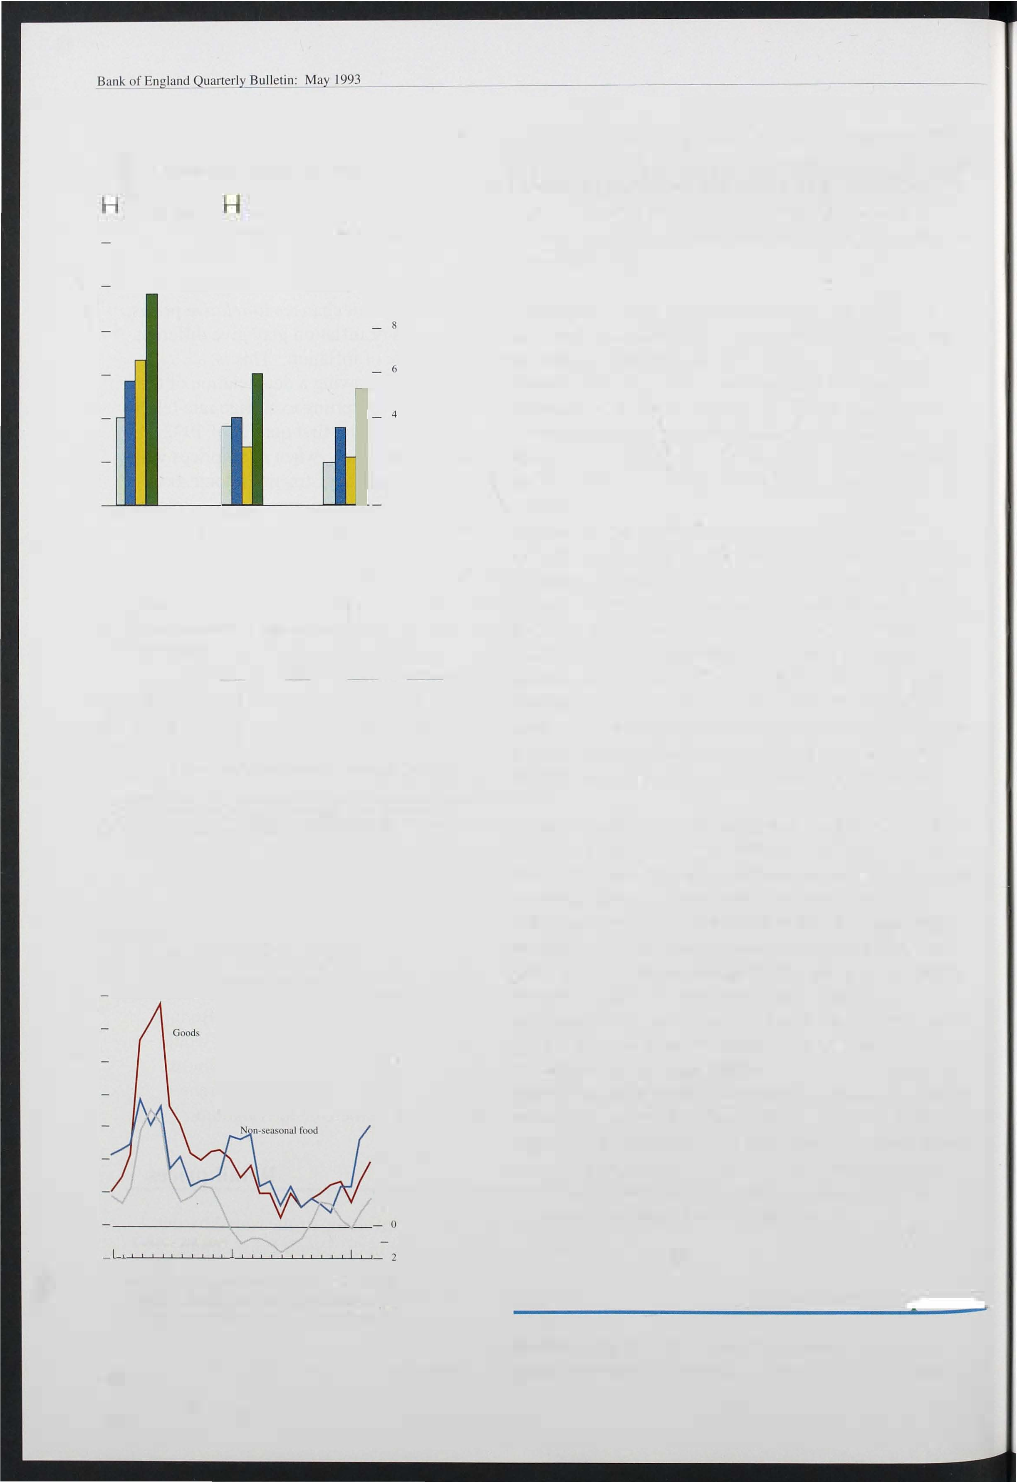

1991

(<t) The ch.mge in the latest month on three months earlier, seasonally adjusted. annualised rates.

1. Con�umer durab�es consists of furniture and furniShings, electrical appilances. clothmg and footwear, audio-visual equipment. records. toys elc.

152

## Manufacturing

Producer output price indices measure the prices of goods leaving UK factories, destined for the domestic

Re art

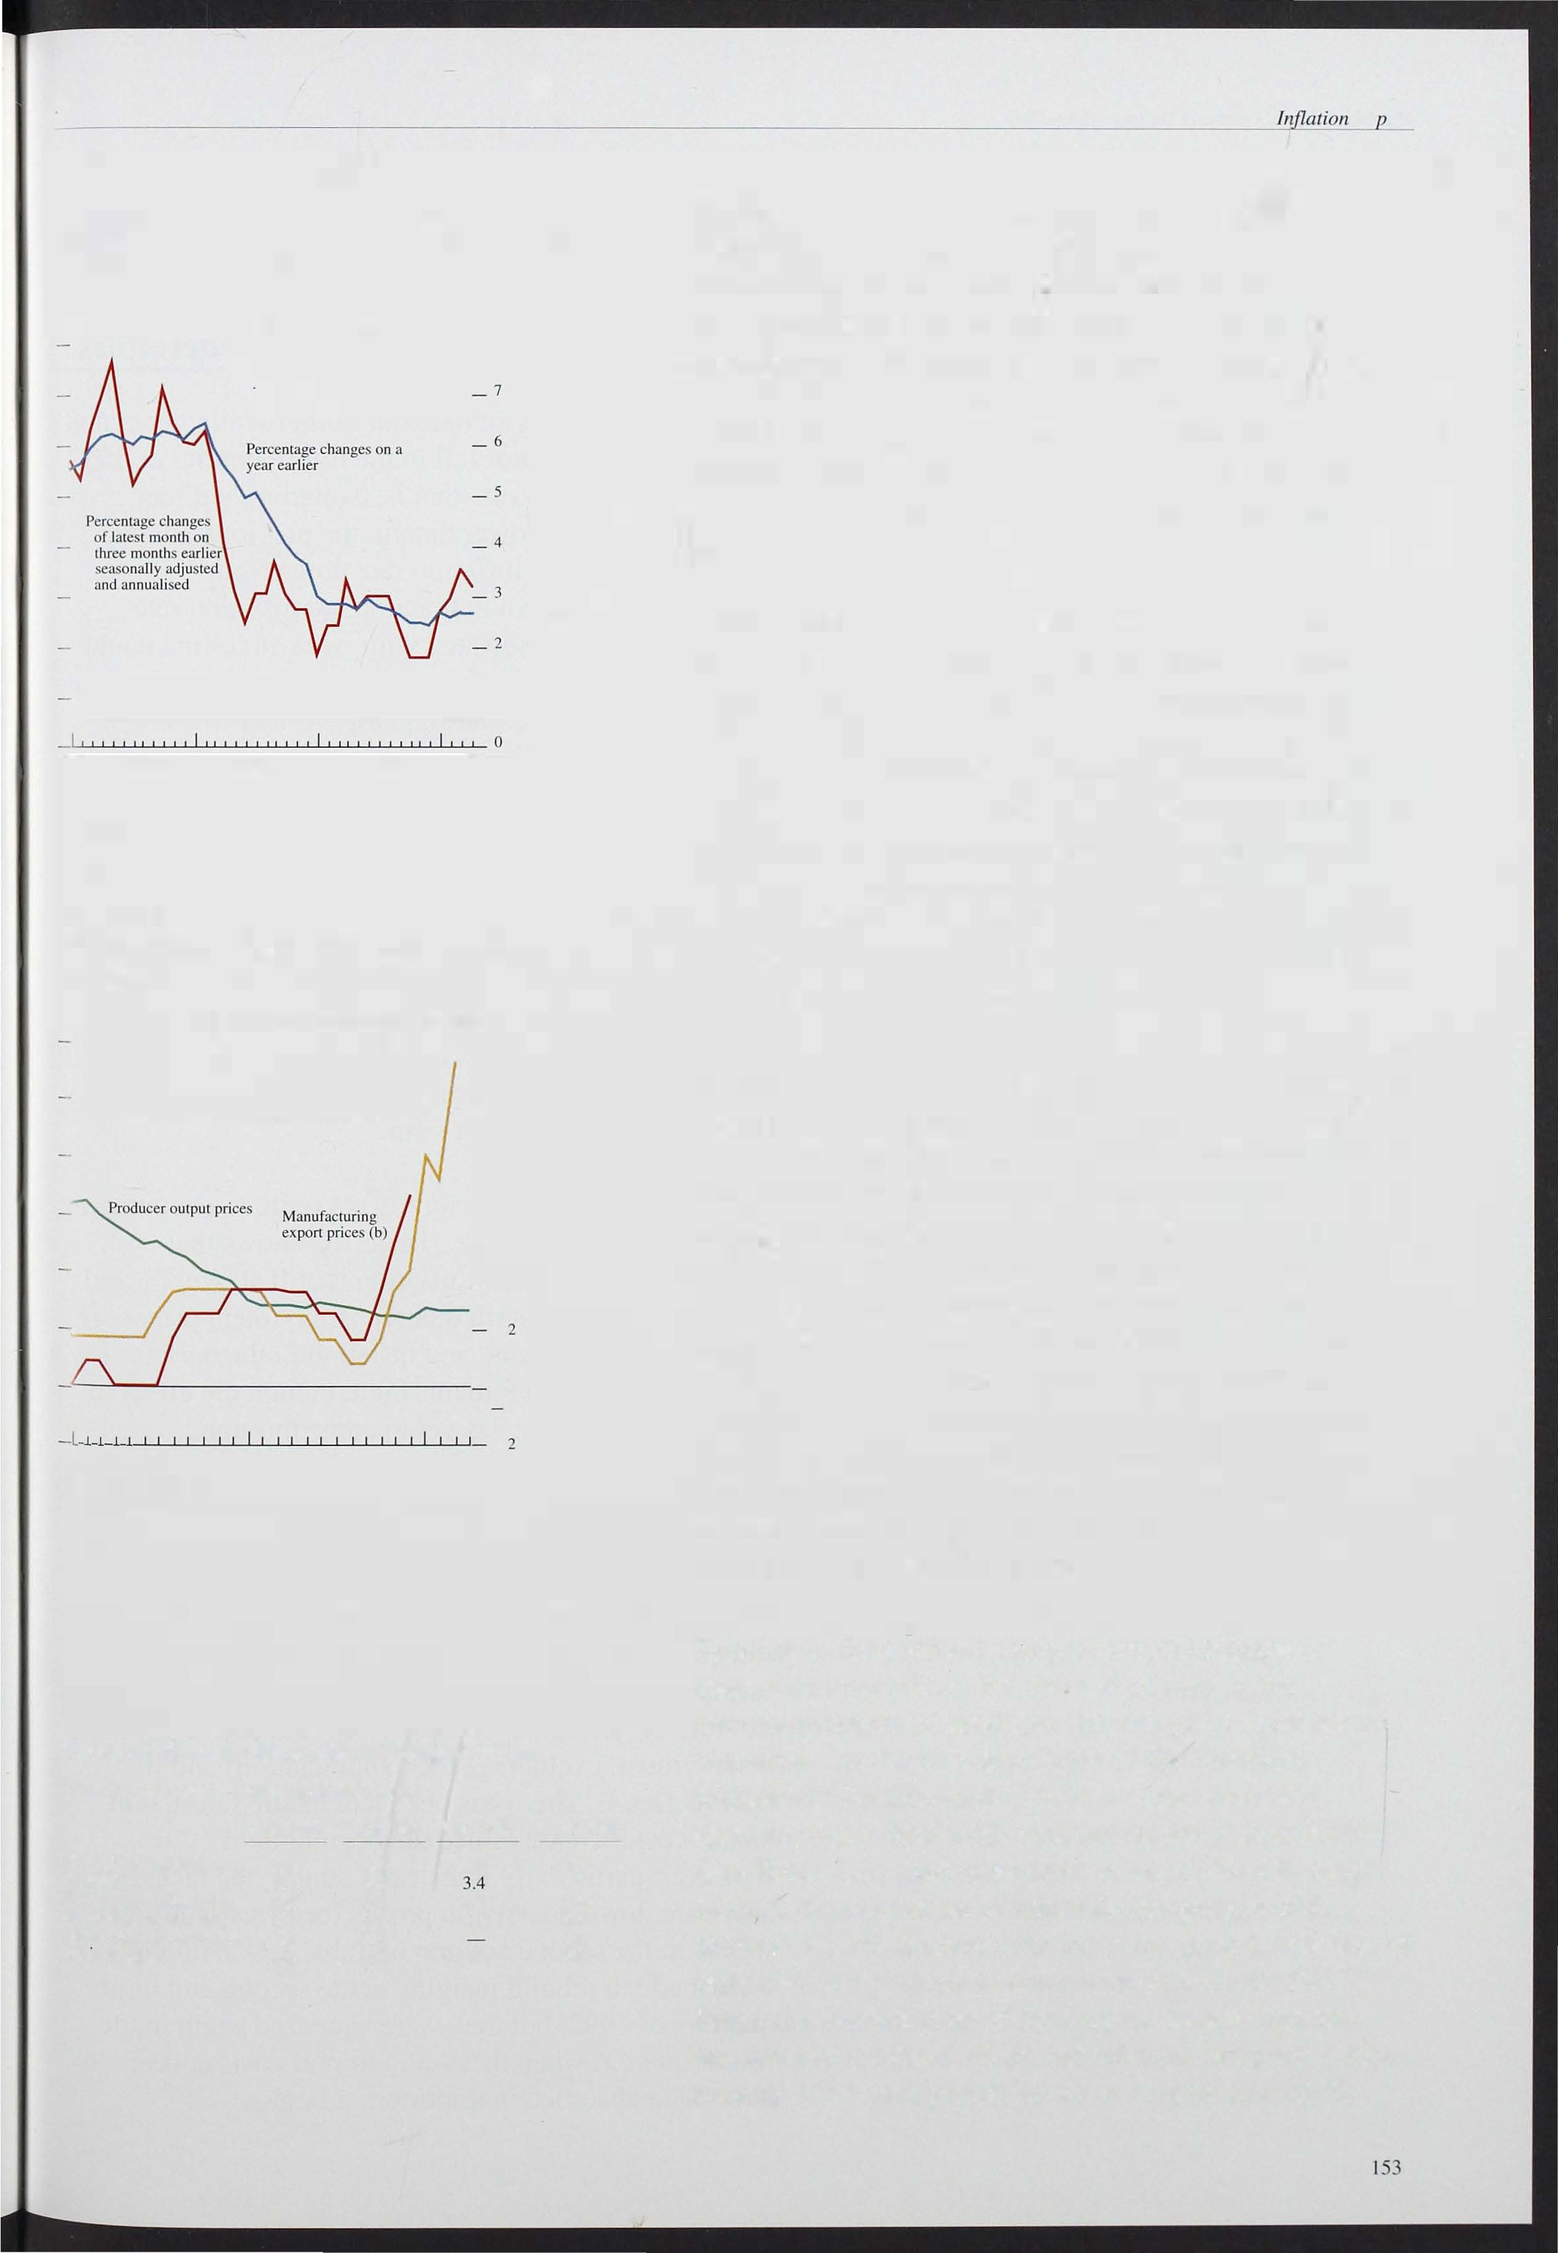

Chart 1.4

Producer output prices

Excluding food, drink and lobacc� 8

_I

1990 9 1 92 93

Chart 1.5

l\[anufacturing export and producer price i1flation

Increase in prices on a year earlier

- 12

- 10

Manuracturing export prices (a)

- 8

- 6

- 4

+

0

199 1 92

93

1. Non-EC based data.
2. Tor.iI trade data.

Table I.B

Sectoral changes in producer output prices

Percentage increase in component in the year to

|  |  |  |  |
| --- | --- | --- | --- |
| April 1 99 1 | April 1 992 | Qct. 1 992 | April 1 993 |
| 6.9 |  |  |  |
| 5.1 | 3.6 |  |  |
|  | 5.1 | 4.6 |  |
| 2. 1 | - 1 .9 | 0.2 | -2.7 |
| 8.3 | 2.7 |  | 1.8 |
| 6.2 | 3.8 | 3.3 | 3.8 |

FOOd. drink and tobacco Textiles

5.5

4.8

All tndltstries

market. These can be compared with UK producers' export prices. To the extent that the two indices refer to the same goods, they indicate the scale of price discrimination between home and export markets.

During l ate 1 990 and early 1 991, after sterling's entry into the ERM, export prices were rising at a much slower rate than domestic producer output prices. Since then the pattern has been reversed, with sterling export prices rising sharply fol lowing sterling's depreciation last autumn.

Excl uding the food, drink and tobacco sectors, the twelve-month increase in producer output prices has stayed at around 21/2% to 3% since the beginning of last year. This followed quite rapid declines during 1 991 ; producer prices had been rising at over 6% in the year to 1 991 Q1. Shorter-run measures show a clear pick-up in output price inflation (excluding food, drink and tobacco) since the end of last year. In the three months to April, output prices rose at an annualised rate of 3.2% compared with an equivalent rate of 1 . 8% in the three months to December (see Chart lA).

Export prices have risen rapidly since last September, as can be seen in Ch�t 1 .5. From January of this year, export price data have been available only for non-EC trade, and these show a twelve-month increase in

manqfacturing prices of 1 1 . 2% in March, up from 1 . 6% in October. Shorter-run measures indicate more clearly the extent to which prices have responded to the

depreciation. Between September 1 992 and March

1 993, export prices (total trade) rose by 10.9%, after rising by only 1 .1 % in the previous six months. Since sterling has depreciated by rather more against the

dollar than against the European currencies these estimates may be higher than the equivalent figures including trade with EC countries.

Turning to the sectoral composition of changes in manufacturing prices, the rates of change in the

sub-components of producer output prices show some

variation. At the two-digit level of the Standard Industrial Classification (SIC) no component was showing more than a 6% increase in the year to April

5.7

(see Table 1 . B), and most were in the 1 1/Z%-4% range.

I ndeed, the extraction of minerals category, which showed a 2.7% decline over the same period, was one of only two components to show a twelve-month fall.

Since the depreciation of sterling the largest increase has been in the food, drink and tobacco category, which rose by 5.2% unadjusted between August and April,

with other large increases in electrical and electronic engineering and miscellaneous manufacturing.

## Domestic deflators

Table 1.e

Domestic deflators--expenditure components

GDP Consump- Invest- Govern- Exports Imports

- tion ment ment I ncrease on a year earlier; per cem

Q3

4.9

|  |  |  |  |  |  |  |
| --- | --- | --- | --- | --- | --- | --- |
| 199 1 QI | 8.1 | 7.2 | 2.2 |  | 0.6 | -4.3 |
| Q2 | 6.6 | 6.7 | -0.4 | 7.8 | 1.2 | -3.2 |
|  | 4.9 | 6.8 | -1.9 | 6.3 |  |  |
|  |  | 6.1 |  | 6.1 | -0.5 | 0.1 |
| 1992 QI | 5.2 | 6.1 | -4.4 | 6.6 | 1.7 | 0.3 |
| Q2 |  |  | -4.7 |  | 0.2 | -0.9 |
| Q3 | 4.5 | 4.4 | -4.1 | 7.0 | -1.5 | -2.1 |
| Q4 | 2.3 | 4.1 | -2.5 |  | 2.4 | 5.7 |

Seasonally adjusted quarterly growth rates

6.4

The GDP deflator is an index of domestically generate inflation. The deflator fell in the fourth quarter of 1 992.

Measured at factor cost (that is, excluding indirect taxes) it was 0.9% lower than in the previous quarter, bringing the annual inflation rate down from 4.5% to 2.3%. The slowdown in this implied inflation rate

during 1 992 was associated with weak investment and export prices in particular. But the sharp fall in the *level* of the deflator in the fourth quarter reflects the rise in import prices. Sterling's fall pushed up import prices sharply, leading to a rise of almost 9% in the fourth

quarter. In most circumstances, this rise would result in a rise in the deflators for other expenditure components leaving the overall GDP deflator unaffected. But durinf.; a period when demand is weak, firms may choose not to pass on import price rises immediately. In particular, domestic i mporters, whose margins are part of total value added, may have decided to absorb some of the devaluation in those margins, reducing the rise in the GDP deflator in the short term.

Q3 on Q2 Q4 on Q3

0.4

·0.9

0.7

1.8

1 .0

1.4 - 1.7 ·0.5

1.9 3.5 8.7

Overall, however, the picture is not quite as encouraging

Source: CSO and Bank of England. The GDP deflalor is measured at factor cost by the CSO. The domestic expendilUre denators are Bank estimates of factor cost deOators, based on published CSO estimates at markel prices.

Table I.D

Domestic denators-cost components

Wage Company Other Import GDP cOSlS profits income prices dellator

Increase on a year earlier; per cem

·4.3

Q4

|  |  |  |  |  |  |
| --- | --- | --- | --- | --- | --- |
| 199 1 Q I | 10.4 | -5.7 | 10.1 |  | 8.1 |
| Q2 | 9.3 | -4.8 |  | -3.2 | 6.6 |
|  | '7.1 | -8.7 |  |  | 4.9 |
|  | 6.3 | -2.0 | 4.8 | 0. 1 |  |
| 1992 QI |  |  | 2.2 |  | 5.2 |
| Q2  Q3 | 4.3 | 9.2 | 4.7 | -2.1 | 5.5 |
|  | 2.4 | 5.1 | 0.7 | 5.7 | 2.3 |

Seasonally adjusted quarterly growth rate

-0.9

as in the previous quarter. Table 1 .e shows that consumer price deflator inflation is still above 4% and

accelerated in the fourth quarter. Investment prices are beginning to rise again, and inflation in the deflator for public consumption remains high, though the effect of

. the 1 112% pay ceiling has yet to come through.

The GDP deflator can also be constructed from its cost rather than expenditure components and this highlights the role played by firms' margins. Table 1 .D shows labour costs, company profits, import costs, a residual category 'other income' (which includes gross trading surpluses of public corporations and general government enterprises, as well as income from rent and self employment, excluding stock appreciation) and the GDP deflator. There has been a dramatic fall in unit labour cost increases since the beginning of 1 991.

However, particularly in its early stages, the recession also bore down heavily on profits (or firms' margins),

Q3 on Q2 0.1 1.7

-0.5

Q4 on Q3 -0.5 -0.3 -2.6 8.7

0.4

shown in the second column of Table I.D. Attempts were made to rebuild margins in the second and thi rd quarters of 1 992, but they were squeezed again in the fourth quarter, when the rise in i mport costs appears to

have been absorbed in importers' margins.

154



## 1.4 'Core' inflation

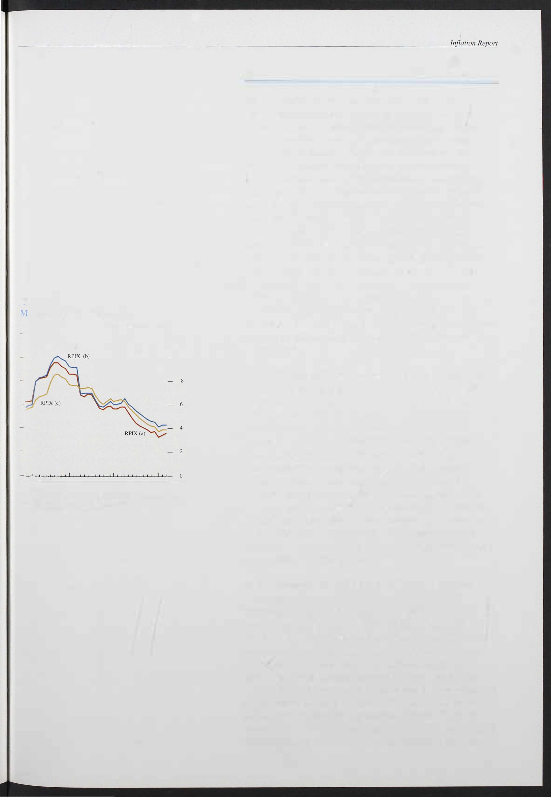

( hart 1.6

easures of 'core' inflation

Increase in prices on a year earlier

- 12

10

1990 91 93

1. RP! excluding mortgage interest payments.
2. RP! excluding mortgage interest payments, food and fuel and light.
3. RPI excluding mortgage interest payments, food. fuel and light. local authority taxes and indirect taxes.

The argument for moving from a broad measure of underlying inflation to a narrower measure of 'core' inflation derives from the problem of distinguishing changes in relative prices from changes in the price level. Large changes in relative prices can provide a misleading impression. They often result from temporary fluctuations of comparatively narrow groups of prices, such as seasonal foods and petrol. Stripping out the more volatile components of the RPI, and those components which directly reflect the Government's policy actions, will produce an index which is less representative of actual price changes but which may offer a more accurate guide to movements in the trend. Chart 1 . 6 presents two alternative measures of 'core' inflation alongside the standard measure of underlying inflation. The two 'core' measures have moved closely with underlying inflation since the February *Report.*

Both measures recorded sharp falls in January and both have risen slightly since then to rates just below those for December.

The definitions of 'core' i nflation shown in Chart 1 . 6 are essentially arbitrary. Some authors, however, have proposed a more theoretically based approach to the measurement of 'core' inflation in which individual price 'changes are ranked for each period and then selected or rejected for inclusion according to some agreed criterion. The technique is a very simple one, and may best be thought of as producing a median inflation rate, or an average over the less volatile components of the index (the 'trimmed mean'). The box on page 156 presents estimates compiled from 74 components of the RP!. Although median inflation rose fractionally between December and March, it has the same general characteristics as underlying inflation and is currently coincident with it.

These measures are interesting, and deserve further investigation. However, the risk remains that, in

stripping out large price movements, the resulting index may be unrepresentative. The Housing Adjusted RPI (HARP index) includes all of the items in the RPI with one exception. It replaces the mortgage interest component of the headline RPI with an alternative

user-cost-of-capital measure of owner-occupied housing costs. The construction of the measure was described in the February *Inflation Report.* The HARP measure of inflation has risen by 0.4 percentage points since three months ago. At 1 . 8%, it remains just below the headline RPI rate having been 1 . 2 percentage points below the

155

Bank of England Quarterly Bulletin: May 1 993

## 'Core' inflation

Measures of core inflation strip out some of the more volatile components of the RPI in order to reveal the underlying trend. But there may be less arbitrary ways of measuring core inflation than simply stripping out particular series such as mortgage interest payments, administered prices or food and energy. One alternative is to use statistical methods to smooth out short-term fluctuations in the RP!. But these methods are also arbitrary. They might generate a less volatile series, but there is no clear reason to suppose that

Retail price inflation and measures of the 'core' rate

Per cent

- 12

- 10

1988 89 90 91 92 93 o

1. The 12-lllonth percentage change in the all-items retail price index:.
2. The 'median' rale.
3. The 70% 'trimmed mean': the average of the central 70% or price changes.

underlying inflation itself is not volatile. Another measure of core inflation, due to Bryan and Cecchetti,(I) is based on the idea that a sigruficant proportion of firms face costs of adjusting prices .

('menu costs'). In such circumstances, changes in

relative prices can affect the aggregate price level, and hence the rate of inflation. Where, for example, the distribution of desired price changes

changes across goods and services would be bunched around this underlying rate. If there were a few larger actual price changes, then the average rate would be pulled away from the underlying rate.

The chart shows a (weighted) median rate of inflation derived from observations on 74 components of the RP!. It shows also the average inflation rate of the central 70% of the distribution of price changes. This 'trimmed-mean' excludes some of those changes in prices which would not be compensated for by smaller changes in the opposite direction because of the menu cost�. The proportion of the distribution which is excluded is arbitrary.

The table illustrates how often certain components appear in the 'trimmed mean'. The components chosen are examples of types of commodity which might be expected to be excluded from 'core' indices (eg foods, administered prices, energy products etc). One of the grounds for excluding mortgage interest payments (MIPs) from the RPI is that MIPs are unusually volatile (depending largely on the level of interest rates). There is support for this in the table, since MIPs almost never appear in the 70% 'trimmed mean'. On the other hand, many components grouped under the heading 'food and energy' or 'administered prices' (and excluded from the RPI by many commentators for the same reason) actually appear frequently in the band (in some cases, they are never excluded). The table suggests that excluding some goods for all time on the grounds of volatility alone is not sensible.

RPl sub-sections and their appearance in the 70% 'trimmed mean' (January 1988-March 1993)

is such that a few large desired changes are

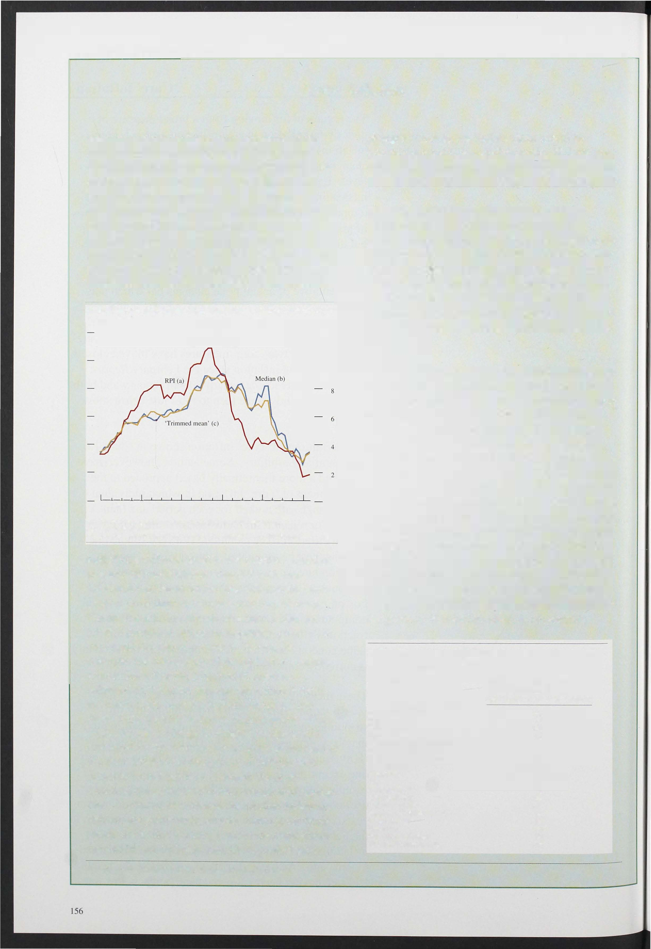

balanced out by many smaller ones, then if there are menu costs, only those firms facing a large desired change will bother to change prices. Thus what was just a change in relative prices, WOUld, measured by the average, show up as an increase in the price level, even though the underlying rate of inflation would not have changed. In such circumstances, one way to uncover the underlying rate of inflation is to choose the median inflation rate among goods and services. Since most firms would not bother to change prices over and above the underlying inflation rate, the spread of price

* 1. Bryan. M and Ceccheni. S (1992). 'Measuring Core Inflation', Mimeo.

Description

Biscuits and cakes Milk, fresh

Restaurant meals Beer

Mortgage interest payments

Rates/Community Charge

Water and other charges Dry materials

Electricity Gas

Telephones etc

Other clothing Chemists goods

Purchase of motor vehicles Petrol and oil

Rail fares

Bus and coach fares Household consumables

Number of appearances in 70% 'trimmed mean'

(percentage of observations used)

100

100

83

2

14

21

100

76

75

100

100

62

57

86

78

100

headline rate in December (see Chart 1 .7). The contrasting behaviour of these two measures since December is partly related to house prices which rose by 0.6% between December and March and which are captured directly in the HARP index but not in the RP!.

(hart 1.7

RPI and HARP inflation rates

Increase in prices on a year earlier

_1 2

_10

- 8

- 6

- 4

_ 2

0

One other price index which is of interest is the Tax and Price Index (TPI). This measures the change in gross

i ncome that would be needed to allow a household to continue purchasing a representative bundle of goods, taking into account not only changes in prices but also changes to direct taxes. The switching of the tax burden from direct to indirect taxes in recent years has contributed to the measured rise in the average level of prices. However, the change in gross income needed to compensate for this i ncrease has typically been less than one-for-one. And in the year to March the rise in the TPI was just 0.7%.

### 1.5

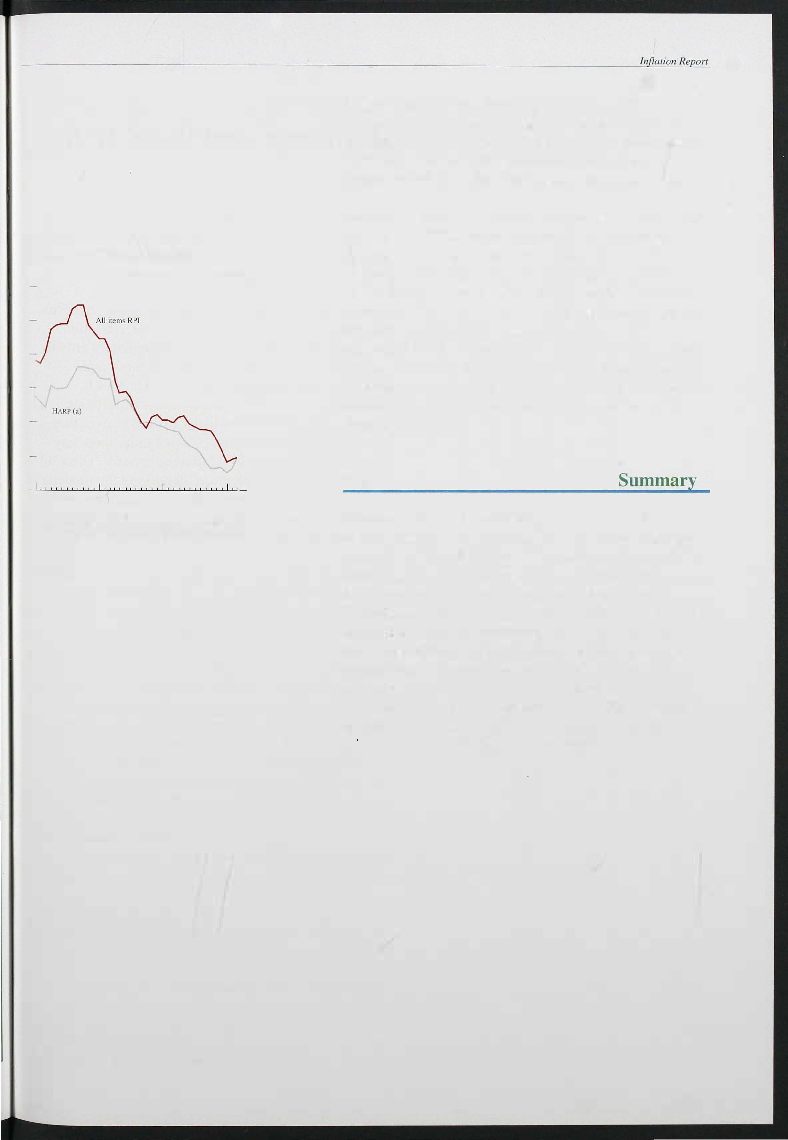1990 91 92 93

1. Incorporates user-cost measures with constant real yield for costs of owner-occupation (using unadjusled Halifax house price index).

Compared with three months ago, it is now somewhat easier to see how last autumn's depreciation is affecting domestic prices. Retail prices of a number of products, including some food i tems and consumer durables, have risen more rapidly since the autumn. And the latest three-month inflation rate has increased a little since the last *Inflation Report* and now stands somewhat further above the twelve-month rate than was the case three months ago. Nevertheless, underlying inflation, at

3. 5 %, is still in line with our expectations in February. Judging the balance of pressures in the coming months requires an examination of the forward indicators of prIces. It is to these that we now turn.

157



# Monetary and fiscal policy

Section 1 discussed recent developments in a range of price indices. The rest of the *Report* considers the factors which will determine inflation in the future, in both the short and long run.

The February *Inflation Report* set out in general terms the Bank's view of the inflation process. Inflation is a monetary phenomenon: more rapid monetary growth will, other things being equal, lead to more rapid

inflation. B ut the transmission from changes in monetary policy to changes in the rate of inflation is a complex process which is likely to change over time. Identification of the impact of a particular monetary shock is thus unlikely to be straightforward. There are also considerable problems in identifying the monetary shock itself, since measured monetary aggregates are all subject to some theoretical or practical difficulties (see the article on page 240 and the box on page 1 60).

Analysis of inflation begins, therefore, with an of monetary policy, both present and anticipated.

Although monetary policy may be analysed in terms changes in the monetary aggregates-and some

discussion of these appears in Section 2. 1 -the primary instrument of monetary policy is short-term interest rates. It is also the primary channel by which monetary policy has its i mpact on the economy, although the impact of any given change in the short-term interest

. rate will depend, in part, on the extent to which the change is reflected in longer-term i nterest rates. This in turn will depend on expectations of future monetary policy. Since the autumn, the inflation target has been the objective to which monetary policy is directed, and if the commitment to the target is fully credible then the authorities would be expected to respond to any

prospective movement of inflation close to the limits of

its target range or beyond. The credibility of the authorities' commitment to the inflation target can thus be judged by examining the markets' expectations of future interest rates. This is discussed in Section 2. 1 .

One important determinant of expectations is fiscal policy. Changes in fiscal policy would be expected to result in short-run changes in output and prices. But if monetary policy does not accommodate the resulting change in prices then fiscal policy of itself should have

1 58

Table 2.A

fficial interest rates overseas

Per cent per annum

1 992 1993

no long-run impact on the price level . But large and persistent deficits may cause investors to fear that the authorities will be tempted to erode the real burden of debt by inflation. In this way, fiscal policy can have a significant effect on expectations of monetary policy and thus of longer-term interest rates. Fiscal policy is discussed in Section 2.2.

United States:

|  |  |  |  |  |  |
| --- | --- | --- | --- | --- | --- |
| Prime | 6.0 | 6.0 | 6.0 | 6.0 | 6.0 |
| Discount | 3.0 | 3.0 | 3.0 | 3.0 | 3.0 |

Japan:

� I Dec. I Mar. I Apr.

7 May

## Monetary conditions

Discount 3.25 3.25 2.5 2.5

Call 4.1 3.9 3.2 3.2

Gelmany:

Discount 8.75 8.25 8.0 7.5

9.5

2.5

3.2

7.25

*Interest rates*

Official interest rates in the United Kingdom have

Lombard 9.75

Fr<.mce:

Intervention 9.6

9.0 9.0

9.1 9.1

9.1

8.5

8.0

remained unchanged since the one percentage point cut-from 7% to 6%-on 26 January. By contrast,

5- I 0 day repo 10.5 10.0 12.0 1 2.0

Itaty:

|  |  |  |  |  |  |
| --- | --- | --- | --- | --- | --- |
| Discount | 13.25 | 13.0 | 1 1.5 | 1 1 .5 | 11.0 |
| Advances | 14.75 | 14.0 | 12.5 | 12.5 | 12.0 |

2.B

E peeted 3-month sterling Libor rates

Per cent per annum

|  |  |  |  |  |  |
| --- | --- | --- | --- | --- | --- |
|  | 1993 | | 1994 | | |
| Date | � | June |  | Dec. | Mar. |
| 14 Sept.1992 | 10.25 | 9.5 | 9.2 |  | 9.1 |
| 21 Sept. | 9.25 | 8.0 | 8.0 | 8.3 | 8.5 |
| 57 Feb. 1993(a) | 6.2  6.0 | 5.9 |  | 5.3  6.0 | 6.3 |

9.2

5.3

May

(a) Quoted in the February Inflation Report.

Chart 2.1

Implied forward interest rates

Per c-ent12

- It

- 10

9.0

5.7

official interest rates in some other European economies have fallen (see Table 2.A). In Germany, for instance, the Lombard rate was cut by 0.5 percentage points in April, and the discount rate has fal len by 0.75 percentage points since March. In France the reductions have been bigger as exchange rate pressures have eased

considerably. Although the intervention rate has declined by just over one percentage point, the 5- 10 day

repo rate has fallen �y three percentage points.

Fol lowing the last i nterest rate cut the markets were

discou,nting a further cut in three-month interest rates of around 3/4 percentage point by June. But by early May sterling interest rates (as derived from interest rate futures prices) were expected to remain broadly flat this year, with a possible rise in early 1 994 (Table 2.B). In the United States, too, short-term interest rates are expected to rise as recovery takes hold: three-month rates are expected to increase by around IIz percentage point, to 3.6%, during the remainder of this year.

European interest rates, on tI-?-e other hand, are expected to fall further as monetary authorities respond to falling i nflation and the slowdown in growth. Three-month euromark rates, for example, are expected to fall from

7112% on 7 May to just 6% by the end of this year.

21 Sep!. t992 - 9

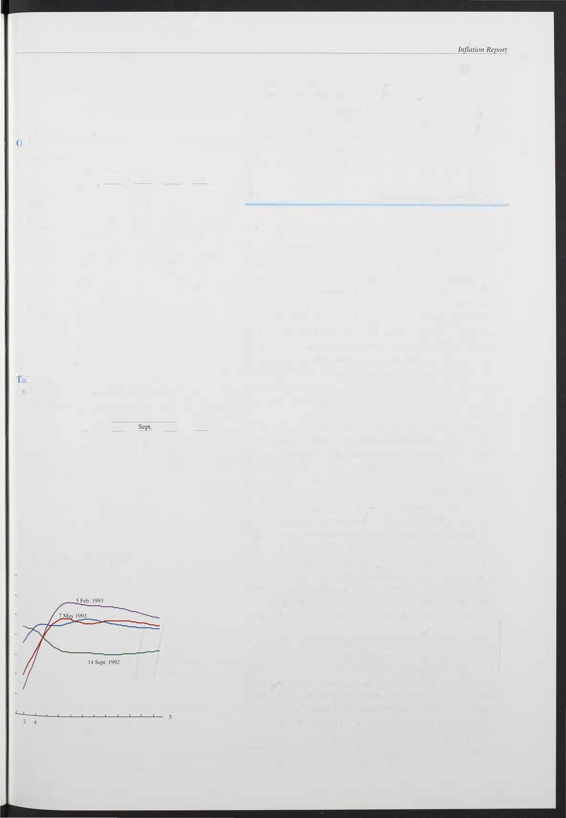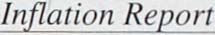

- 8

- 7

- 6

6 8 10 t2 14 16 t8 20 22 24

Years

Although sterling interest rates are now expected to be higher in the near future than was thought likely at the time of the last *Inflation Report,* expected interest rates have actually declined at all maturities beyond six years. Chart 2. 1 shows implied forward interest rates on 7 May, and contrasts them with implied rates in early February (when the last *Report* was completed), and with those around the time of the suspension of sterling's ERM membership. The implied rates are derived from the par yield curve on the given date. They represent a

159

Bank of England Quarterly Bulletin: May 1 993

## Divisia indices for money

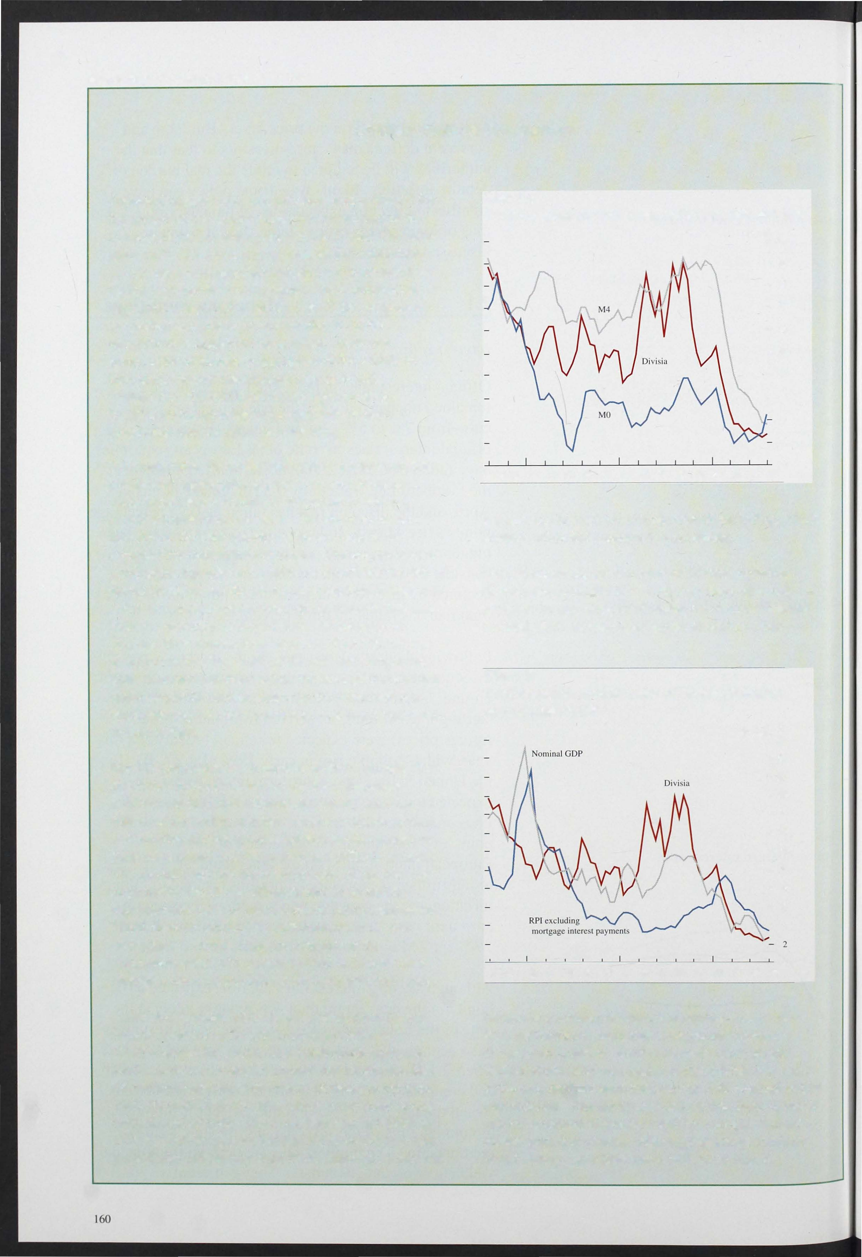

Published targets (more recently monitoring ranges) for the growth of the money supply have been part of the framework for monetary policy in the United Kingdom since 1976. The monetary aggregates for which there are monitoring ranges (MO and M4) are constructed by adding together their components. Such simple-sum aggregation implicitly assumes that all the components are perfect substitutes for one another from the perspective of holders of these assets. However, components of monetary aggregates differ widely in their ability to provide monetary services and, furthermore, these differences change over time.

Treating all components of an aggregate as perfect substitutes may therefore be misleading.

A Divisia index for money attempts to improve on this simple-sum aggregation approach by weighting each component asset according to the extent to which it provides transactions services. The aim is to produce a measure of the total quantity of money held in the economy for transactions purposes. The weight of each component depends on the difference between the rate of interest it offers and the return on a benchmark asset that offers no transactions services, on the grounds that asset holders are willing to forgo interest as the price of 'buying' these transactions services. This difference is described as the 'user cost' of the relevant component.

Thus cash and non-interest-bearing deposits have a high user cost and the largest weight in the index, whereas wholesale deposits have a low user cost and a very small or zero weight.

But a Divisia index has a number of shortcomings. The first is the difficulty of measuring the transactions services provided by each monetary asset, when the effects of the variety of other services available to bank and building society account holders and the impact of bank charges and new technology are difficult to isolate. The second concerns the determination of the user cost, in particular the choice of benchmark asset and the representative rates of interest for the component assets. Third, there are difficulties with interpretation; for example, in a Divisia index the weights of the component assets will change as soon as interest rates change, even if no portfolio shifts have yet taken place.

A detailed appraisal of the issues arising from Divisia indices is set out in the article on pages 240-55.

Chart A shows the growth of a constructed aggregate Divisia index and compares it with that of MO and M4. Of particular interest is the lise in Divisia growth from 1985 Q2 until 1986 Q3, after which it remained strong until the end of 1988. However, between end-1988 and 199 2 Q4 Divisia growth fell sharply to below 3%. M4 growth also fell sharply from 1990, although its fall was

ChartA

Twelve-month growth rates of Divisia, MO and M4

Per cent

- 20

- 18

- 16

- 12

- 10

- 8

- 6

4

2

o

1978 79 80 81 82 83 84 85 86 87 88 89 90 91 92 93

less severe. In 1993 Ql Divisia growth picked up, albeit slightly, while M4 continued to decelerate.

Chart B shows the growth rates of Divisia, inflation (RPIX) and nominal GDP. Although there does not appear to be any close relationship between Divisia and nominal GDP, Divisia does appear to lead nominal

Chart B

Twelve-month growth rates of Divisia, inflation and nominal GDP

Per cent

- 22

- 20

- 1 8

- 1 6

- 1 2

- 1 0

- 8

- 6

-

4

o

1 978 79 80 81 82 83 84 85 86 87 88 89 90 91 92 93

income at a number of important turning points. No such association is immediately apparent between Divisia and inflation. Further analysis using simple statistical causality tests suggests that Divisia has some value as a medium-term indicator of both nominal output and inflation. One advantage of a Divisia index is that it can be explained reasonably well by a simple demand for

money equation whereas other aggregates, particularly broad money, have been more difficult to model.

succession of one-year interest rates at future one-year intervals which would, if realised, yield the same return as the relevant longer yields on the date in question. If the term risk premium is small, these i mplied rates can be interpreted as expected future short interest rates.

The yield curves from which they are derived are calculated by fitting curves through observed yields on a large number of government bonds. As a result the shapes of the implied forward yield curves are sometimes difficult to rationalise. The most recent curve in Chart 2. 1 , for example, shows some slight

fluctuation beyond the nine-year maturity, and there is no obvious economic explanation for this. Hence the curves should be interpreted as illustrating expected general trends, rather than offering precise estimates of expected yields.

able 2.C

The sterling exchange rate(a)

15 Sepl. 31 Dec.

5 Feb.(b)

7 May

In this spirit, the most recent data show that interest rates are expected to rise to around 9112%. On average this is around 112 percentage point lower than expectations at the time of the last *Report,* although still over one percentage point above expectations before suspension of sterling's ERM membership.

Sterling ERl(c) US dollar

Deutschmark ECU

SDR

(a) Close of business.

90.9

1.89

2.78

1.38

1.31

79.6

1.52

2.45

1.26

1.10

77.7

2.40

1.45

1.23

1.06

80.9

1.58

2.49

1.27

1.1 1

These changes may provide a guide to the credibility of the monetary stance, and to the new framework for monetary policy. In this context it is not surprising that

the events of last September apparently raised the

1. Quoted in the February IlIjlmioll Report. (c) 1985=100.

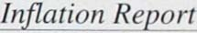

market's expectation of long-term inflation in the United Kingdom. B ut it is encouraging that the

i mplementation of the new framework is beginning to enhance the credibility of monetary policy.

Nevertheless, while expectations have improved, they have still not adjusted to the long-run inflation

target.

*The exchange rate*

Between 15 September 1 992, the last day before

suspension of sterling's membership of the ERM, and 5 February 1 993, the effective sterling exchange rate depreciated by 1 4.5% (see Table 2.C). The overall index masked a sharp difference between the changes against European and non-European currencies:

sterling fell by 1 0.9% against the Ecu, but by over 23% against the dollar. In the following week sterling depreciated slightly further (to a low point of 76.0 on

1 1 February), but has since more than recovered that decline. By 7 May the effective rate had risen by 4.l % from its 5 February level, although by rather more against the dollar (9%) than against the deutschmark

(3 .8%) or the Ecu (3.3 %).

161

Chart 2.2

UK and trade-weighted world interest rate yield (April 1993)

Per ce� 7.3

-7.2

-7.1

-7.0

-6.9

- 6.8

-6.7

-6.6

- 6.5

- 6.3

- 6.2

- 6.1

-6.0

- 5.9

- 5.8

3·monlh 6-month 12-Thonth

Chart 2.3

Yield curves (April 1993)

UK-trade weighted interest rate differential Per cent

--0.60

--0.70

--0.80

--0.90

--1.00

--1.10

--1.20

--1.30

- 7.70

- 7.60

- 7.50

- 7.40

- 7.30

- 7.20

- 7.10

- 7 00

- 6.90

- 6.80

- 6.70

The pattern of present and expected i nterest rates implies a particular path for the sterling exchange rate in the coming year and beyond. Chart 2.2 compares the short-term yield curve for the United Kingdom (over a twelve-month horizon) with a similar yield curve for 'world' interest rates. The latter is calculated by weighting together interest rates in sixteen countrie where the weights are those used in the construction f the sterling effective exchange rate index (ERI).(l) Thf' biggest contributions are those of the United States, Germany and France. The slope of the world yield curve is strongly influenced at present by the expectation that European rates will fall further throughout this year.

This can be seen from Chart 2.3 which plots the money-market yield curve for the United States and Germany separately. It also plots the i mplied interest *diferential* between the United Kingdom and the rest of the world, which narrows from around -1 .2% for three-month in terest rates, to only -0.6% at the twelve-month maturity. On the assumption that the differential in the interest rate is exactly balanced by

the expected capital gain from holding sterling over the same period (ie assuming uncovered i nterest parity), d twelve-month differential of - 1 % would imply that the markets expected sterling to appreciate by 1 % over the next year. B ut the narrowing of the interest rate

differential is such that the expected appreciation of sterling over the next year is likely to be less than that. It should be noted that expected exchange rates calculated in this fashion have a poor record in

predicting actual changes.

*Monetary and credit aggregates*

The monetary and credit aggregates continued to offer conflicting signals in the first quarter. MO growth rose above its target (now monitoring) range of 0%-4%,

while M4 growth remained below its interim

United Sll.ltc�

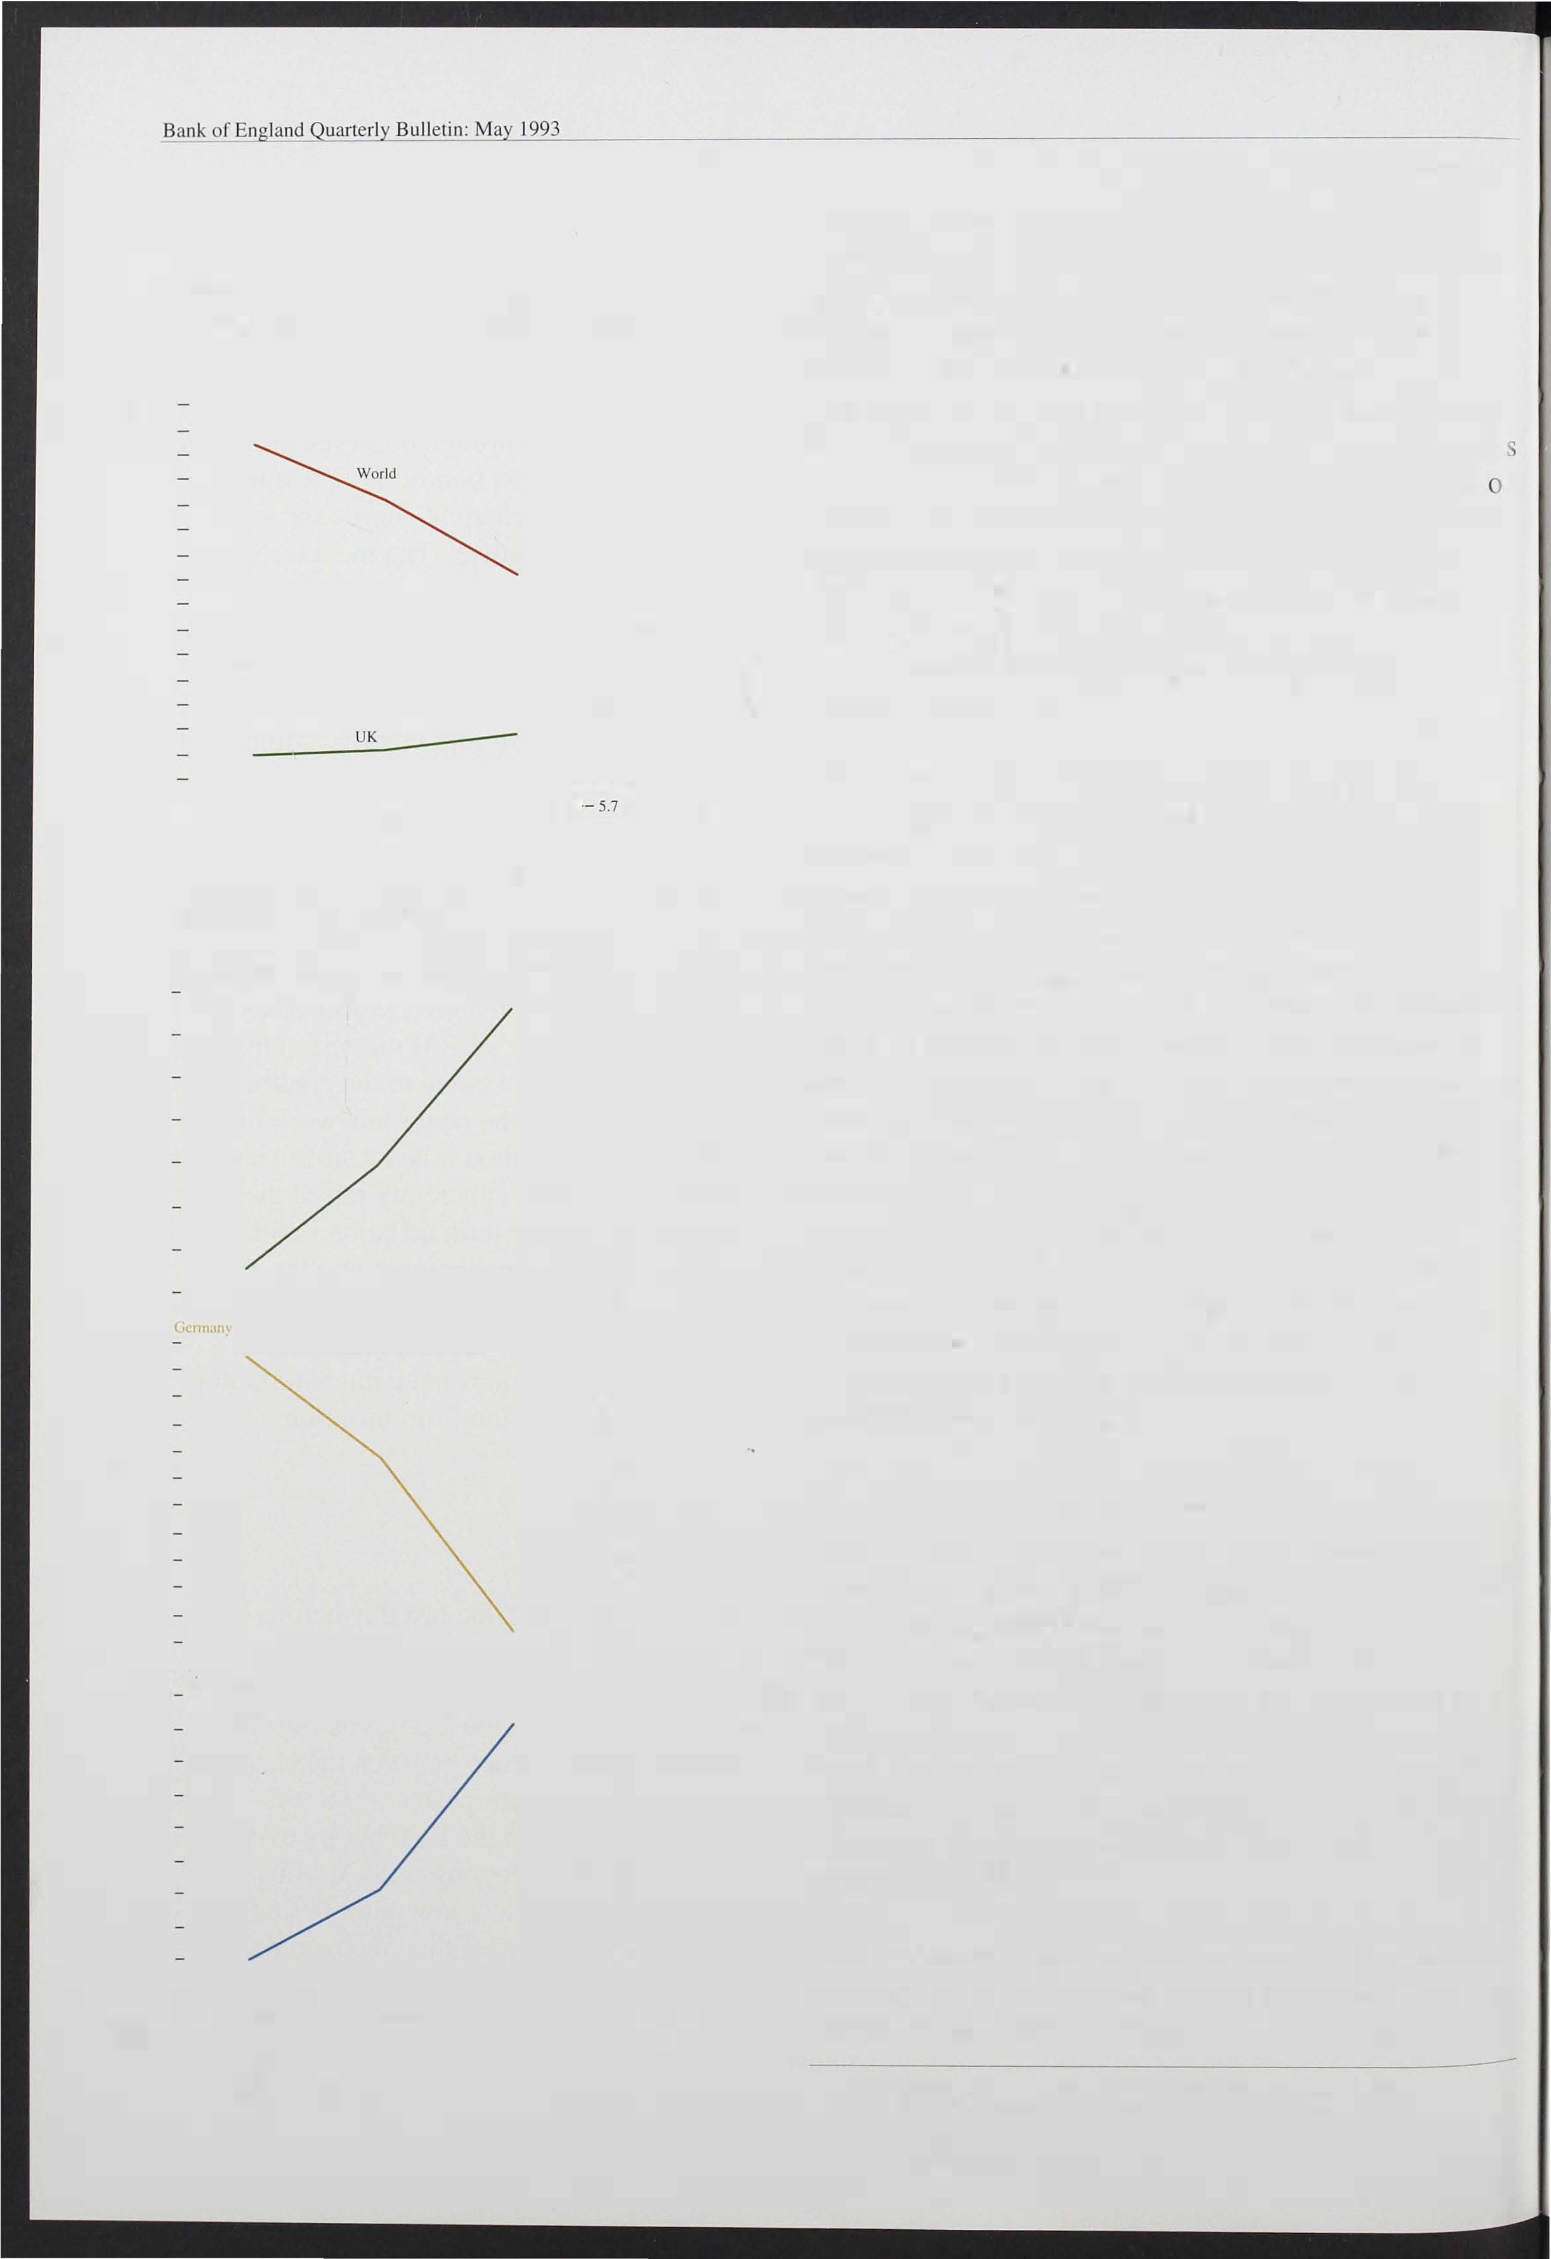

3-month 6-Thonth 12-monlh

162

- 3.45

- 3.40

- 3.35

- 3.30

- 3.25

- 3.20

- 3.15

- 3.10

- 3.05

3.00

monitoring range of 4%-8% (subsequently widened to a range of 3%-9% in the March 1 993 Budget). There was some evidence from the monthly figures that M4 growth was beginning to rise, but growth in the private sector credit counterpart remained weak (see

Chart 2.4).

MO continued to grow rapidly during the first quarter of 1 993. Its twelve-month growth rate rose to 4.9% in March (from 2.8% in December). Shorter-run growth

(I) The construction of the sterling ERI is described in more detail in the November 1 988 edition of the *Bank oJ England Quanerly Bl.Illerin.*

( hart 2.4

1welve-month growth rates of MO, M4

� Id the credit counterpart to M4

Per cent

- 22

- 20

- 18

- 16

- 14

- 1 2

- 1 0

- 8

- 6

- 4

- 2

0

rates have been rapid, with six-month and three-month annualised growth rates of 7. 1 % and 9.5% respectively.

Growth slowed a little in April, although the twelve-month rate remained outside the monitoring

range, at 4.8 %-see Chart 2.5. Much, but not all, of the strength of MO can be explained by faster growth of the value of retail sales, and the impact of lower interest rates (which lower the opportunity cost of holding cash). Other factors, such as changes in the composition of expenditure, may also be important.

M4 growth slowed further towards the end of last year, and M4 actually fell in January, when the twelve-month increase was only 3.1 %-the lowest rate since the monthly series began in June 1 983. The weakness of M4 was consistent with a number of other nominal

indicators, reflecting the relatively flat profile for real demand and output, coupled with falling inflation. But in the past two months M4 has risen again, taking the three-month annualised growth rate to 5. 3% in March,

and the twelve-month rate to 3.6%. The main credit

990 92 93

( <It Bank and building society lending 10 the private sector.

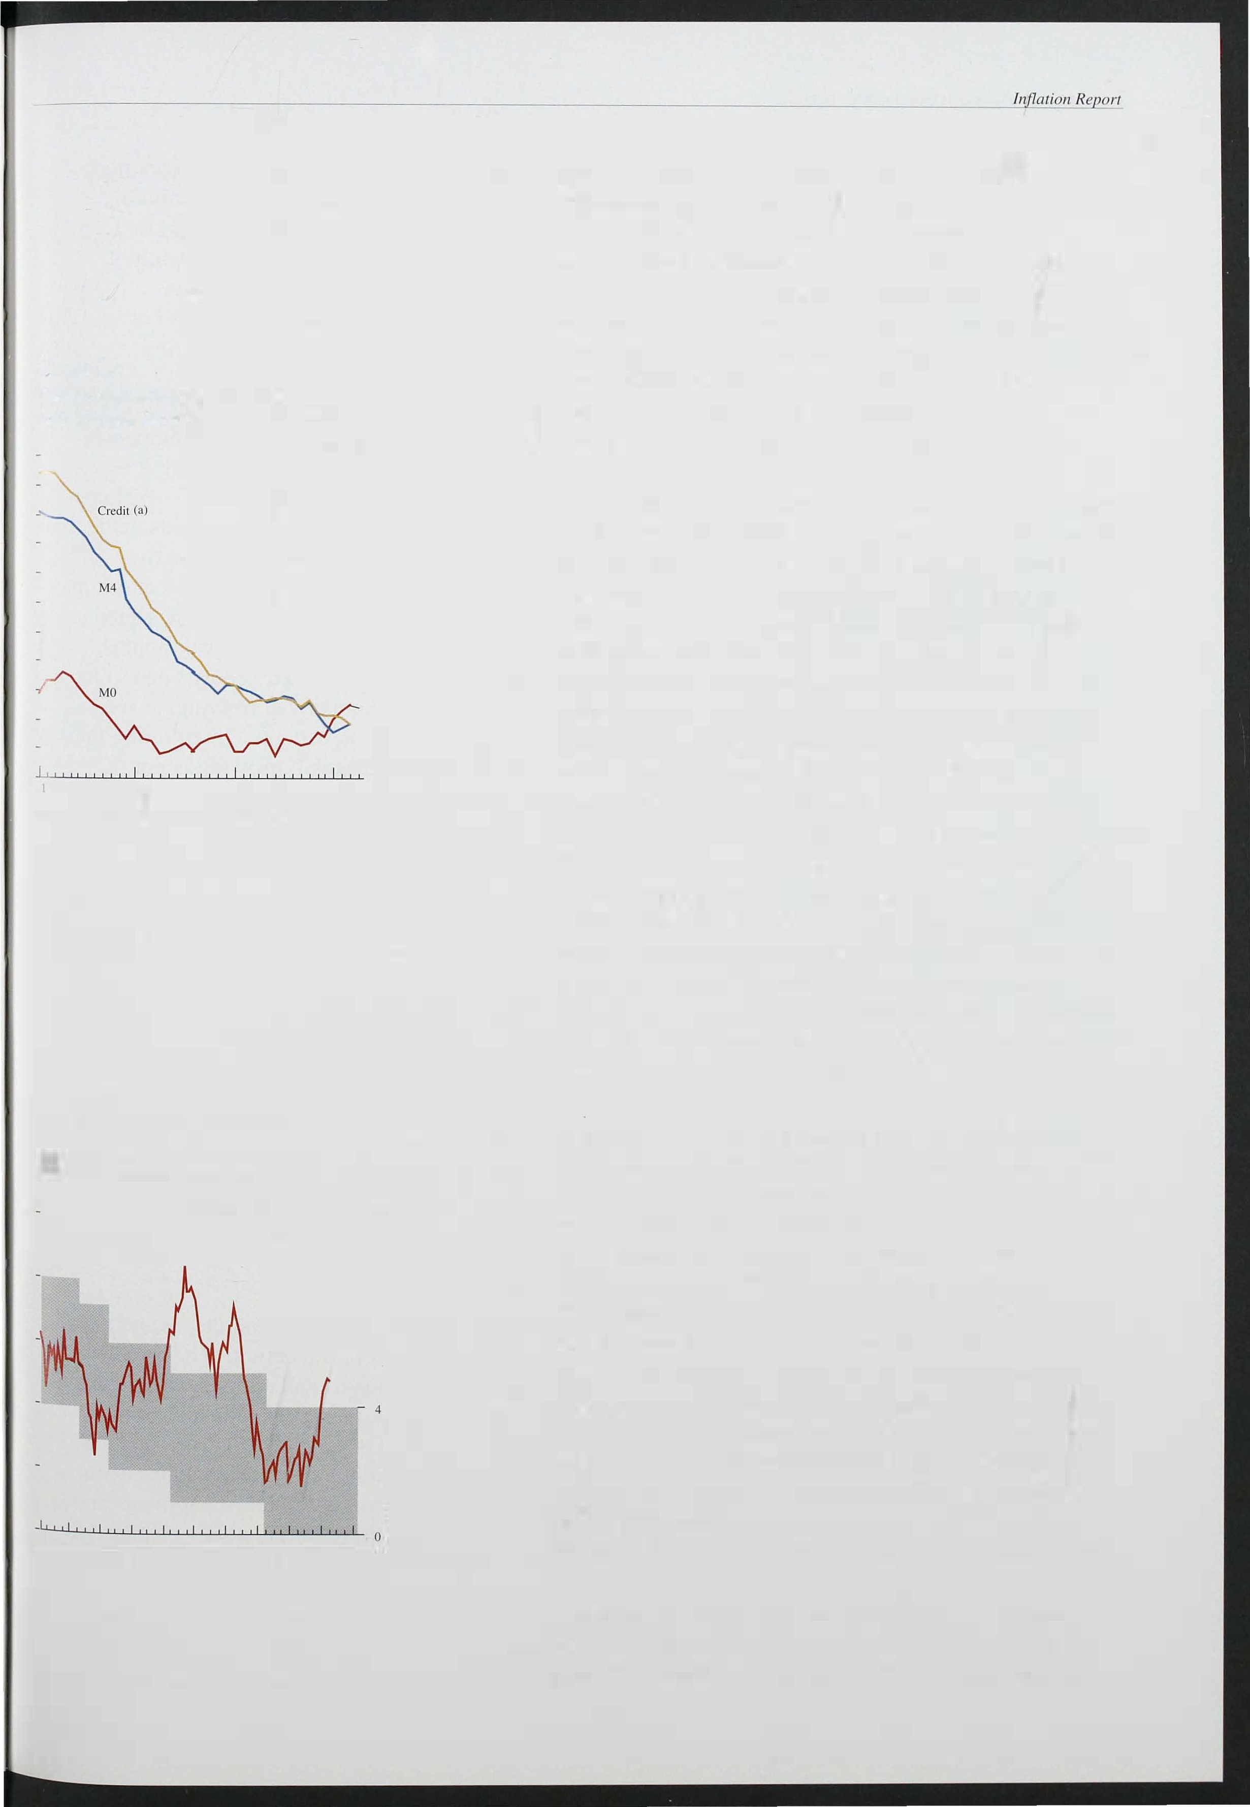

Growth rates of MO

o MO target ranges from April 1984 10 March 1993

l, Ilclusive: monitoring range thereafter

Percentage changes on a year enrti� 10

- 8

- 6

- 2

1 984 85 86 87 88 89 90 91 92 93 94

counterpart to M4-bank and building society sterling lending to the rest of the private sector-may, however, be a more timely indicator of future nominal demand because banks a�d building societies tend to act as liability managers, seeking to vary deposits according to the profitability of lending opportunities. Credit rose by. 0.4% in the first quarter, the smallest quarterly increase for over 25 years. In March credit actually fell by 0.2%. As a result the twelve-month growth rate fell to 3.7%, from 4. 1 % in February.

Examination of the sectoral money and credit figures shows that borrowing was focu sed largely in the personal sector, but that the growth in deposits was more equally spread. Within the personal sector, net borrowing by individuals from banks and building societies was £1 .9 billion. Borrowing amounted to

£4.6 billion, compared with £3 .8 billion in 1 992 Q4, and is consistent with a recovery, albeit from a very low level, in personal spending and the housing market.

Borrowing for house purchase increased by £4.2 billion (1 .4%), up £0.5 bil lion on the fourth quarter. Although recent reports in the press have suggested stronger

activity in the housing market, this has not yet fully filtered through to the lending figures. This may be

because enquiries have not yet resulted in completions.

Consumption borrowing increased 0.9% in the first quarter, after 0.5% (adjusted for a loan transfer) in the previous quarter-consi stent with the rising trend in

163

Chart 2.6

Private sector net sterling borrowing from banks and building societies(a)

retail sales seen over the quarter. Unincorporated businesses both reduced their bank and building society deposits and repaid debt during the first quarter. The repayment of debt, in the region of

£0.6 billion, was the largest repayment by

unincorporated businesses since the series began. This

* OFls
* Total

o ICCs 0 Persons

£ billion-s 14

- 12

- 10

- 8

- 6

+

- 2

- 4

- 6

may reflect continued financial restructuring.

Although their deposits increased by £2.0 billion in the first quarter, i ndustrial and commercial companies (ICCs) repaid substantial volumes of debt. It is estimated that ICCs borrowed in January-perhaps reflecting the heavy corporate tax payments made that month-but that this was more than offset by repayments in February and March. This pattern may be the counterpart to the substantial public sector borrowing requirements in the latter two months, which are l ikely to have boosted deposits and to have

reduced the need for company borrowing, as well as

_ - assisting repayment of bank debts. Interpreting the

1 990

Table 2.D

91 92 93

behaviour of corporate bank borrowing is not straightforward, since companies also have access to other sources of finance. In the first quarter ICCs raised £2.6 billion from sterling capital issues.

General government finances

£ billions; figures in ilalics as a percentage of GDP

Bank estimate 1993 FS BR forecasl

43 //4

## Fiscal

Since the last *Inflation Report* the fiscal measures announced in the March Budget have reinforced the medium-term credibility of the new monetary framework. Although the announcement of the revised PSBR projection of £50 billion for 1 993/94 had the effect of raising long bond yields, they have since fal len back, as noted in the sub-section above on

interest rates. This may reflect the reactions of the markets to the pre-announced tax changes for this year and next.

from the 1993 Budgel measures

|  |  |  |  |  |
| --- | --- | --- | --- | --- |
|  | 1989190(P) | 1992/93 | I 993/94(T) | 1 997/98 |
| Expendilure | 201 | 260 | 280 | 342 |
|  | 381N | 43112 | 44112 |  |
| oJ which. New Control Total | | | | |
|  | 175.1 | 231 | 244 | 284 |
|  | 33//4 | 38t12 | 383N |  |
| Receipts | 207 | 224 | 229 | 311 |
|  | 39112 | 37t12 | 36112 |  |
| PSBR(a) | -8 | 36112 | 50 | 30 |
|  | -1 112 | 6 | 8 | 33/4 |
| Pri vatisation proceeds | 4 | 8 | 5 1/2 |  |
| PSBR excluding privalisalion | | | | |
| proceeds | -4 | 44112 | 551 12 | 31 |
|  | -3/4 | 7112 | 8JN | 4 |
| Expecled direcl revenue gain | | | | |

Memo items:

Nel public seclor

debl ralio (b) 28

P: Peak of eyele. T: Trough of cycle.

33112

0. 1

It is difficult to distinguish between the cyclical and structural components of the deficit. Their rel ative magnitudes depend, in particular, on the size of the output gap. However, one crude i ndicator of the

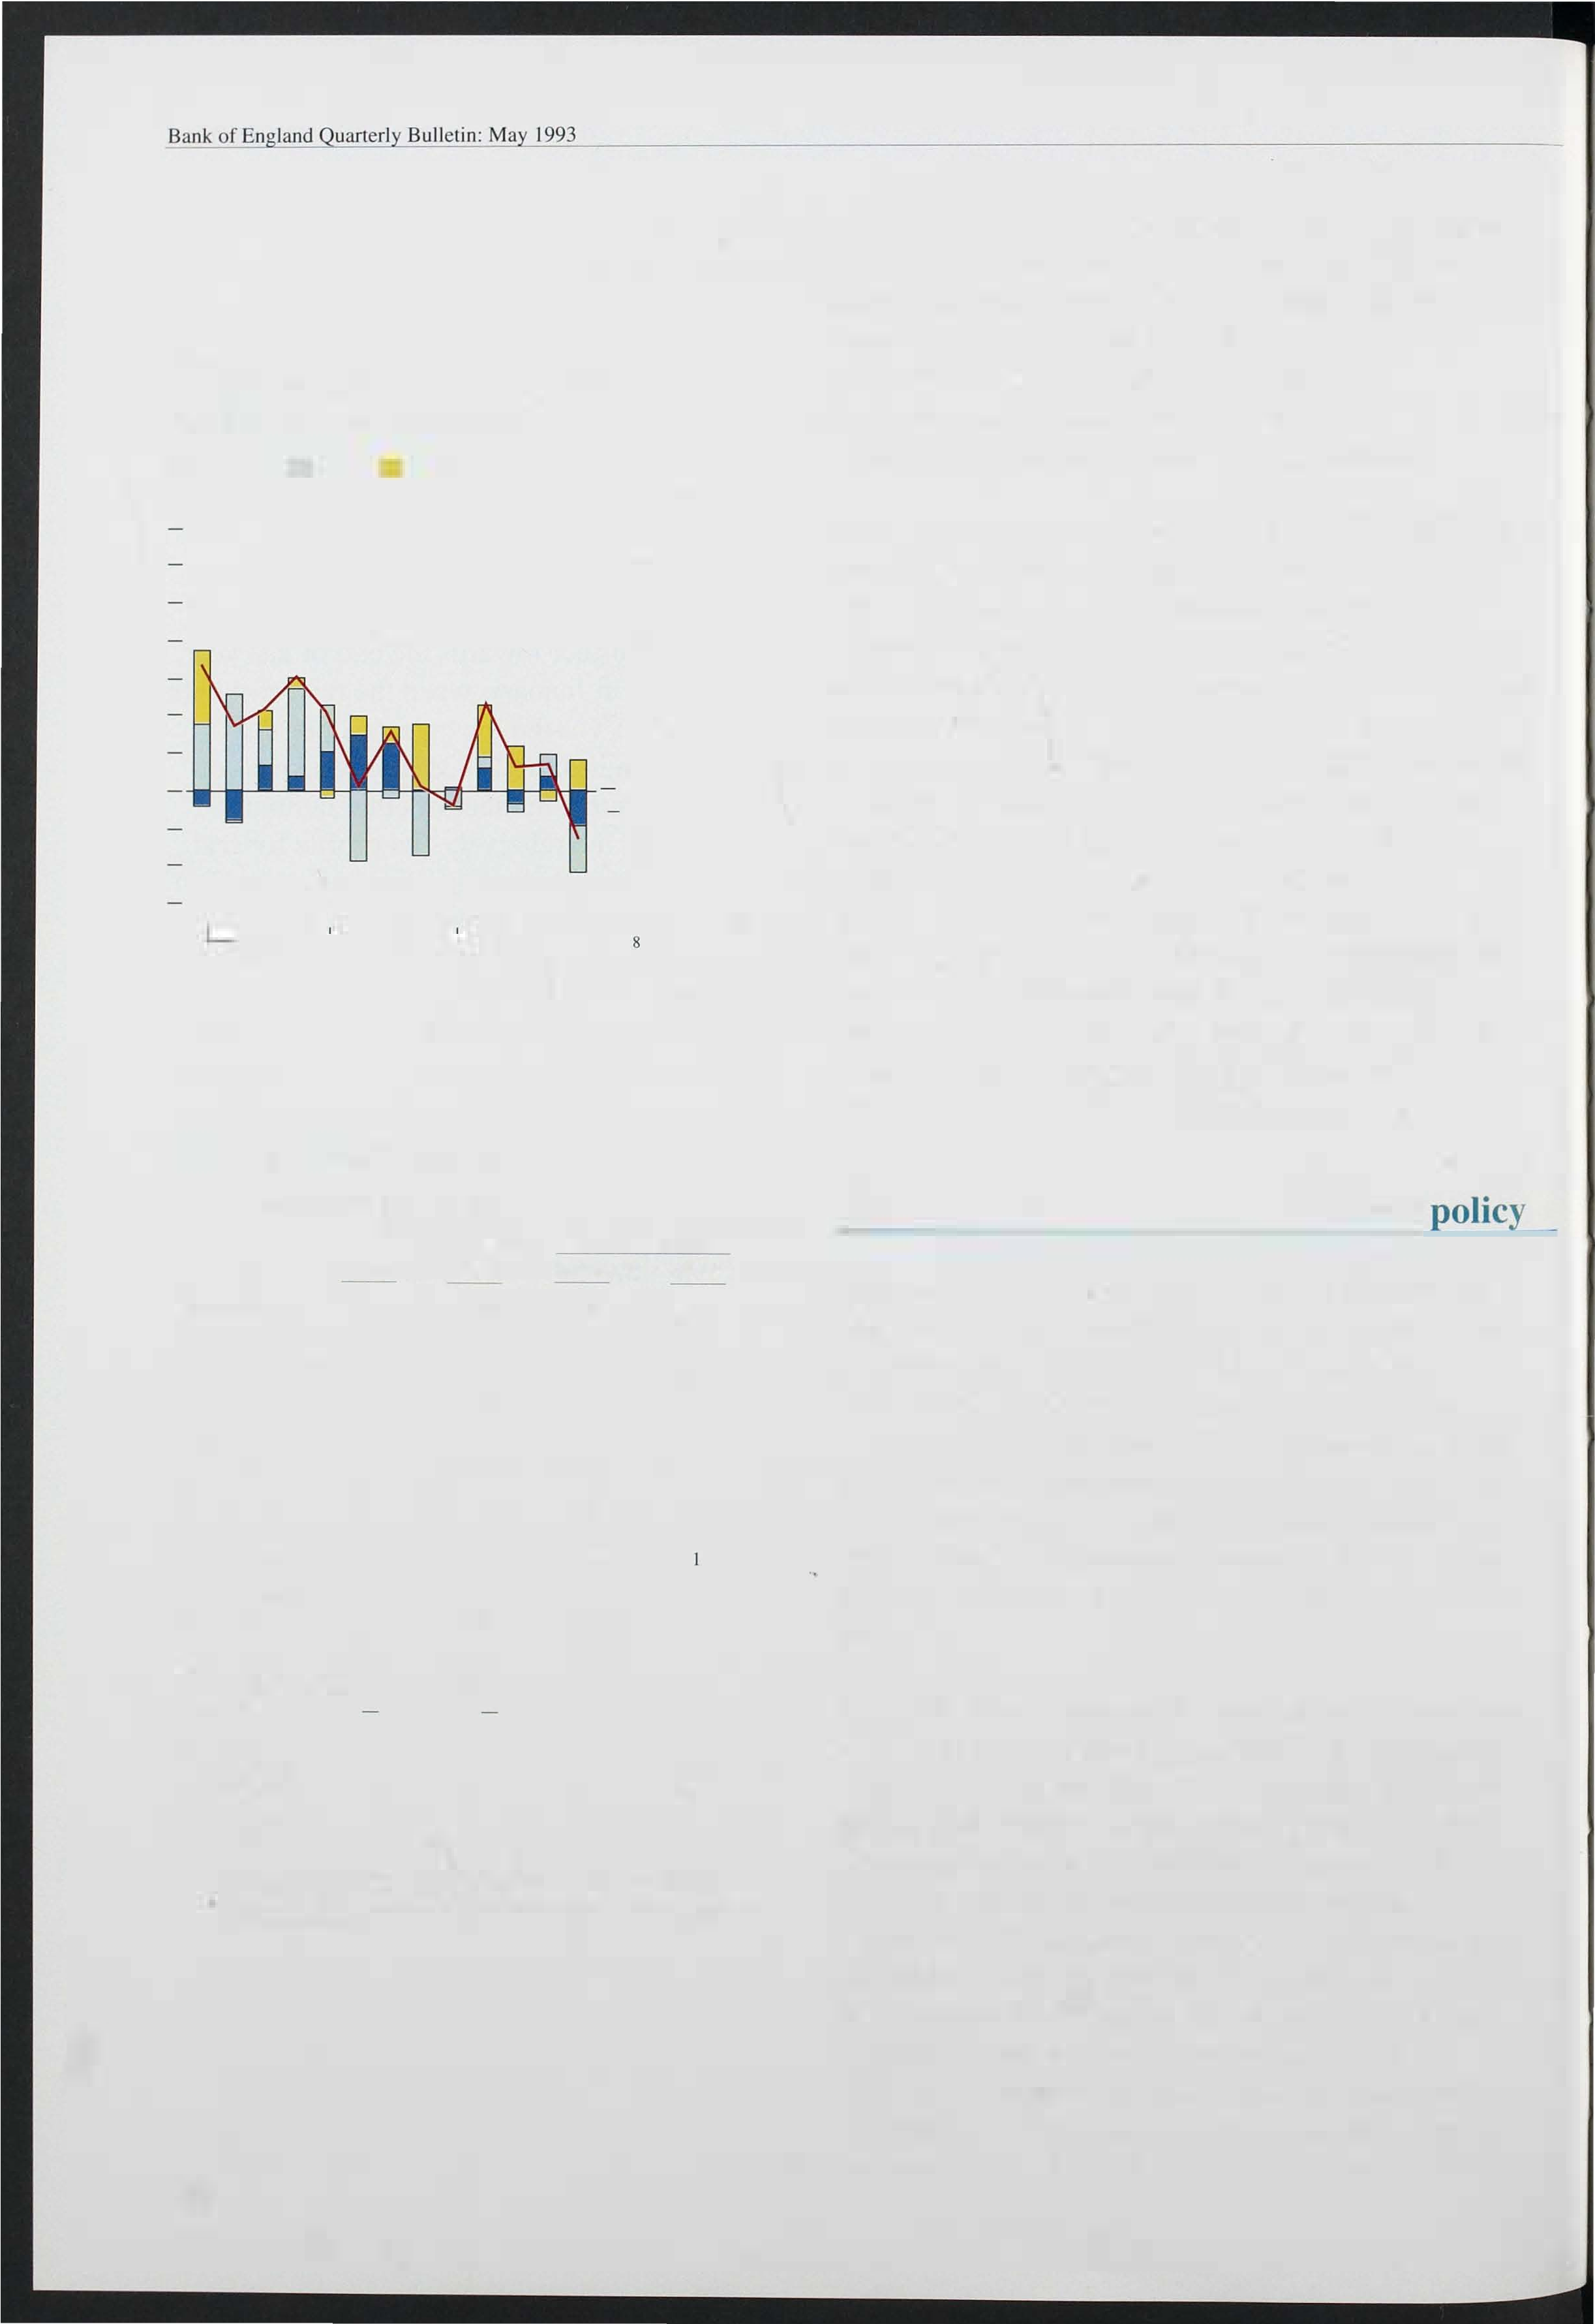

1. Public corporations Tharket and overseas borrowing accounts for the difference between expenditure less receipts and the PSBR.

l

1. et public sector debt a end-March as a percentage of Thoney GDP in four quarters centred on end-March.

1 64

structural component is the New Control Total (NCT)

for government expenditure, which excludes cyclical social security payments and interest payments and is designed to capture discretionary policy changes. It has risen markedly during this recession. But the Autumn Statement measures, coupled with a resumption of growth, should reduce it substantially.

As Table 2.D shows, government estimates suggest that the NCT will, on the basis of average GDP growth

of 2.6% per annum over the next five years, decline to 353/4% of GDP in 1 997/98 from a peak of 383/4% in the present fiscal year. This would still be higher than in the second half of the 1 980s: the average between



1 984/85 and 1 989/90 was 34.6% of GDP. Government estimates suggest that tax receipts will be

1 .7 percentage points higher as a proportion of GDP in 1 997/98 as a *direct* result of the tax changes announced in this year's Budget. Although this change represents a tightening of the fiscal stance relative to 1 992/93, receipts are still li kely to be lower in 1 997/98 than in the late 1 980s. Given that output was probably above trend in the late 1 980s, these comparisons suggest the planned fiscal tightening will reduce the structural deficit.

Even with substantial reductions in the deficit, however, the ratio of net debt to GDP is expected to rise further. FSBR estimates suggest it may rise by over 16 percentage points between last fiscal year and 1 997/98. This rise shows that large deficits not only create large financing requirements in the year they are incurred, but also leave a significant burden of

financing for future generations.

165

# Demand and output

Chart 3. 1 Domestic output

1985=100

- 122

- 120

- 1 1 8

- 1 1 6

- 1 1 4

- 1 1 2

- 1 1 0

- 108

- 1 06

- 1 04

- 102

- 100

- 98

In the long run the rate of inflation is determined by monetary growth. But in the short run the speed at which inflation adjusts to the underlying rate implied by monetary policy depends on supply and demand in goods markets. If output is high relative to ' normal ' output or 'productive potential ' then inflation will, other things being equal, rise. And if potential output exceeds actual output there will be downward pressure on inflation. Short-run changes in the inflation rate reflect the size of this 'output gap' . In this section we discuss the most recent evidence on output, and hence the output gap, and on total demand which will influence short-run movements in total output.

Preliminary estimates suggest that GDP rose by around

1 /4 % in the first quarter of 1 993, with non-oil output rising by more than 112%. Domestic demand also appears

1985 86 87 88 89 90 91 92 93

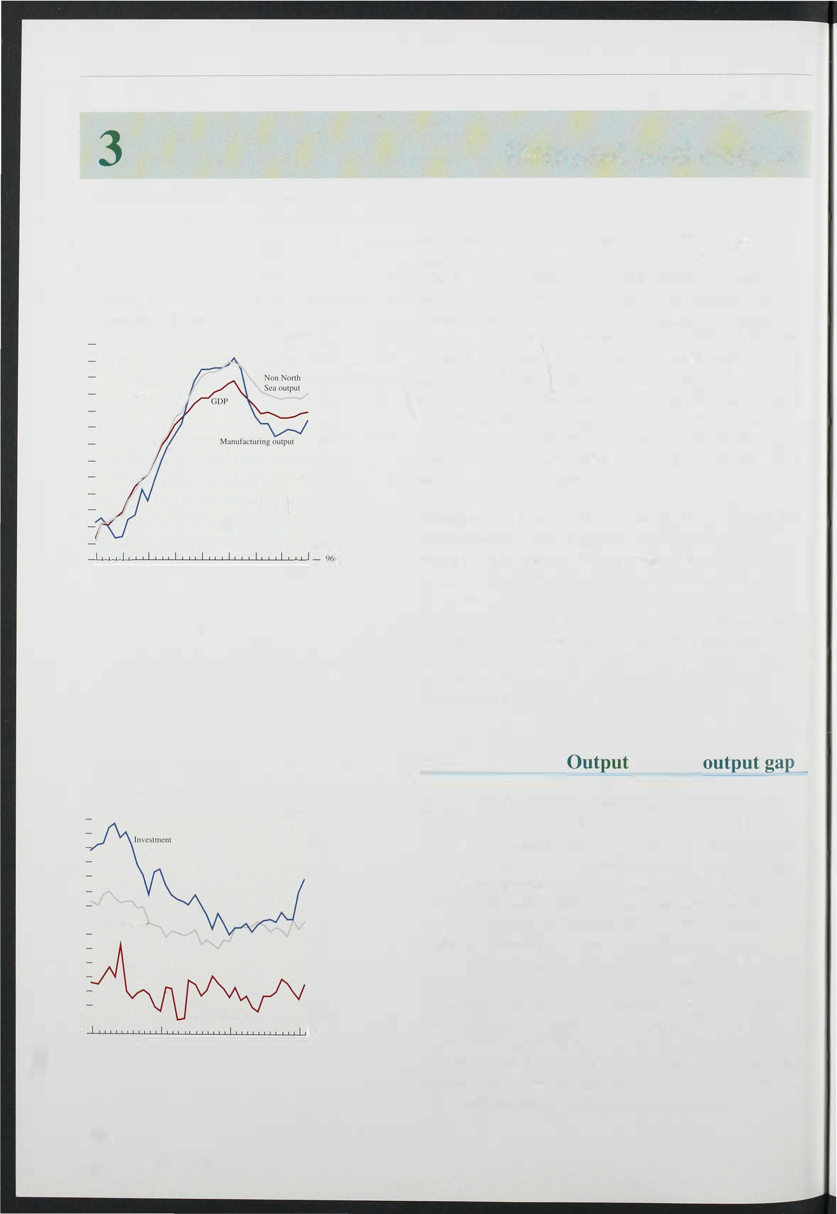

|  |  |
| --- | --- |
| Chart 3.2  Industrial production |  |
|  | 1985=100  - 126 |
|  | - 1 24 |
|  | - 122 |
|  | - 120 |
|  | - 1 1 8 |
|  | - 1 1 6 |
|  | - 1 1 4 |
| - Consumplion | - 1 1 2 |
|  | - 1 1 0 |
|  | - 1 08 |
|  | - 1 06 |
|  | - 1 04 |
|  | - 102 |

- 1 00

* Intermediate goods _ 98

1990 91 92 93 96

1 66

to have risen in the first quarter, and survey data suggest that further increases in demand and output may be expected in the second quarter. Although the increases in output have been a little stronger than expected (especially in manufacturing) the gap between actual and potential output remains sizeable, although it is

difficult to measure with any precision.

## and the

The preliminary estimate of GDP in the first quarter suggests that total output rose by 0.2%, the third successive quarterly increase in GDP. Excluding North Sea output, the rise is estimated at 0.6%. No detailed sectoral disaggregation is yet available, but the monthly data on industrial output indicate that much of the recovery has been in manufacturing, where output rose

by 1 .2% in the three months to February over the previous three months (see Chart 3. 1 ) . This rise was the largest since February 1 992, and was broadly based.

Disaggregating industrial production by class of good, most of the recent i ncrease has come in investment goods, with output up by 2.6% in the three months to

February over the previous three months. Over the same

period, output of consumer goods was up 0.9%, whereas output of intermediate goods fell by 0.9% (see

Chart 3. 2).

Chart 3.3

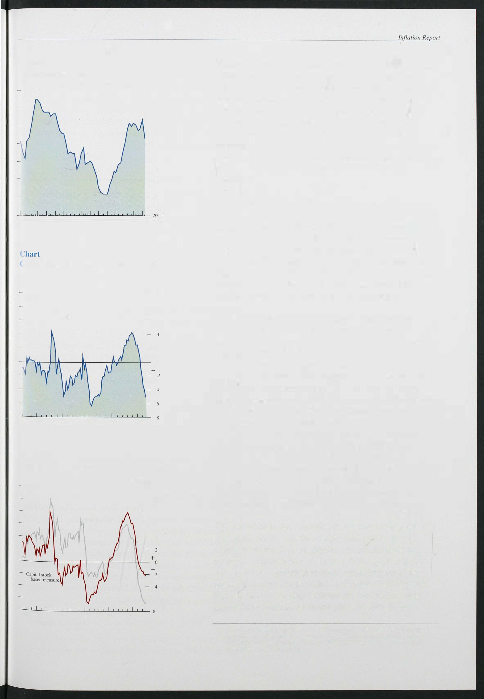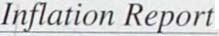

C apacity utilisation

Percentage or firms reported working below capacity

- 90

- 80

- 70

- 60

- 50

- 40

- 30

1979 80 81 82 83 84 85 86 87 88 89 90 91 92 93

3.4

)utput gap: deterministic trend measure

Per cent

- 10

- 8

- 6

- 2

+

0

1967 70 75 80 85 90

Chart 3.5

Output gap: production based approaches

Per cent

- 12

- 10

- 8

DEeD Theasure

- 6

- 4

- 6

19� ro � w e �

The recent increase in output is unlikely to have been sufficiently rapid to narrow the output gap (the gap between actual output and the level of output consistent with a constant rate of inflation). But Chart 3.3 shows that the percentage of firms reported in the latest CBI Survey as working below capacity fell from 73% in January to 63% in April-the lowest figure since the beginning of 1 991. The other CBI utilisation measures also suggest an increase in the rate of capacity

utilisation, although it remains low by historical standards.

Statistical estimates of the size of the output gap vary widely. There are two main approaches to the measurement of 'potential' output. The first identifies a trend in previous output growth and extrapolates it into the future. Such trends can be calculated in numerous ways. But they share a common implicit assumption that the trend in output is independent of other economic forces. Chart 3.4 shows the output gap implied by a simple deterministic trend with structural breaks.( I )

The second method of measuring potential output attempts to take account of changes to productive capacity over the course of the cycle. Such measures are based on explicit 'production functions'-relationships between output and inputs of labour, capital and raw materials-and their assessment of the output gap will depend on assumptions about the growth of both the capital stock and the labour force. Two measures based on such techniques are shown in Chart 3.5 which presents the OEeD estimate of the output gap (based on an explicit production function) and a series which is based on estimates of capacity derived solely from changes in the capital stock. The two can be seen to vary widely in their assessment of the size of the gap not only at present, but also on many occasions in the past (including the previous recession). They also differ

from the simple trend-based measure shown above.

The variation in the estimates of the gap in the past is important, for it will also lead to di fferences in the degree to which a given gap is believed to influence inflation. An estimate of the size of the present gap is not, therefore, sufficient to enable conclusions to be

drawn about the future path of inflation. This depends also on the relationship between the calculated output gap and actual inflation in the past. Although the

1. The major breaks occur in 1975 Q3, 1 984 Q4 and 1990 Q2. The assumed growth rates are as follows: before 1975, 2.2% per annum: between 1 975 and 1984, 0.7% per annum: between 1 984 and 1990. 3.3% per annum; and after 1 990, 2.2% per annum.

167

Bulletin: 1 993

Table 3.A

Expenditure components of GDP at constant prices, Q4 1992

Percentage change

|  |  |  |
| --- | --- | --- |
| Consumers' expenditure | Quarterly change  0.3 | Twelve-month change  1.3 |
| Public consumption | 0.2 | -1.2 |
| Investment | -0.8 | 0.7 |
| SlOckbuilding(a) |  | -0.4 |
| DOlllestic demand | -0.3 | 0.4 |
| Exporls | 0.7 | 1.9 |
| Imporls | -1.1 | 3.6 |
| GDP(b) | 0.2 | 0.1 |

1. Contributions 10 GDP growth.
2. Expenditure estiThate.

Chart 3.6

Indices of consumer confidence

Percentage balanc� 30

estimates of the current gap which are generally quoted are in the range of 3% to 7%, it is not clear that such estimates are useful without the additional piece of

information about the impact of the measured gap on inflation in the past. But most models would be consistent with the view that the output gap remains

sufficiently large that it is continuing to exert downward pressure on inflation.

## Demand

Domestic demand is estimated to have declined by around 1/4% in the final quarter of last year, having

increased in each of the previous five quarters. It nevertheless remained 0.4% above its level a year earlier (see Table 3.A). The fall was more than accounted for by a reduction in corporate expenditure: investment fell by 0.8%, while faster destocking reduced growth by almost Ih%. Consumers' expenditure rose by 0.3%, the third successive quarterly increase. Public consumption also rose, by 0.2%, but the most significant contribution came from the external sector, as imports fell by 1.1 % while exports rose by 0.7%

Consumers' expenditure increased in the fourth quarter despite a sharp fall in real personal disposable income (-0.8%). Real incomes remained 2.5% higher than a year earlier, although they were reduced by a combination of lower employment and reduced overtime working.

Latest indicators suggest that consumer demand grew sharply in the first quarter. Comparing the three months to March with the previous three months, the volume of

·retail sales rose by 1 . 6%, although the apparent weakness of sales in December last year contributed to this increase. Comparing the latest four months with the previous four, the increase was 1 . 1 %. In the first quarter, sales were 3.3% above their level a year earlier. Further evidence of the strength of consumer demand is contained in the sales of new cars (with registrations up almost 1 2% in the year to the first quarter), as well as

t990

92 93

the increase in MO and the growth of consumer credit

(see Section 2). Measures of consumer confidence have

1. Response 10 enquiry concerning the general econoThic situation in the count.ry.

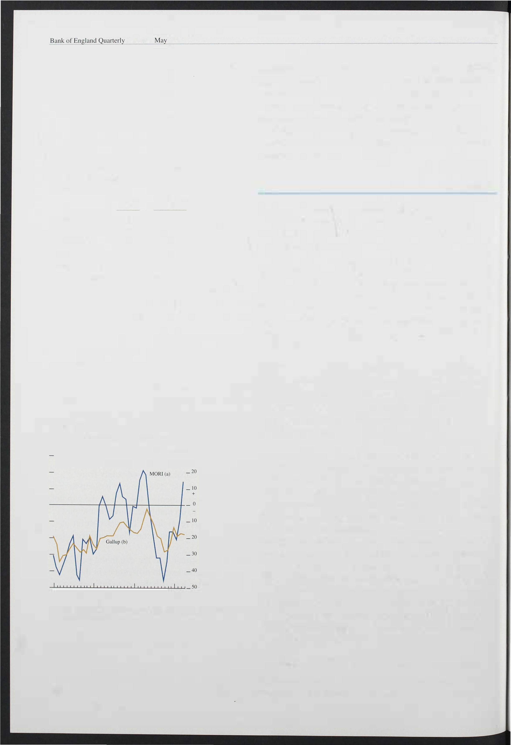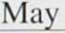

1. Based upon five questions concerned with households' finances and their assessThent of econoThic conditions.

168

also continued the recovery from their October trough, although both the MORI and Gallup measures remain lower than a year ago (see Chart 3. 6).

*Personal sector debt, gearing and the housing market*

High levels of personal debt and debt servicing costs appear to have acted as a constraint on the recovery of

personal sector demand in the past two years, but this effect now seems to have diminished. Falls in interest rates have already had a marked effect on income gearing (the ratio of interest payments to disposable income). Chart 3.7 shows that, for the personal sector as a whole, income gearing has declined from a peak of around 1 4% during 1 990 to an estimated level of only around 1 0.3% at the beginning of this year. This is still higher than at any time before 1 989, but the reduction will have been sufficient to ease constraints on many borrowers-especially younger borrowers whose propensity to consume may be relatively high.

Chart 3.7

P sector gearing

Income gearing (b)

Per cent 16

14

12

10

A further constraint on consumption may have been the level of indebtedness. Capital gearing (outstanding lending as a proportion of net financial and tangible wealth) has continued to rise throughout the recession, as asset values (house prices) have fallen. At the same time it is likely that individuals have reduced their desired levels of borrowing as they reassess their l ikely li fetime income and wealth. But recent evidence suggests that the housing market may be recovering.

The Halifax house price index rose by 1 .4% in March and a further 1 .6% in April, more than offsetting the total fall recorded since last September. This rise in prices accords with the anecdotal evidence of increased interest in the housing market since the new year, with the recovery in lending for house purchase, and with the recorded rise in turnover, as particulars delivered rose

again in March (albeit from a very low base).

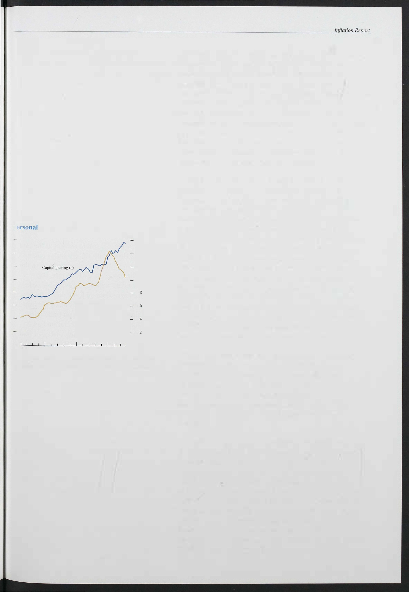- _ 0

1976 78 80 82 84 86 88 90 92

1. Borrowing from banks and building societies as a proportion of personal sector financial and physical assets.
2. Gross personal sector interest payments as a proportion of disposable income.

The recent Budget measure to double the stamp duty threshold on property purchases from £30,000 to

£60,000 is likely to assist the pick-up in activity, especially among first-time buyers. The Council of Mortgage Lenders estimate that only 23% of first-time buyers made property purchases of less than £30,000 in 1 992, but 82% purchased properties for less than

£60,000.

The rise in house prices will have particular significance for those households whose mortgage debts are greater than the value of the home on which they are secured. A note on negative equity was published in the August *Bank of England Quarterly Bulletin.* Bank estimates of the scale of negative equity have risen reflecting further falls in the Halifax house price index (unadj usted). The number of households with negative equity is thought to have risen to 1 . 8 million in the first quarter of this year, from 1 .0 million in the second quarter of last year. The aggregate shortfall has also grown, to reach an estimated level of £1 1 . 7 billion, or £6,500 per household. The

169

extent of negative equity is likely to have fallen a little from these estimates, following the rise in house prices in April. If prices were to remain at their new level for the rest of the second quarter, the number of households with negative equity could fall below I lh million.

The precise estimates of numbers and value of negative equity are particularly sensitive to the house price used in the calculation. The estimates also depend on a number of factors which are not well measured. These include possessions, which serve to reduce the estimates, and further advances and mortgage arrears which serve to increase them. If these factors are ignored, then using the Department of the Environment index, which is available to the fourth quarter of l ast year, the number would be closer to 1 .05 million, and the value to

£5 .9 billion.

*Overseas trade*

With the completion of the EC single market at the end of 1 992, data on trade flows with EC countries can no longer be obtained from Customs decl arations as in the past. Data will now be based on VAT returns, but aggregate visible trade data will not be available before June 1 993. The absence of data on trade with European Community countries complicates analysis of the impact of sterling's depreciation. But the data on trade with non-EC countries suggest that the depreciation has resulted in a sharp increase in the sterling prices of both imports and exports. Between August 1 992 and March

1 993 non-oil import prices rose by 1 5 % while non-oil export prices rose by j ust under 1 0% implying a slight fall in the terms of trade. The volumes of both exports

.and imports have continued to grow sharply. Between August 1 992 and March 1 993, exports (excluding oil

and erratics) rose by almost 1 2% while imports on the same basis rose by almost 1 1 %.

It seems probable that the growth in export volumes to the EC has slowed in recent months, reflecting the general weakness of demand in Europe, and in Germany in particular. Weakness in their home countries may also have encouraged European producers to make greater efforts to penetrate the UK market, especially given the

growing evidence of recovery in UK demand. In addition, sterling's depreciation has been smaller against the EC than against the rest of the world. These factors

suggest that the improvement in the trade position

*vis-a.-vis* the EC may be relatively less than that for other countries. B ut the 'J-curve' effect, whereby prices react faster to exchange rate changes than do volumes, may

Chatft 3.8

Sutfvey data on business optimism

CBI Industrial Trends Survey

Percentage balance of firThs

- 40

- 30

- 20

_ 1 0

+

- 10

- 20

- 30

- 40

- 50

CBI Indus trial Trends Survey

Perccnlage balance of firThs

- 20

- 10

+ o

- 10

- 20

- 30

QI Q2 Q3 Q4 QI Q2 Q3 Q4 QI

Q2 Q3 Q4 QI Q2 60

QI Q2

Q4 QI Q2

Q4 Q I Q2 Q3 Q4 Q I Q2 40

1990 91

JptiThislll regarding the general business situation.

92 93

1990 91 92 93

Expected trcnd in volume of output in next four months.

CB I/Coopers and Lybrand

Percentage balance of firms

60

50

40

30

20

10

+

0

10

20

30

Dun and B radstreet

Percentage balance of firThs

- 50

- 30

-+10

- 10

QI Q2 Q3

1990

Q4 QI Q2 Q3

91

Q4 Q I Q2 Q3

50

60

Q4 QI 70

93

QI Q2 Q3 Q4 QI Q2 Q3 Q4 QI Q2 Q3 Q4 QI

1990 91 92 93

OptiThism regarding the overall business situation with respect to the previous three months.

British Chambers of Commerce

Percentage balance or firms

- 40

Firms expecting net sales to iThprove during the next three months.

Bu ilding employers' confederation

Percentage balance of firThs

-10

-20

-30

-40

QI Q4

QI Q2 Q3

Q4 QI Q2 Q3

- 10

+

0

Qi l O

QI Q2 Q3 Q4 Q I

Q2 Q3

QI Q2 Q3

Q4 QI

-50

-60

-70

-80

1990

92 93

1990 91

92 93

Firms expecting profitabi lity 10 improve in the next twelve Thonths.

Firms expecting more work.

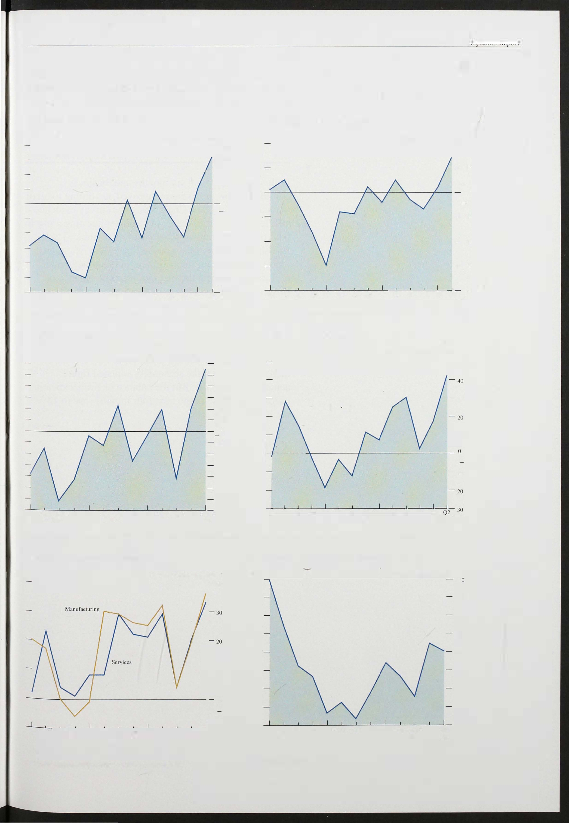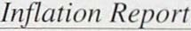

171

Bank of England Quarterly Bulletin:



imply that initially there will be a greater relative worsening in the trade position with non-EC countries than with EC countries following the depreciation of sterling.

## evidence

Following a sharp fall six months ago, business confidence appears to have improved, according to all of the main surveys (see Chart 3 .8). The survey evidence also lends support to the CSO data in suggesting a rise in both orders and output in the past few months. The British Chambers of Commerce Survey for example reports a significant improvement in manufacturers' performance during the first quarter. The balance of firms reporting an increase in domestic orders rose from

-1 0% to +7 %, a similar increase to the balance on reported deliveries. The balances in the service sector rose by a little less, but orders now stand at their highest level since the first quarter of 1 990. Although the rise in the CBI optimism balance in the April survey was the largest since 1 983, the seasonally adjusted figure

actually fell slightly. But the balance of firms expecting output to increase in the next four months rose to 1 4%, the highest since 1 989.

# Price dynamics

Chart 4. 1

lanufacturing and whole economy underlying

�verage earnings

Percenwge changes on a year earlier

- 12

Whole econoThy

- 10

- 8

- 6

- 4

- 2

Section 3 noted the practical difficulties in assessing the growth rate of potential output, and thus the size of the output gap. It is therefore sensible to examine indirect evidence on these factors from other sources.

Particularly significant are developments in the labour market, the behaviour of firms' profit margins and their impact on short-run price-setting behaviour. Such factors matter less in the long run when the inflation rate will be set by the rate of monetary growth. But it is

i mportant to understand the path along which inflation will adjust to its long-run level, both to ensure that inflation is kept within the target range, and as a benchmark against which to measure the ' news' on

i nflation from period to period.

## 1 The labour market

-

1990

93 Employment costs· account for two thirds of total value added. Hence unit labour costs are likely to be a

powerful influence on price-setting behaviour in the economy as a whole, both directly and through their

i mpact on the prices of intermediate inputs purchased by firms. Unit labour costs principally reflect changes in

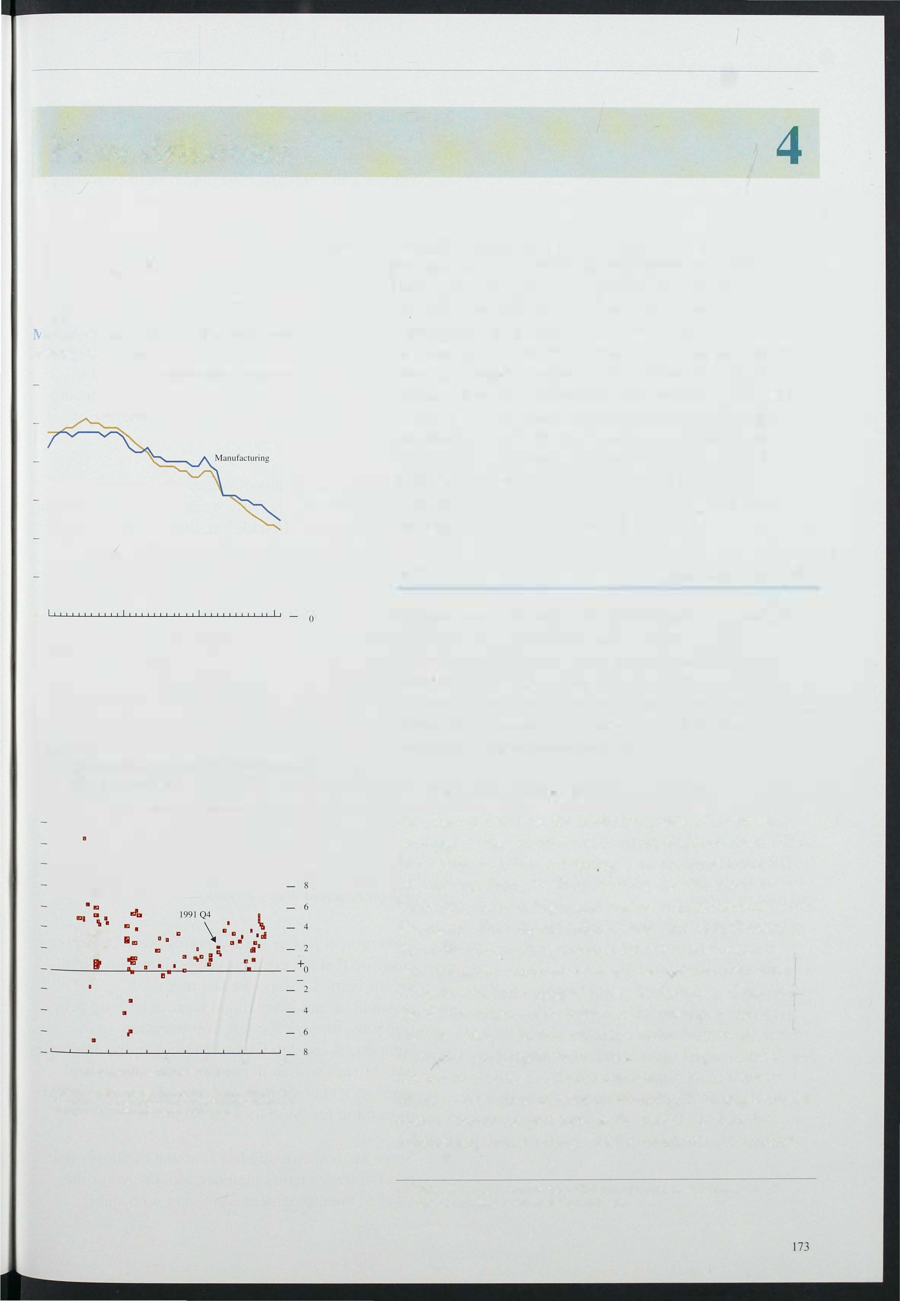Chart 4.2

Lnemployment and growth in real earnings (1965 QI-199 1 Q4)(a)

Four quarter percentage changes in real earnings

_ 14

- 12

- 10

....

.a a m" I!:!"

If' .. .

II'

. , .. " .

o 2 4 6 8 10 12

UneThployment (percentage of workforce)

(a) Real earn ings is the average earnings index denated by the RP!. The change in real earnings al time I is the di fference between real earnings at time I and real earnings at lime

I + I.

earnings and labour productivity.

*Earnings and settlements*

As Chart 4. 1 shows, the underlying rate of increase of earnings in the economy as a whole declined from 5% in November to 4112% in Febr\lary. In manufacturing the decline was from 53/4% to 5% over the same period .

Unemployment is high, and was increasing steadily until February. This should inhibit wage inflation directly in the more competitive external labour markets and by worsening the alternatives available outside their own firms to workers engaged in pay bargaining. Chart 4.2 shows the relationship between the unemployment rate

and the changes in real earnings in the following year.( I)

If employees bargain with a *real* wage target in mind and predict retail price inflation reasonably well, there is likely to be a clear inverse relationship if unemployment exerts downward pressure on the target. In fact the

rel ationship is not strong. At the moment real earnings

( I) Hence this is not a conventional Phillips curve that relates increases in nominal earnings to the unemployment rate.

are sti ll increasing quite rapidly; earnings deflated by the Tax and Prices Index rose by 3.6% in the year to February 1 993, despite the fact that the unemployment rate was 9.4% in February 1 992, and rose to 1 0.6% a year later.

Chart 4.3

Unemployment and real settlements using data from Barclays' BASIX su rvey

(1986 Q4-1992 Q4)(a)

Real selllcll1e�s 2.0

- 1 .8

- 1.6

* l A

- 1.2

- 1.0

- 0.8

- 0.6

* OA

- 0.2

-+0.0

- 0.2

OA

- 0.6

- 0.8

- 1.0

9 1 1

Unemployment (percentage of workrorce) Note: Dates refer to the first quaner in each year.

(a) Real selllement figure is IRS 3-momh median selllemenl denaled by the 12-monlh rise in RPI innation forecast by trades union general secretaries.

Table 4.A

estimates for the United Kingdom (claimant definition)(a)

Period wilhin which Ihe eSlimales fall

|  |  |  |  |  |
| --- | --- | --- | --- | --- |
| 1969-73 | | 1974-80 | 1981-87 | 1988-90 |
| AIRU range | 1.6%-5.6% | 4.5%-7.3% | 5.2%-9.9% | 3.5%-8.1% |
| AClual U rale | 2.5% | 3.8% | 10.1% | 6.8% |
| Number of estimates | 1 1 | 13 | 15 |  |

(a) R Cromb. 'A survey of recent econometric work on the NAIRU', JOllnwlofEconomic Studies ( 9 .

1 93 forthcoming),

There is more sign of an inverse relationship if unemployment rates are compared with the real earnings increases expected by trades union leaders when pay settlements are concluded. Chart 4.3 shows this using polling data on expectations and IRS data on settlements. This illustrates the problem which arises if wage bargainers do not regard the inflation target as credible; nominal wages will be set too high, reducing employment and temporarily increasing inflation by increasing unit labour costs.

Many econometric models of wages also suggest unemployment has a relatively weak restraining effect in the United Kingdom. In addition, they imply that it is the deviation of the unemployment rate from some

equilibrium rate rather than the rate itself which leads to rises or falls in wage inflation. Unfortunately, estimates of the unemployment rate consistent with stable inflation (the 'NAIRU') differ widely. A recent paper identified a large number of studies which had attempted to evaluate the NAlRU in the United Kingdom over the past twenty-five years. Table 4.A shows that the range of estimates varies considerably both within and across decades. There is, therefore, a considerable degree of uncertainty about what will happen to nominal wage growth when the end of rapid reductions in retail price

* inflation starts to affect wage bargaining.

There are some grounds for thinking that high unemployment levels will continue to exert downward pressure on nominal wage growth:

* + Government labour market policy has focused on ensuring that the unemployed remain active in the labour market. Since the last recession, expenditure has been aimed more at helping people

find jobs, through Restart, Job Interview Guarantees and Job Clubs. Moreover, the emphasis has shifted away from employment subsidy and

employment placement and towards the provision of training for those looking for work.

* + Some econometric models find that the lower the level of trades union membership, the lower the level of unemployment consistent with stable

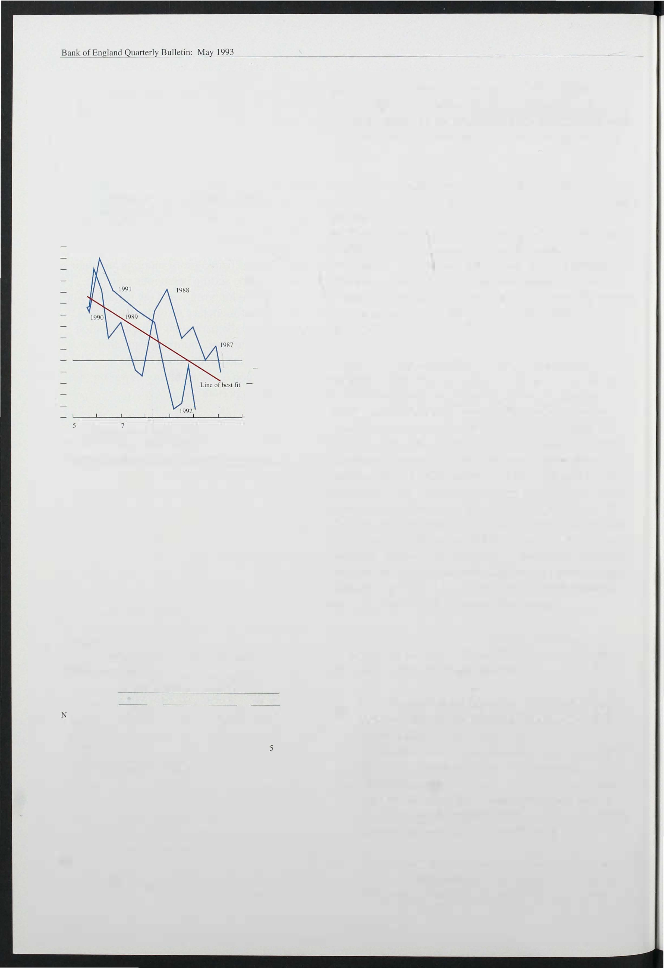

1 74

inflation. Trades union membership (based on data from the Certification Officer) fell considerably over the 1 980s, from 57% of employees in 1 979 to

44% in 1 990.

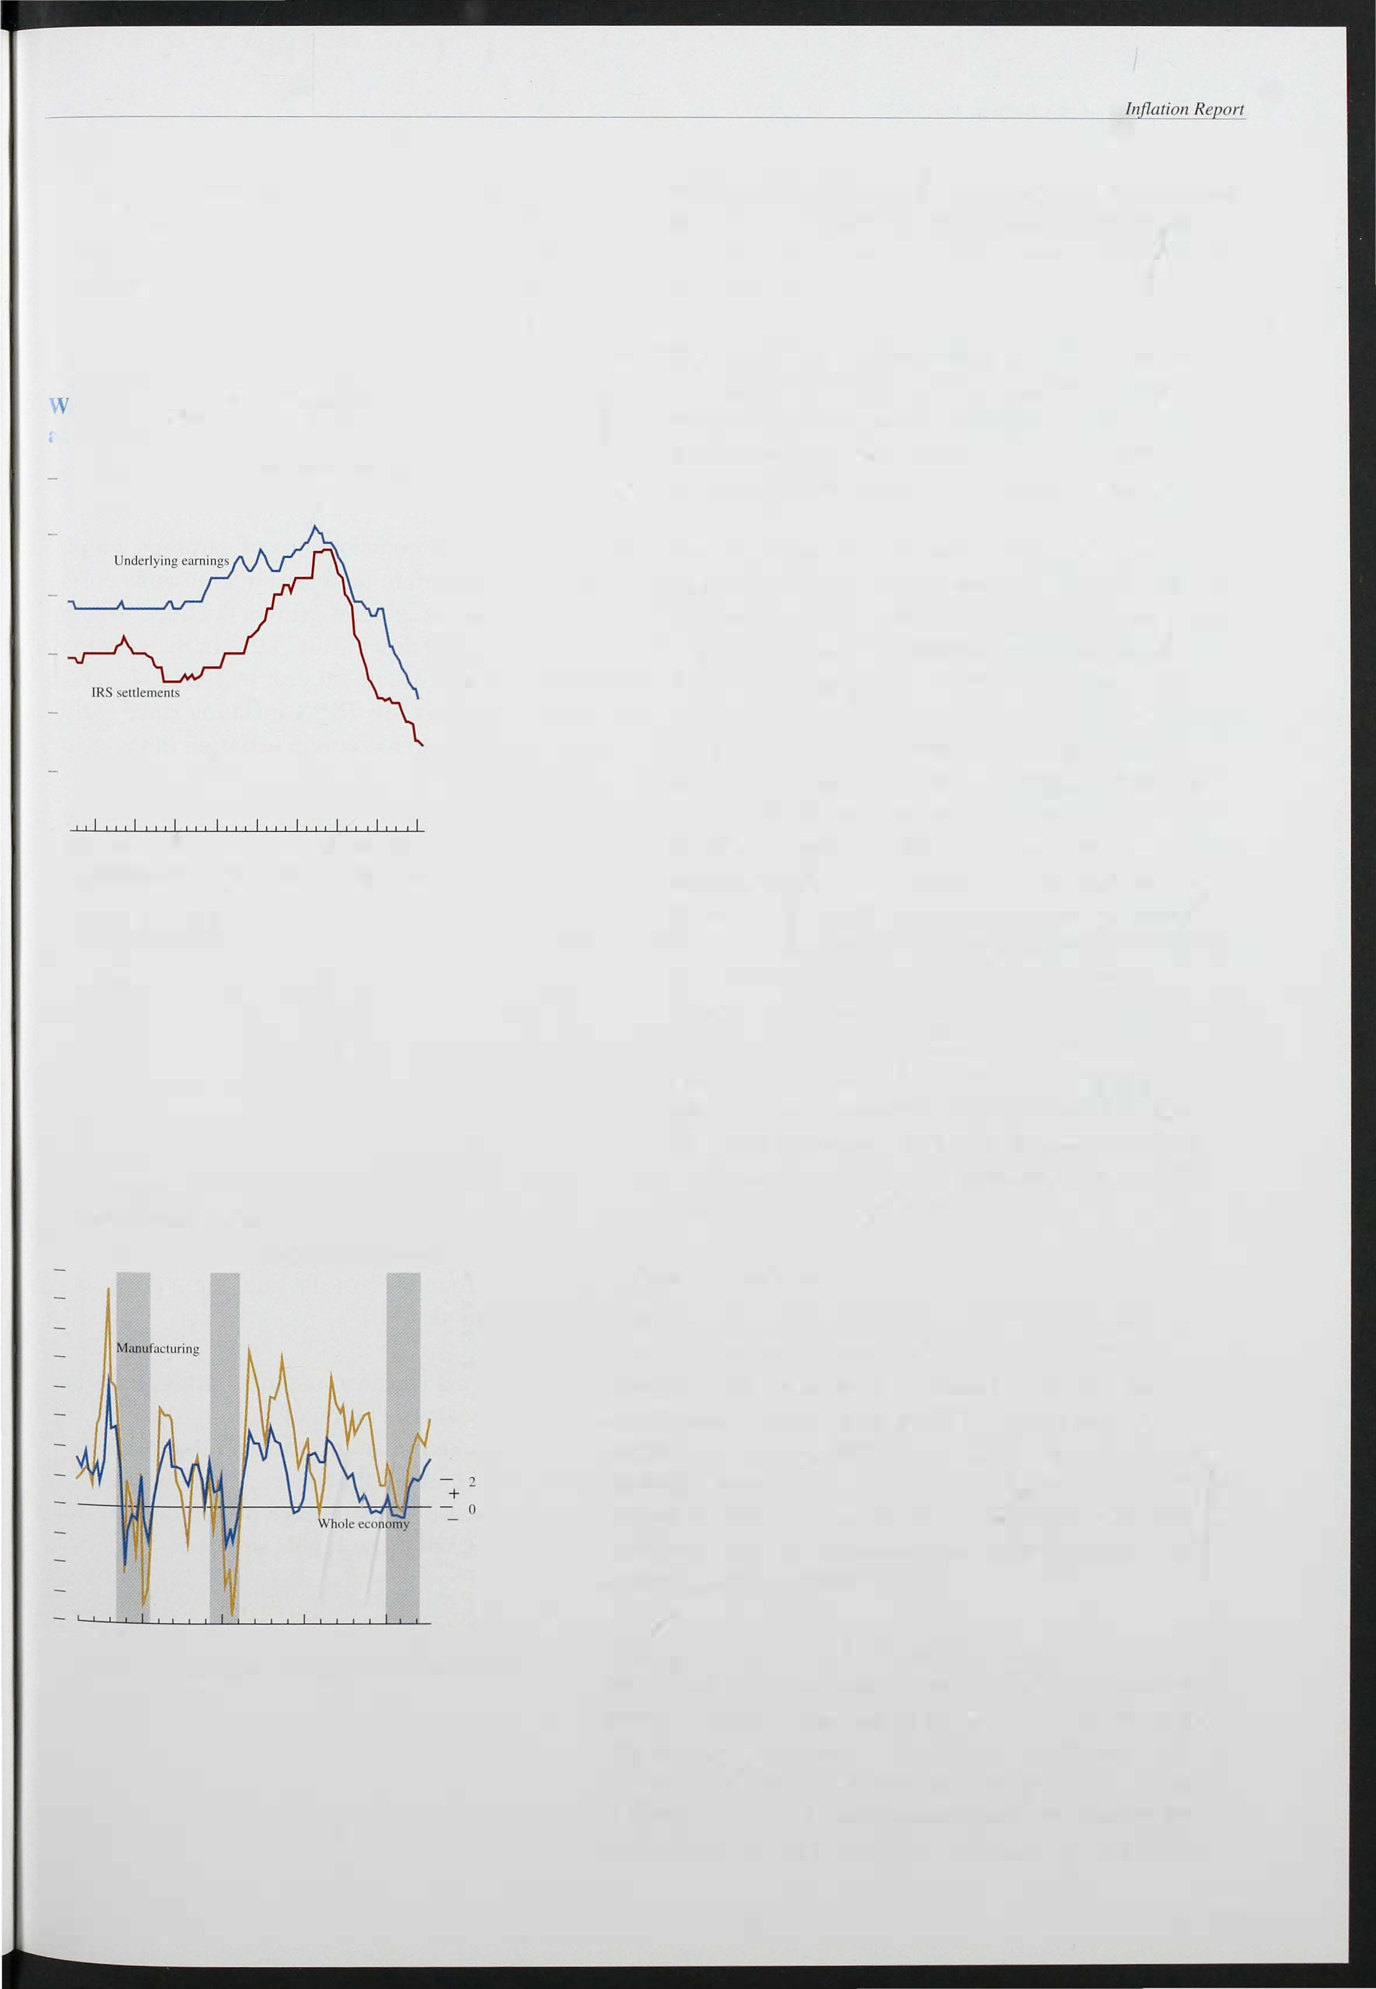

Chart 4.4

hole economy wage settlements md earnings(a)

Percentage changes on a year earlier

- 12

- 10

- 8

- 6

- 4

- 2

- _ 0

1984 85 86 87 88 89 90 91 92 93

fa) Datil ranges are deterThined by availability or seltlcmcnts data.

Chart 4.5

Labour productivity

Percentage changes on a year earlier

- 16

- 1 4

- 1 2

- 1 0

- 8

- 6

- 4

- 2

- 4

- 6

-

8

1971 73 75 77 79 81 83 85 87 89 9 1

* The composition of the unemployed is different from that in the early 1 980s; more come from skilled and professional occupations; they may be looking for jobs more actively because their

financial loss due to unemployment is greater.

* The fall in pay settlements over the last three months has been more pronounced than the fall in earnings growth. Settlements are often treated as a leading indicator of earnings growth, although, in practice, turning points in settlement rates have tended to coincide with turning points in the growth of earnings. The Industrial Relations Services measure of whole economy settlements fell from 3.6% in the three months to December to 2. 9% in the three months to March (see Chart 4.4). In manufacturing, according to the CBI, settlements fell to 2.5% in 1 993 Q l (excluding companies freezing pay for up to six months), which compares with 2.9% in 1 992 Q4. Service sector wage

increases continue to exceed those in manufacturing

* + industry. The CBI Pay Databank Survey shows private service sector pay awards averaging 2.8% in 1 993 Ql. In November 1 992, the Government announced funding arrangements for public pay predicated on public sector pay increases in 1 993 fal ling between 0% and 1 .5%.

*Labour productivity*

The annual rate of growth 9f productivity in the whole economy has continued to rise, reaching 3.2% in

1 992 Q4 (see Chart 4.5). In manufacturing industry productivity was on average 5.9% higher in 1 992 Q4 than in the same period a year earlier. Monthly figures show no sign of a slowdown: the twelve-month rise to February 1 993 in productivity in manufacturi ng was 7.8% the same as in January, but higher than December (6.2%) and November (5.5%).

During the early stages of this recession firms did not hoard labour to the same extent as during the previous two downturns. The rate of labour shedding increased in the second half of 1 992. As Chart 4.5 indicates, it is not unprecedented for such productivity growth to occur in the recovery phase. But there is probably less labour hoarding to unwind this time, so employment growth

1 75

Table 4. B

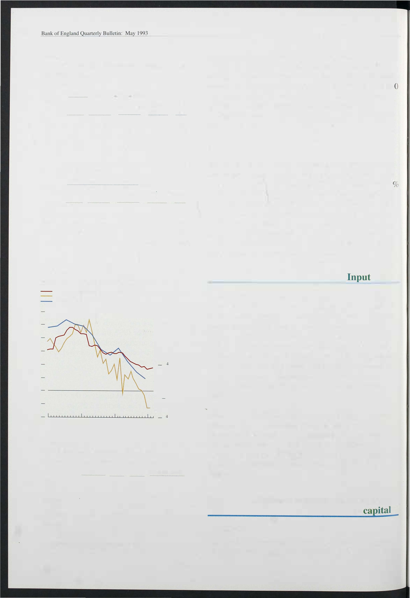

Contributions of earnings and productivity to unit wage costs

1. Whole economy

Twelve-month percentage changes in :

9.9

7.4

|  |  |  |  |  |  |
| --- | --- | --- | --- | --- | --- |
| Period | Olllput | Employment | Labour prOductivity | Earnings per employee | Unit wage costs |
| 1 990 |  |  | -0.1 |  | 10.1 |
| 1 991 | -2.5 | -2.8 | 0.4 | 7.8 |  |
| 1992 | -0.4 | -2.8 | 2.4 | 6.4 | 3.9 |
| 1992 QI | -1 .1 | -2.9 | 1.8 | 8.3 |  |
| Q2 |  | -2.4 | 2.0 | 6.5 | 4.4 |
| Q3 | -0.4 | -2.9 | 2.7 | 5.6 | 3.0 |
| Q4 | 0. 1 |  | 3.2 | 5.2 | 1.9 |

1. Manuracturing industry

Twelve-month percentage changes in:

|  |  |  |  |  |  |
| --- | --- | --- | --- | --- | --- |
| Period | Output | Employment | Labour productivity | Average earnmgs | Unit wage costs |
| 1990 | -0.5 | -1.9 | 1.5 |  | 7.8 |
| 199 1 | -5.2 | -6.6 |  | 8.2 |  |
| 1992 | -0.8 |  | 5.0 | 6.6 | 1.6 |
|  | - 1 .9 | -6.6 | 4.9 | 8.6 | 3.6 |
|  | -0.7 | -5. 1 |  | 6.0 | 1.2 |
|  |  | -4.7 | 4.1 | 6.2 | 1.9 |
| Q4 | 0.4 | -5.2 | 5.9 | 5.7 | -0.2 |

1992

Q2

Chart 4.6

Retail prices and unit wage costs

RP] excluding mongage interest payments Whole economy

Percentage changes on a year earlier

_ 12

_ 10

_ 8

_ 6

_ 2

+

_ 0

_ 2

1990 91 92 93

Table 4.C

Manufacturers' input price inflation (.)

Percentage changes on a year earlier

Materials(b) Fuel(b) Total(b) All manufacturing

|  |  |  |  |
| --- | --- | --- | --- |
| 1990 | -1.7 |  | -0.9 |
| 199 1 |  | 1.5 | -2.2 |
| 1992 | -1 .6 | 2.6 | -0.7 |
| 1 992 Q I | - 1 .8 | 0.2 | -1.3 |
| Q2 | -3.3 | 2.2 | -2.2 |
|  | -4.4 | 3.2 | -2.9 |
|  |  |  | 3.8 |
| 1993 Jan. | 6.2 | 2.8 | 5.5 |
| Feb. | 7.9 | 2.6 |  |
| Mar. | 6.8 | 7.6 |  |

-0.2

-1.2

0.5

-0.1

-1.2

-0.8

6.4

7. 1

8.4

(a) Materials and fuels purchased by the manufacturing �cclor.

(b)

Excluding food. drink and tobacco manufacturing industries.

176

may pick up sooner, particularly if the costs of employment adjustment are now less. The falls in unemployment in February and March, the much smaller fall in the workforce in employment in 1 992 Q4 (9 1 ,00 compared with 398 ,000 in 1 992 Q3) and, in February

1 993, the smallest monthly fall in manufacturi ng employment since the first half of last year, all support this conclusion.

*Unit wage costs*

Table 4.B tabulates the contributions of earnings, output and employment growth to increases in unit wage costs. Whole economy unit wage cost growth declined to 1 . 9 in the year to 1 992 Q4, down from 3.0% in the year to the third quarter and 5.3% in the year to 1 991 Q4. The growth rate has fallen below RPIX inflation since early 1 992, which should help to contain inflation in the near future. In manufacturi ng, unit wage costs declined by 0.7% over the twelve months to December 1 992 and by 2.6% in the twelve months to February 1 993.

## costs

It is important to examine other input costs faced by businesses. The CSO compiles an input price series for manufacturing industries which includes the cost of raw materials and fuels, but not, unfortunately, bought-in services. Table 4.C shows recent trends in input price inflation for manufacturers, and illustrates that the costs of these inputs fell in 1 990 and 1 991, and through much of 1 992. Price declines were particularly common for material purchases, although increases in fuel costs (which comprise around 6% of the total input price index) have been modest.

Almost half of the net inputs to manufacturi ng industry are imported, so the depreciation of sterling since September has resulted in an increase in input prices. Not all inputs are imported, however, and domestic demand conditions are likely to have placed downward pressure on the price of those inputs sourced

domestically.

## Business margins and the return

to

*Profitability*

The profitability of the existing capital stock is a guide to the pressures on producers to alter prices and costs as

well as invest in new capacity.(I) Pre-tax profit rates­ profits divided by the net capital stock valued at cunent replacement cost-have fal len in this recession, but they remain relatively buoyant in comparison with previous downturns. More recently, it appears that the decline in pre-tax profit rates has slowed, with the all-ICCs measure averaging 7.4% in 1 992, compared with 7.9%

|  |  |  |
| --- | --- | --- |
| Chart 4.7 Profitability(a) |  | |
|  | - | 14 |
|  | - | 12 |
|  | - | 10 |

in 1 991 (Chart 4.7).

*Business mark-ups*

o

(a) AclUal profits as a percentage of net capital stock at current replacement cosl. with adjustments for the impact of inflation on stock appreciation and for capital consumption.

Chart 4.8

Profit to cost ratios

1985=1 � 1 30

- 120

Non North Sea

- 1 1 0

- 100

90

80

70

Measures of total profits divided by total costs can be calculated for both the whole economy and the non North Sea economy (Chart 4.8). After increasing in the second and third quarters of 1 992, the ratio for the non North Sea sector fell by 4.4 percentage points in the fourth quarter, because of rising costs and fall ing profits. This ratio is now higher than in both the mid- 1 970s and the early 1 980s, so the pressure to restore margins as the economy recovers is unli kely to give rise to substantial inflationary pressure, although a short-run effect is to be expected.

Another way to assess profitability is to compare movements in producer output prices (excluding food, drink and tobacco.industries) with weighted movements in manufacturers' costs (Table 4.0) . This also indicates that, given the length of the recession, profit margins have held up relatively well in recent years. In the

Table 4.D

M n w � � �

60

g W �

initial stages of the downturn, fall ing input prices ensured that the increase in unit labour costs did not cause producers to pare their margins in the face of

Contributions(a) to manufacturers' output price inflation(b)

Percentage poims

increased competition.

199 1 1992

QI

Q2 Q3

1293

Jan. Feb.

The evidence on profitability, mark-ups, and comparisons of input and output prices suggests that

Labour productivity 0.7

Labour costs 3.6

Unit labour costs

-

(3=2 1) 2.9

4 Input prices -0.7 5

1. Margins(d)

(6=7-(3+4+5) 0.5

1. Output prices(e) 4.9

2.2

3.8

1.6

-OA

1.8

-0.2

2.8

2.1 1.8

2.6 2.7

0.5 0.9

-0.7 - 1.0

1.1 0.9

2.0 1.9

2.7

2.6

2.5

-0. 1

1.2

1 .2

0. 1

2A

2.3 2.3

- 1 .2 -1 .2

�

1.8 2.2

1 .0 1.0

1.0 0.6

2.7 2.6

profitability has been maintained during the recent recession. The effect of the sterling depreciation on

profit margins depends on how input and output prices will be affected by the lower exchange rate. In turn, this

depends on the extent to which the goods making up

(a Cal.culated for each component as the twelve-month growth fate scaled by W�lghts derived from 1984 input-output tables as follows:

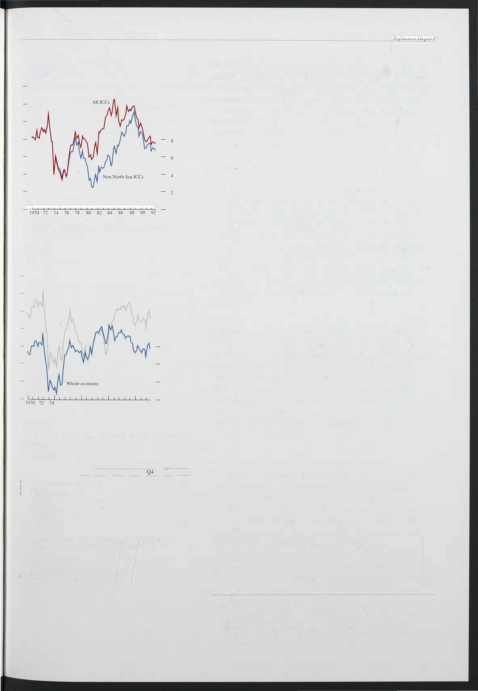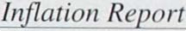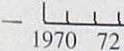

input prices 0:33

(c) Proxied by unit labour costs in the service sector.

«d) Figures may not add to tow.ls because of rounding.

e)

Percentage change on a year earlier.

these indices are homogeneous and traded in internationally competitive markets. Although there appears to be a relatively close correlation between movements in the exchange rate and input prices, output

(I) Un fortunately, precise data on the capital stock are difficult to obtain. The measures here use data provided by the CSO on the net capital stock of lCCs valued at replacement cost. The measures may not capture fully the extent of capital consumption and scrapping, and so may overstate the value of the capital stock. As only annual estimates are provided. quarterly observations have been interpolated by the Bank. Moreover. data for 1992 are Bank projections. These limitations mean that large revisions are possible.

177

Chart 4.9

Producer prices(a) and the exchange rate

-- Effective exchange rale (b)

i

-- Producer input pr ces

Producer output prices

Percentage changes on a YC<lr earli� 25

- 20

- IS

- 10

- + 5

- 0

- 5

- 10

- 15

1. PPI series excludes food. drink and tobacco industries.

a

1. An increase in this Theasure reflects depreciation.

Chart 4. 10

The exchange rate and import prices

Percentage changes on a year earlier

|  |  |
| --- | --- |
|  | 18 |
| - | 16 |
| - | 14 |
| - | 12 |
| - | 10 |
| - | 8 |
| - | 6 |

- 4

-

+-

- 2

- 4

- 6

- 8

- 10

prices show a much more stable trend (see Chart 4.9). Data for 1992 Q4 and for early 1 993 suggest that the response of input prices to the depreciation has been significantly greater than that of output prices. One explanation for this output price 'stickiness' could be the heterogeneous nature of many manufactured products,

which may allow producers the scope to delay passing

on the impact of exchange rate changes until they have established whether the changes are permanent or temporary.

### 4.4

Import prices fell in the two years before sterling's departure from the ERM. This resulted from lo�er growth in competitor countries, weak demand in the

United Kingdom and the delayed i mpact of earlier sterling appreciation against the dollar. Since last

autumn, however, import prices for al l main commodity categories have risen substantially (see Chart 4. 10 and Table 4.E). Between August and December, the last month for which data on imports from all destinations are available, i mport prices of finished manufactures rose by almost 1 0% (within which car prices rose by

1 4%) compared with around 7% for basic materials. More recent data show that in the seven months to this March i mport prices of goods from outs ide the EC rose

by between 1 4. 1 % and 2 1 .6% for all major categories of

Import prices: goods (a)

1981 83 8S 87 89

+ means price rise or sterling depreciation.

(a) Unit value index .

Table 4.E

- 12

- 14

16

91 93

imports.

Reflecting the earlier weakness of i mport prices of materials, which account for almost two thirds of the index, input prices for materials and fuels purchased by manufacturers fell during 1 990 and 1 991. During the

first nine months of 1 992, input prices (seasonally

UK import prices (goods only)

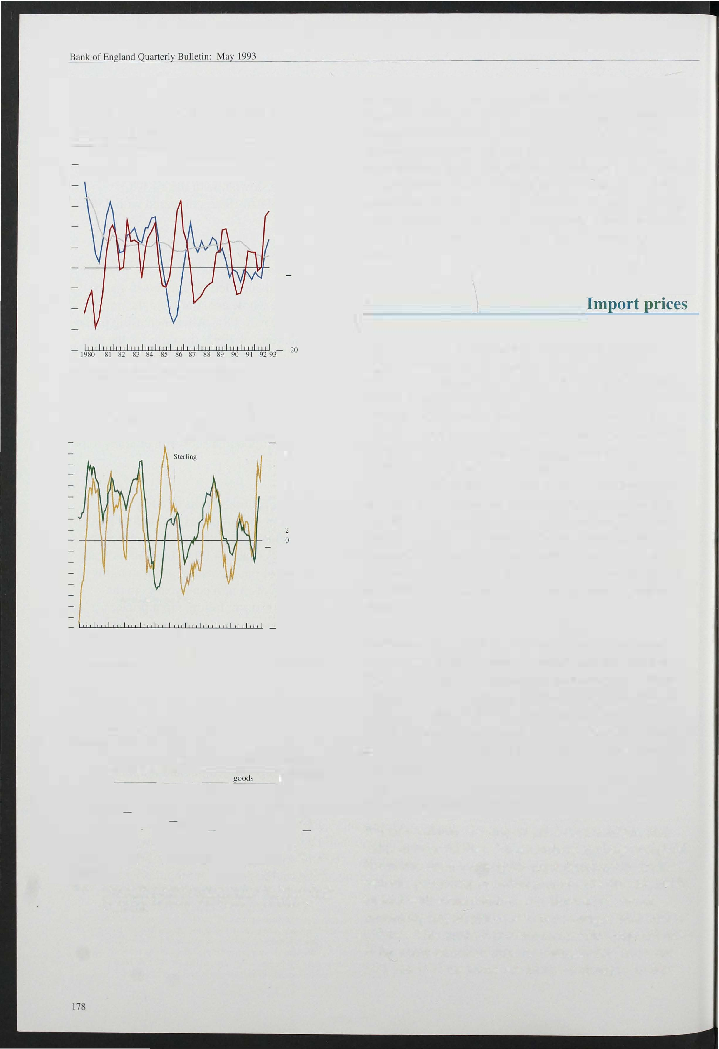

Percentage change on previolls period

Food. drink Basic Fuels Semi- Finished

and tobacco materials manufactured manufactured

-0.9

Q3

|  |  |  |  |  |  |  |  |  |
| --- | --- | --- | --- | --- | --- | --- | --- | --- |
| 1 991 |  | - 1 0.9 | | -5.0 | | -2.6 |  | 4.3 |
| 1992 QI |  | - 1 . 1 | | -10.5 | | - 1 . 8 |  | -0.8 |
| Q2 | 0.9 |  | | 2.0 | |  |  | - 1 . 6 |
|  | -2.7 | -3.4 | |  | | -0.9 |  |  |
| Q4 | 4.5 |  | | 1 1 .5 | |  |  |  |
| Aug.-Dec. | 6.4 |  | 7.1 8.2 | | 18 .0 17.6 | 9.3 | | 9.8 9.9 |
| Aug.-Mar. |  | 1 7.9 | 14. 1 | | 2/.6 | 1-1.8 | | 15. 7 |

Note: Figures in italics are prices of iThports froTh outside lhe EC. Data on trade with Ihe EC teThporarily ceascd to be published in January. Total rigures are on the OI'er.wlIs Trade SWlI.Xtics basis. Non-EC figures are on the Balance Of Paymellts basis.

*9.4*

adjusted) were broadly flat. In the eight months to April 1 993, however, prices rose by 1 0. 1 % (7.2% seasonally adjusted).

*Measurement of import prices*

Where available, the import price data used are unit value indices (UVIs). These indices are base weighted. However, since the weights are determi ned by trade patterns prevail ing in earlier periods, the data should be treated with some caution. An alternative way of

measuring import prices is to use average value indices

( AVIs). This method produces a current weighted index. If the composition of imports changes over time, the

AVI and UVI measures are likely to diverge. In fact, as

Table 4.F

UK i mport prices: total

tfercentage changes on the previous quarter

|  |  |  |  |
| --- | --- | --- | --- |
|  | Total goods | Services | Total |
| 1990 QI | 1.0 | 2.3 | 0.9 |
| Q2 |  |  | 0.7 |
| Q3 | -3 8 | 1.1 | -2.3 |
| Q4 | 1.0 |  |  |
| 1992 QI | - 1 .9 |  | - 1.6 |
| Q2 | 1.0 | 6.3 | 2.0 |
|  | - 1 .0 | 5.0 | 1.2 |
|  |  |  | - 1.7 |
| 1992 QI | -1 .0 |  | - 1.4 |
| Q2 | 1.0 | J.2 | 1 . 2 |
|  | -3.0 | 8.0 |  |
| Q4 | 8.2 | 0.4 |  |

Note: These data are average value indices CA Vis) on the

-5.4

Q3

0.3

Ba/ol/ce of Payments

basis. Unit value indices of services and thus or lowl goods and services arc unavailable.

C art 4. 11

h Iport prices-all goods

Percentage changes on a year earlier

- 16

- 14

shown in Chart 4. 1 1 , the growth in the two measures has in the past been quite similar. ( I) During 1 992 Q4, import prices of total goods rose by 8.2% on the AVI measure compared with 9. 1 % using the UVI.

*Commodity prices*

About 42% of imports are used as inputs rather than for satisfying final demand. Most imports of raw materials fall into the former category. This is one avenue

through which inflation elsewhere in the world can be imported to the United Kingdom, unless the exchange rate moves to offset it.

The Economist All-Items index of non-oil commodity prices measured in SDRs rose by 7.2% in the first

quarter of the year, compared with the previous quarter. The largest price increases in the first quarter of the year were in agricultural products excluding foodstuffs, and most notably in timber which rose by more than 30%.

Timber prices were particularly affected by restrictions

Unit value index

1981 82 83 84 85 86 87 88 89 90 91 92

Table 4.G

Commodities prices breakdown

Percentage changes on previolls quarter

1 992

Q3

- 12

- 1 0

- 8

- 6

- 4

-+ 0

- 2

- 4

- 6

- 8

_ [ 0

Q4

1 993

QI

on supply related to environmental concerns, but the rise in commodity prices has been quite widespread. Cotton prices rose significa�tly. Food prices, notably sugar, rose further after the increase in the fourth quarter. But during the second quarter, commodity prices have fallen back spmewhat.

Commodity prices have risen despite the low level of activity in the major economies, even after allowing for special supply factors. Output in the major six

economies is growing at an annual rate of about 1 112%,

and its level is significantly below trend. The recovery in North America, and more recently in the United

Kingdom, may exert an impact on certain commodity prices but it is unlikely that this alone accounts for their buoyancy in the first quarter.

The Economist All-Items index uses weights based on

Index (£)

3.0 1.7 -7.3 1 6.7

20.7

the values of commodity imports to all OECD countries

Index (£) 2.0 0.3

Economist all-items

14 .4

12 .2

in 1 984-86,(2) UK i mports, however, contain a higher proportion of non-food agricultural products than these

iIldex (SDR)

o/which:

Metals

0.8 3. 1 -5.0 - 1 . 5

4. 1 4.2

3.4

2.9 4.4 -0.3 -9.8

7.2

24.3

1.4

weights suggest. This means that commodity price developments may have a larger impact on the United

Foods - 1 .7 0.3 -7. 1 3.8

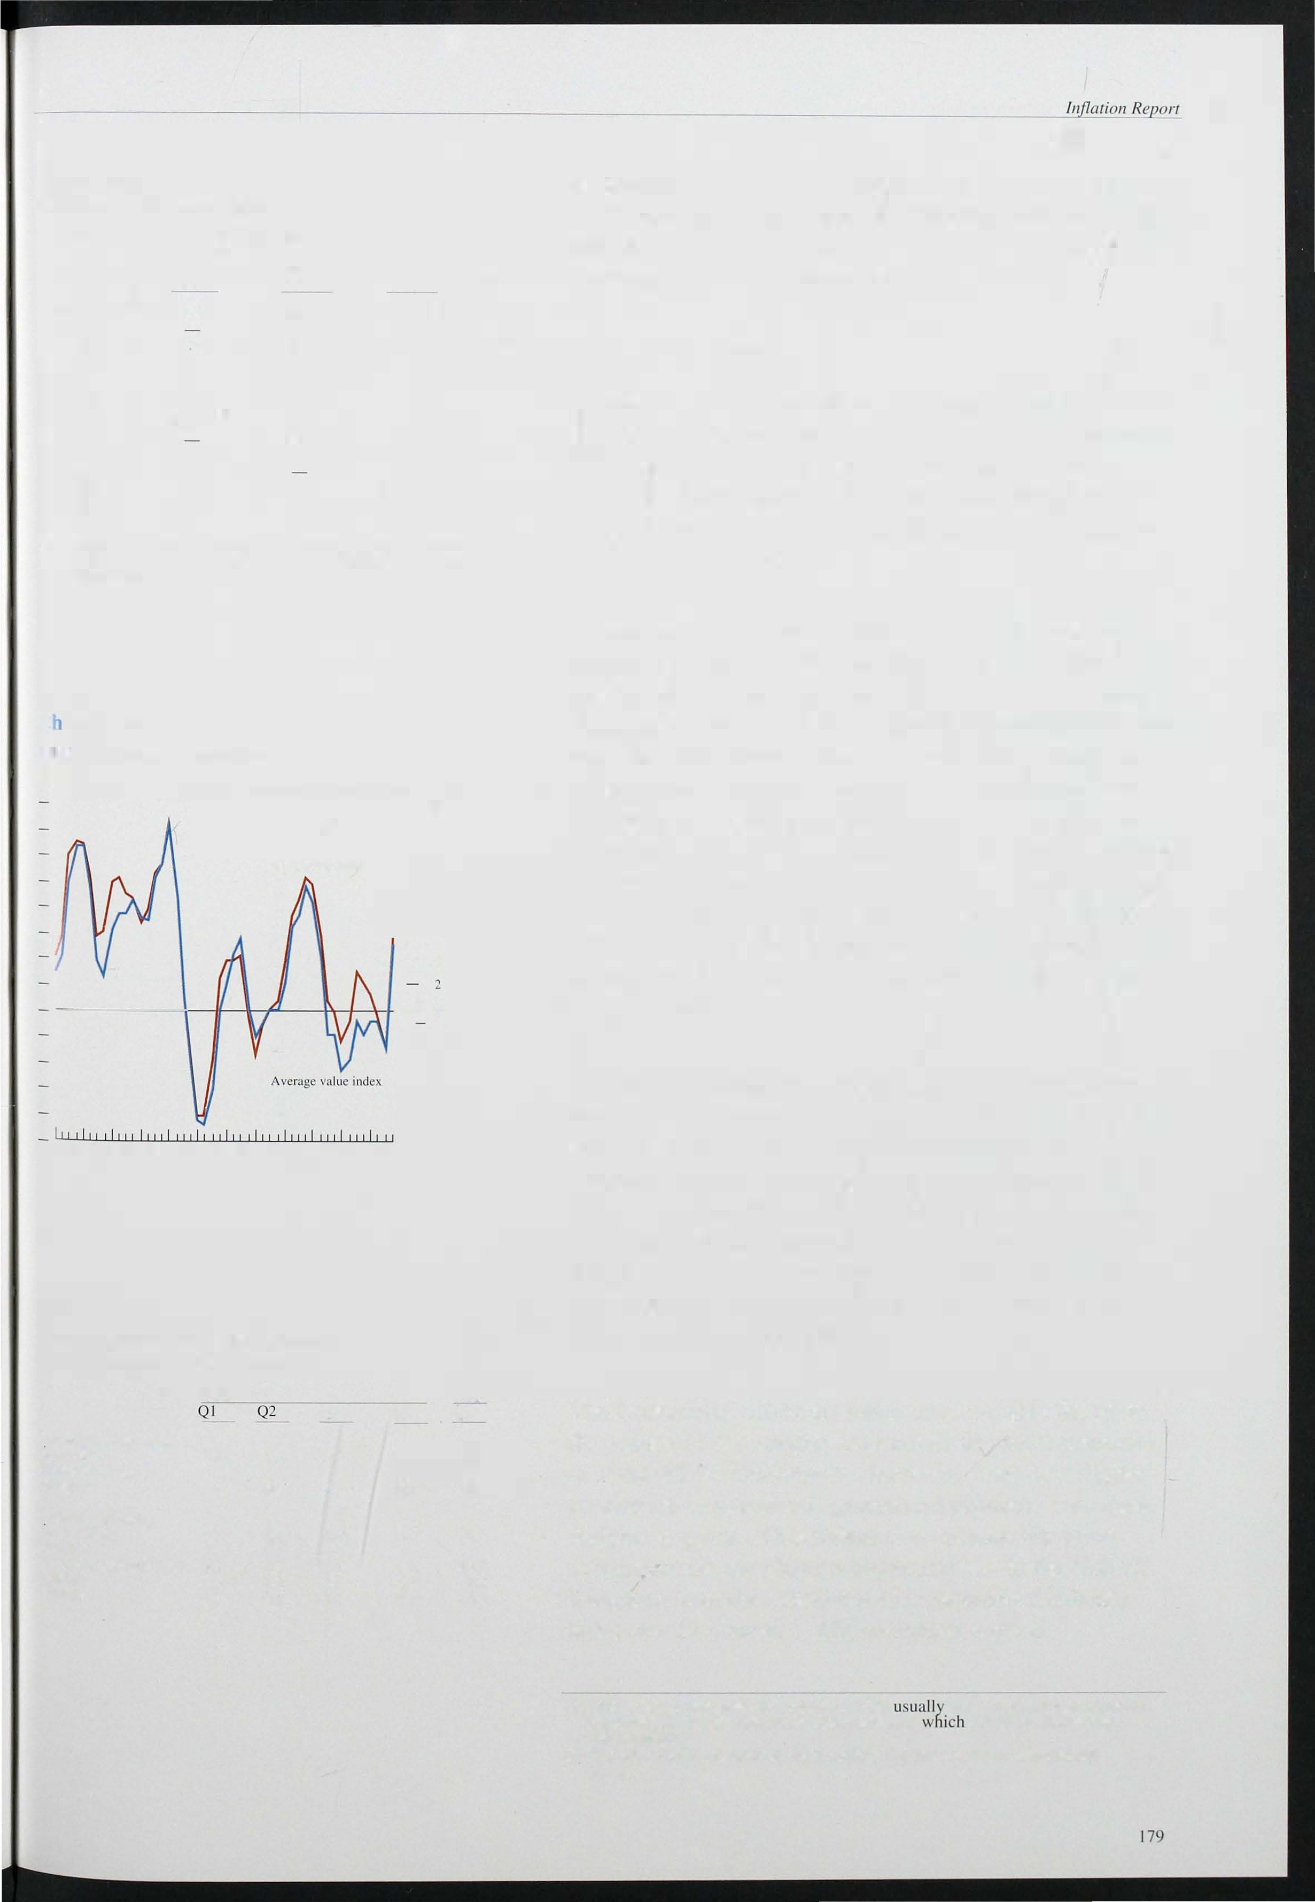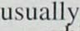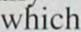

3.9

Kingdom than the OECD-based Economist All-Items index would indicate. UK-weighted non-oil

( I) When the growth rates diverge the AVI is lower because this measure captures the substitution away from goods for prices are increasing most rapidly.

1. Net of intra-EC commodity trade covered by the Common Agricultural

Policy.

Bank of En land

Chart 4. 12

Sterling and SDR commodi ty prices

1990=100

- 1 20

UK weighted sterling - 1 15

- 1 1 0

- 1 05

- 100

- 95

- 90

- 85

- 80

QI Q2 Q3 Q4 QI Q2 Q3 Q4 QI Q2 Q3 Q4 Q I 1 990 91 92 93

Source: EconoThist all- iteThs index. Bank UK weighted coThThodity index.

Chart 4. 13

Sterling and dollar oil prices(a)

1990= 1 00

- 140

- 130

- 120

- 1 1 0

- 1 00

commodity prices rose by over 20% in the first quarter, following a rise of around 1 7% in the fourth quarter.

The marked rise in the UK index in the first quarter reflects the timing of the large increase in non-food agricultural product prices (see Table 4.G). As with the Economist index, however, commodity prices have

fallen back from their last quarter levels.

The price of oil, as measured by close-dated B rent crude, was $18 .3 per barrel in the first quarter, slightly lower than in the previous quarter. The trading range for oil prices was comparatively stable in the first quarter.

The February OPEC meeting agreed a cut in production for the second quarter of the year but the markets remain sceptical that this will be fully achieved. There is li ttle prospect that Iraqi exports will resume in the short term, but even without this the market seems set to continue to be well supplied. Sterling oil prices fell by 0.7% in the first quarter, after rising substantially in the fourth, so further cost pressures from this source are likely to be muted.

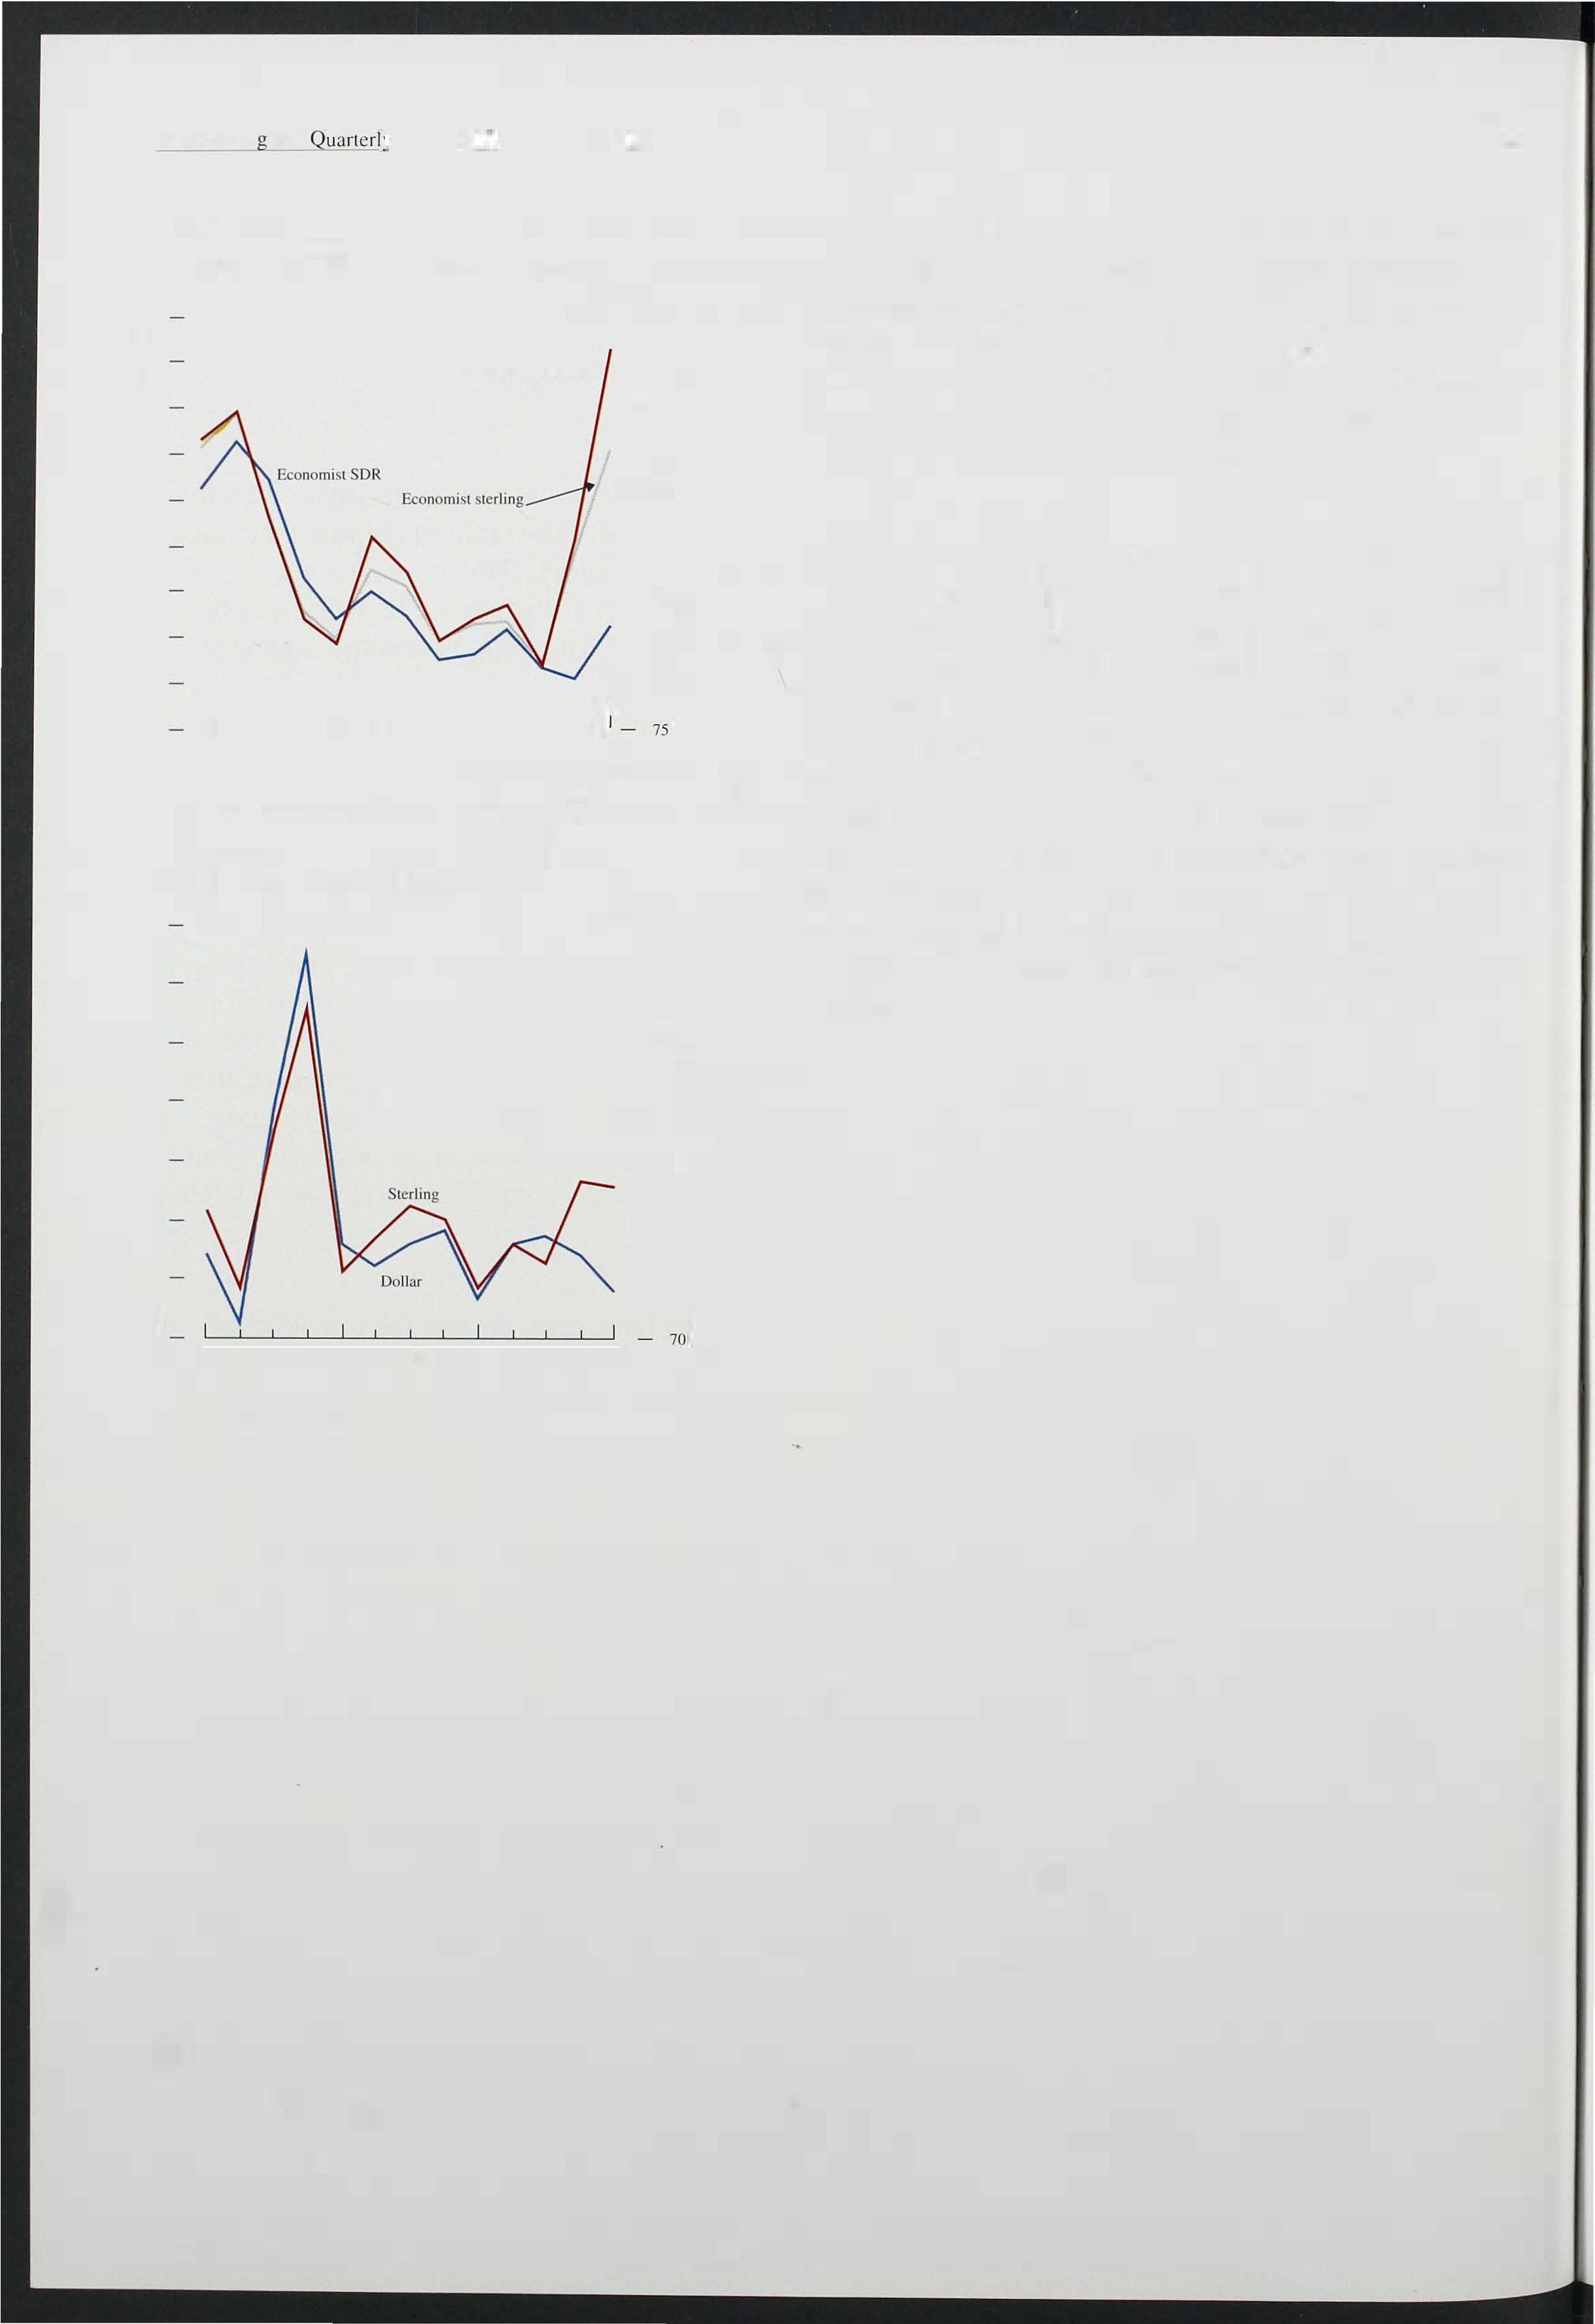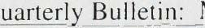

- 90

- 80

QI Q2 Q3 Q4 QI Q2 Q3 Q4 QI Q2 Q3 Q4 QI

1990 92 93

(a) Measured by close-dated 8renl crude.

1 80

# Prospects for inflation

5. 1

)un and Bradstreet S urvey on expectations of

. elling prices and E C/Gallup consumer inflation xpectations

Gallup Survey 60

12 months ahead (a)

The outlook for inflation depends on both the starting point (discussed in Section 1 ), and the interaction between monetary policy (Section 2) and the state of the real economy which determines the speed with which inflation adjusts to its long-run rate (Sections 3 and 4). This section analyses the prospects for inflation. It presents information on private sector expectations of inflation derived both from direct surveys and independent forecasts, and indirect inferences from the

(lah))

Dun and Bmdslreel Survey Percentage points (b)

1988 89 90 91 92 93

Weighted average of responses to Gallup question.

- 50

- 40

30

20

10

+

- 0

10

20

30

yields of government securities. The section concludes with Bank projections for inflation over the next two years based on the analysis presented above. An

essential element in this is a comparison between the projections in the February *Report* and both the current projections and the actual outturn for inflation over the past three months. Differences between the earlier and CUlTent projections .reflect the 'news' that has emerged since the February *Report.*

Balance of those expecting an increao;c (+) or decrease (-) in their selling prices.

Chart 5.2

Gallup Survey of employees' price expectations(a)

Per cent

- 25

- 20

- 15

- 10

- 5

+

- 0

- 5

- 10

- 15

- 20

## . Surveys of inflation

Survey evidence suggests that, on balance, expectations of future inflation are higher now than before suspension of sterling's ERM membership. The April *CBI Industrial Trends Survey* showed a balance of 1 0% of respondents expecting a rise in domestic output prices over the next four months, compared with 1 1 % in January and -3% last October. Even allowing for the normal seasonal increase at this time of year; price expectations are still higher than six months ago. The *Dun and Bradstreet Survey* on expectations of selling prices paints a similar picture. The balance of respondents still expect prices in the following three months to be lower than a year

earlier, but the balance is much less than in the previous

two quarters (see Chart 5.1 ) . The *EC/Gallup Survey* of consumer inflation expectations also indicates

diminishing disinflationary pressures. In March and April one-year ahead inflation expectations were at their

- J F M A M J J A S O N D J F M A

1992 93

- 25

highest since June 1 991 -although sti ll low by historical standards (see Chart 5. 1 ) .

(a) PcrcClllnge balance expecting inflation to be morc than 4% over the coming year.

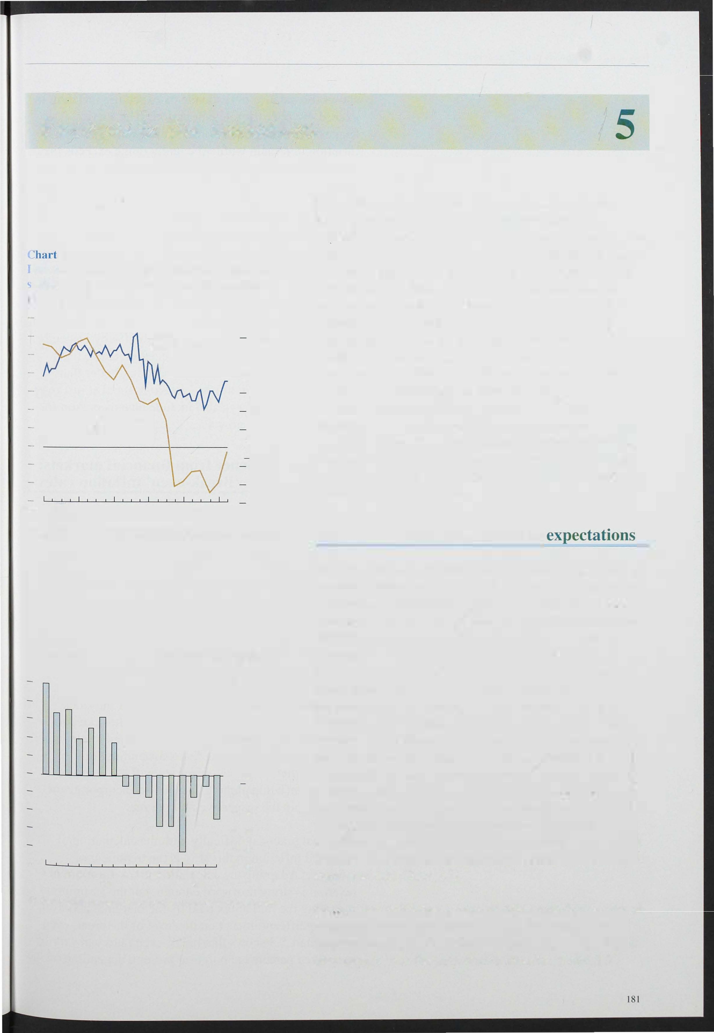

*Gallup* also publishes a more detailed monthly survey of wage and price expectations, in which around 1 ,000 employees are asked what percentage increase in prices they expect over the next twelve months. Chart 5.2

Bank of Quarterly Bullelin: May 1 993

shows the balance of respondents expecting inflation to exceed 4% over the relevant period. The survey

suggests that the proportion of employees expecting inflation to remain within the target range exceeds the proportion expecting inflation to exceed the top of the range by 1 2%.

The *Barclays/NOP Survey* of the general public in March also indicates that expectations of inflation

one-year ahead are just above 4%. The two-year ahead expectation is rather higher, at 5%. By contrast, the *Smith New Court/Gallup Survey* of fund managers

suggests a gradual reduction in year-end RPI inflation expectations for both 1 993 and 1 994. In October of last year respondents expected inflation of 4% by December 1 993. But since last autumn expectations have been

revised downwards-possibly reflecting better than expected inflation outturns-and now stand at just over 3%. The l atest surveys also include an expectation for end- 1 994, which is now 4%.

## Evidence from financial markets:

'Break-even ' inflation rates

A potentially more accurate source of information about expectations of future inflation comes from a comparison of yields on index-linked gilts (IGs) and conventional gilts. Such 'break-even' inflation rates are calculated by subtracting the yield on index-linked bonds from the yield on conventional gilts of similar maturity. In practice, the assumption that index-linked

. gilts are independent of inflation is unlikely to be valid.

In the first place, index-linked gilts are not perfectly indexed: coupon payments are indexed only up to eight months before they are made, so that infl ation in the intervening period can erode the value of the stock.

Second, if a risk premium attaches to either category of bond (and the risk premium may be related to a number of uncertainties, including that surrounding future

inflation) then the break-even rate will not measure expected inflation alone, but will also incorporate the difference in the respective risk premia.

One final practical difficu lty with the calculation of expected inflation in this way is the treatment of taxation. Adapting the calculation to take account of taxation is straightforward enough, but the assumption regarding the rate of tax paid by the marginal taxpayer has a significant impact on the level of the break-even

rate. Chart 5.3 shows that break-even rates can vary by over three percentage points at present, depending on the

182

Chart 5.3

Break-even inflation rates(a)

25% lax

Per cent

- 5

- 4

- 3

tax assumption. Such wide variation, when coupled with the other problems associated with the calculation of these rates, creates difficulties with the use of such calculations as estimates of future inflation.

Ignoring the problems of risk premia, and assuming that the marginal rate of tax paid by the marginal investor is zero (which is consistent with that investor being a

pension fund, for example), it is possible to derive a continuous profile for the term structure of inflation. Section 2 above discussed the calculation of i mplied

40% I", - I

Jan. Feb. Mar. Apr.

- 0

1993

la) Comparison between assuThed tax rates.

Chart 5.4

ominal and real implied forward rates

Per cent

- 1 1

- 10

- 9

- 8

- 7

- 6

- 5

Real rales - 4

o 2 4 6 8 10 12 14 16 18 20 22 24

Year

Chart 5.5

Inflation expectations(a)

Per cent

- 7.0

|  |  |
| --- | --- |
| - | 6.5 |
| - | 6.0 |
| �- | 5.5 |
| - | 5.0 |
| - | 4.5 |
| - | 4.0 |

forward interest rates from the yield curve for

conventional gilt-edged securities. In an analogous fashion it is possible to derive a continuous term structure of real returns on index-linked gilts (see

Chart 5.4). The difference between the nominal and real implied forward rates provides a measure of the expected rate of inflation at any point over the next twenty-five years. The resulting inflation profile is shown in Chart 5.5. This indicates that inflation is expected to rise from j ust over 4% in two years time to an average rate of a little over 5% from around six years onwards.

## Outside forecasts

Charts 5.6 and 5.7 show the latest projections of RPIX inflation from 36 independent forecasters, including City firms, academic institutions and other private sector organisations. Comparing these forecasts with those at the time of publication of the previous *Report* it is clear that the variance of the distribution of forecasts for inflation at the end of this year is now less than before, and that the median has fallen slightly, to 3.6%. The variance of the distribution of the end- 1 994 forecasts is also lower. Both the median and the mode of the

distribution are around 4%. Of the 36 forecasters, 18 expect inflation to be at or below 4% by the end of next year, whereas in February this view was shared by only 12 forecasters.

## Bank

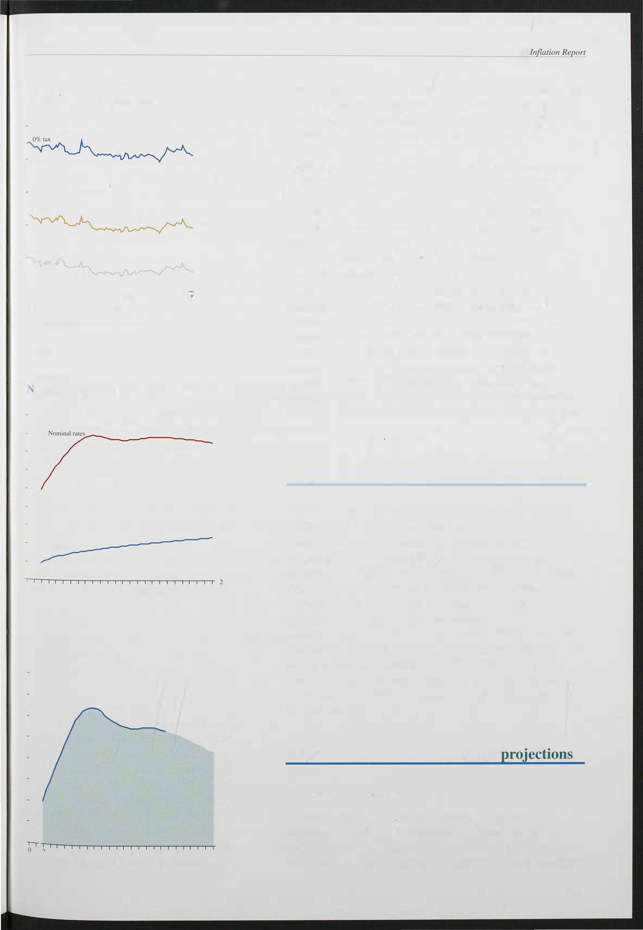

- 4 6 8 10 12 14 16 18 20 22 24

(a) :At clos� or business 7 May 1993: derived rroTh conventional and

3.0

*The short-run outlook*

As in the February *Inflation Report,* projections of inflation over short and longer-term horizons are presented below. These are based on statistical and

structural models of inflation. In the short-term model,

183

Bank of England

Chart 5.6

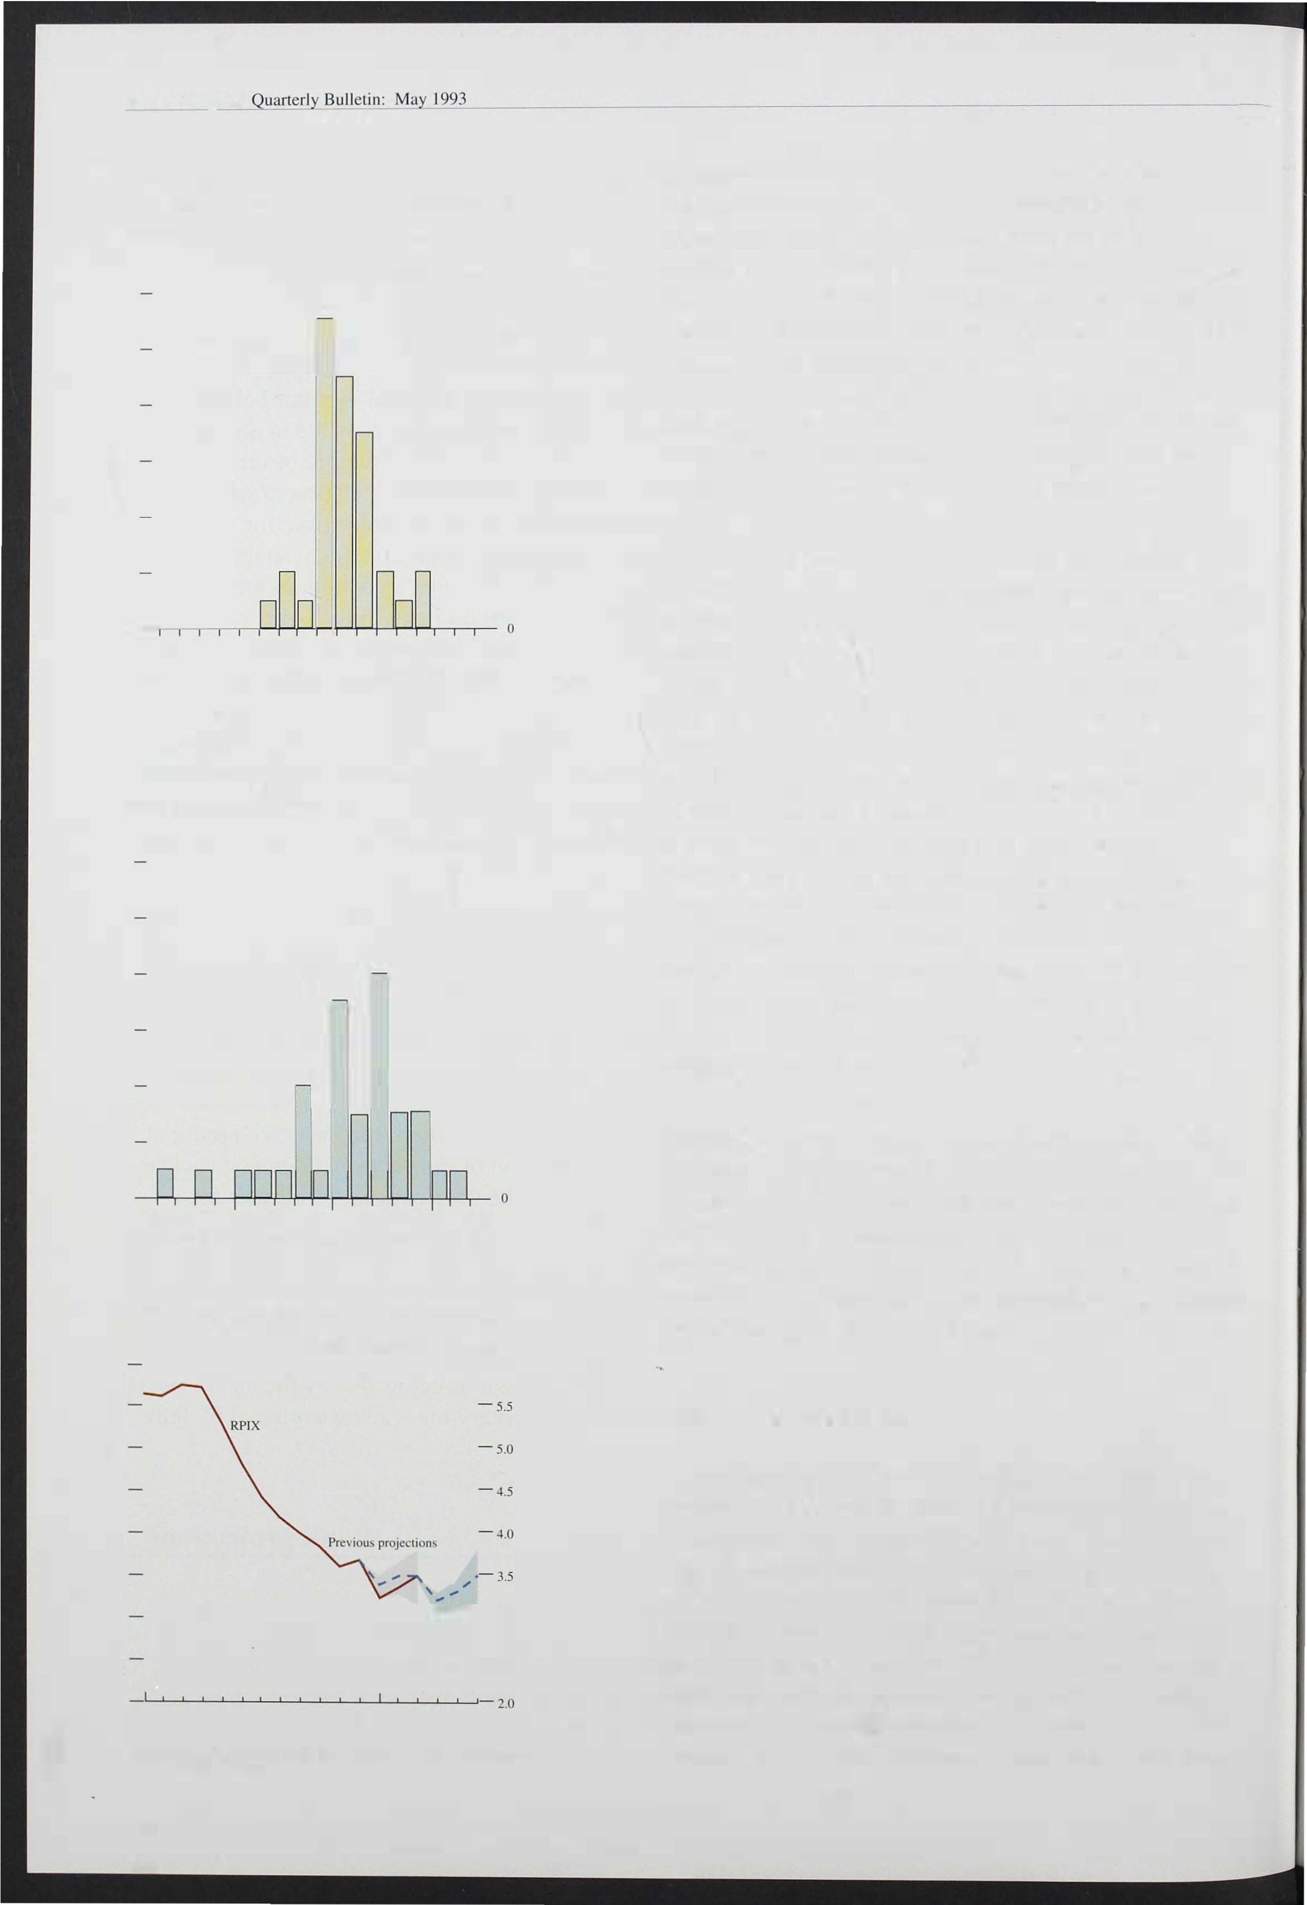

Distribution of private sector forecasts for inflation in 1993 Q4

Number of forecasts

- 1 2

- 1 0

- 8

- 6

- 4

- 2

1.0 1.6 2.2 2.8 3.4 4.0 4.6 5.2 5.8

Range of forecast values (RPIX percentage changes on a year earlier).

Chart 5.7

Distribution of private sector forecasts for inflation in 1994 Q4

Number of forecasts

- 12

- 1 0

- 8

- 6

- 4

- 2

1 .0 1.6 2.2 2.8 3.4 4.0 4.6 5.2 5.8

Range of forecast values (RPIX percentage changes on a year earlier).

Chart 5.8

RPIX inflation projections and outtUrllS

Increase in prices on a year earlier

- 6.0

Currcm - 3.0

projections

- 2.5

M J S D M J

1992 93

The range is defined as the central projection plus or minus the average error on such forecasts in the pas!.

1 84

the projections of inflation are based on statistical extrapolation of recent trends in a number of components of the RP!. These extrapolations are modified to reflect known administered price changes (for example, changes in rail fares or postal charges), or where the short-run behaviour of particular components is thought likely to respond to some external shock which is not already embodied in its past behaviour. The depreciation of sterling, or changes in the value of the green pound, are examples of shocks requiring some modification to the short-run extrapolation.

Chart 5.8 presents the latest projections for RPIX

inflation over the next three months, and also shows the projections made at the time of the last *Report,* together with the recent outturns. The difference between projection and outturn may simply be the result of en"ors in the modelling of short-run inflation, but where errors become large and persistent it may be that the

divergence represents 'news' about inflation which constitutes information relevant to policy. Thus last autumn the outturns for inflation were significantly­ and persistently-lower than had been predicted, suggesting that the disinflation in train at that time was greater than had been realised. But although inflation in January and February was slightly lower than expecteu, the March outturn was exactly in line with the last forecast. There has been little news contained in the inflation figures published since the last *Report.*

The projections for the next three months show inflation declining in April, but then rising to 3.5% by June. The initial fall l argely reflects the impact of the change from the Community Charge to the Council Tax. The subsequent rise is expected to be broadly based and is associated with the direct pass-through of higher import prices into domestic retail prices.

*VAR models of inflation*

Vector autoregressive ( VAR) models of inflation use historical relationships between inflation and a set of other variables to predict inflation in the future. Such models are described in more detail in the article on pages 23 1 -9. Research in the Bank suggests that variables which are useful in predicting the monthly

profile of i nflation include MO, producer output prices,

retail sales and the output of the production industries. The quarterly profile of inflation is predicted by using MO and the EC/Gal1up index of consumer confidence.

It is important to understand the way in which these variables were chosen. Although it is possible to estimate VAR models which have a structural

interpretation (that is, which can be interpreted in terms of a plausible economic model), the models used here were selected solely on the basis of their ability to track inflation.

. The latest forecasts from the two preferred VAR models are broadly consistent in suggesting that inflation may begin to rise during the course of 1 994. But their projections for 1 993 conflict, with the monthly model offering a central estimate of RPIX inflation rising above the target range in May. This is also at odds with the extrapolative model, the projections from which are likely to be more soundly based in the short-run reflecting the known adjustments it incorporates, and the more detailed examination of the components of

inflation which is undertaken in that approach. The size of the standard errors on the VAR forecasts should .also be noted. Although the central estimate from the monthly VAR model is slightly over 4% this year, a 95% confidence interval around this estimate would embrace any rate of inflation between 1 % and 7%.

VAR models can be useful additions to the range of techniques available for analysing current and prospective developments. Where the models are unanimous in their projections it is likely to be easier to draw robust conclusions. But where models conflict the projections derived from structural models become increasingly important.

*Longer-term structural projections*

In the absence of major shocks, projections for inflation over a two-year horizon are unlikely to change substantially within a three-month period. But new

information can be grouped into three categories:

* The outturn for inflation compared with expectations. As noted above, the outturns for twelve-month RPIX inflation were a little lower than expected in January and February, but exactly as predicted in March.
* The outturn for the other factors which determine the RPIX projections compared with expectations. This includes changes to the exchange rate and other variables, such as asset prices, labour market conditions and output data, which contain some

185

Bank of England Bul leli n:

short-run information on the likely outturn for inflation.

* The announcement of future measures which are likely to have some effect on prices. The increases in indirect taxes announced in the March Budget, including the extension of VAT to domestic fuel and power, are an example.

The first of these factors shows that there has been little 'news' in the outturn for inflation itself. But the second set of factors contains several pieces of information which lead to a revision of the projections. The most important of these is the 5% rise in the exchange rate since the February *Report.* If the exchange rate were assumed to remain unchanged at an effective index of 81 (compared with 77.2 at the time of the February *Report),* inflation would be expected to be about one percentage point lower both this year and next. Among other

indicators, wages have risen less than expected-leading to a slight downward revision to expected inflation­ while the increase in output, which has been greater than expected, acts in the opposite direction.

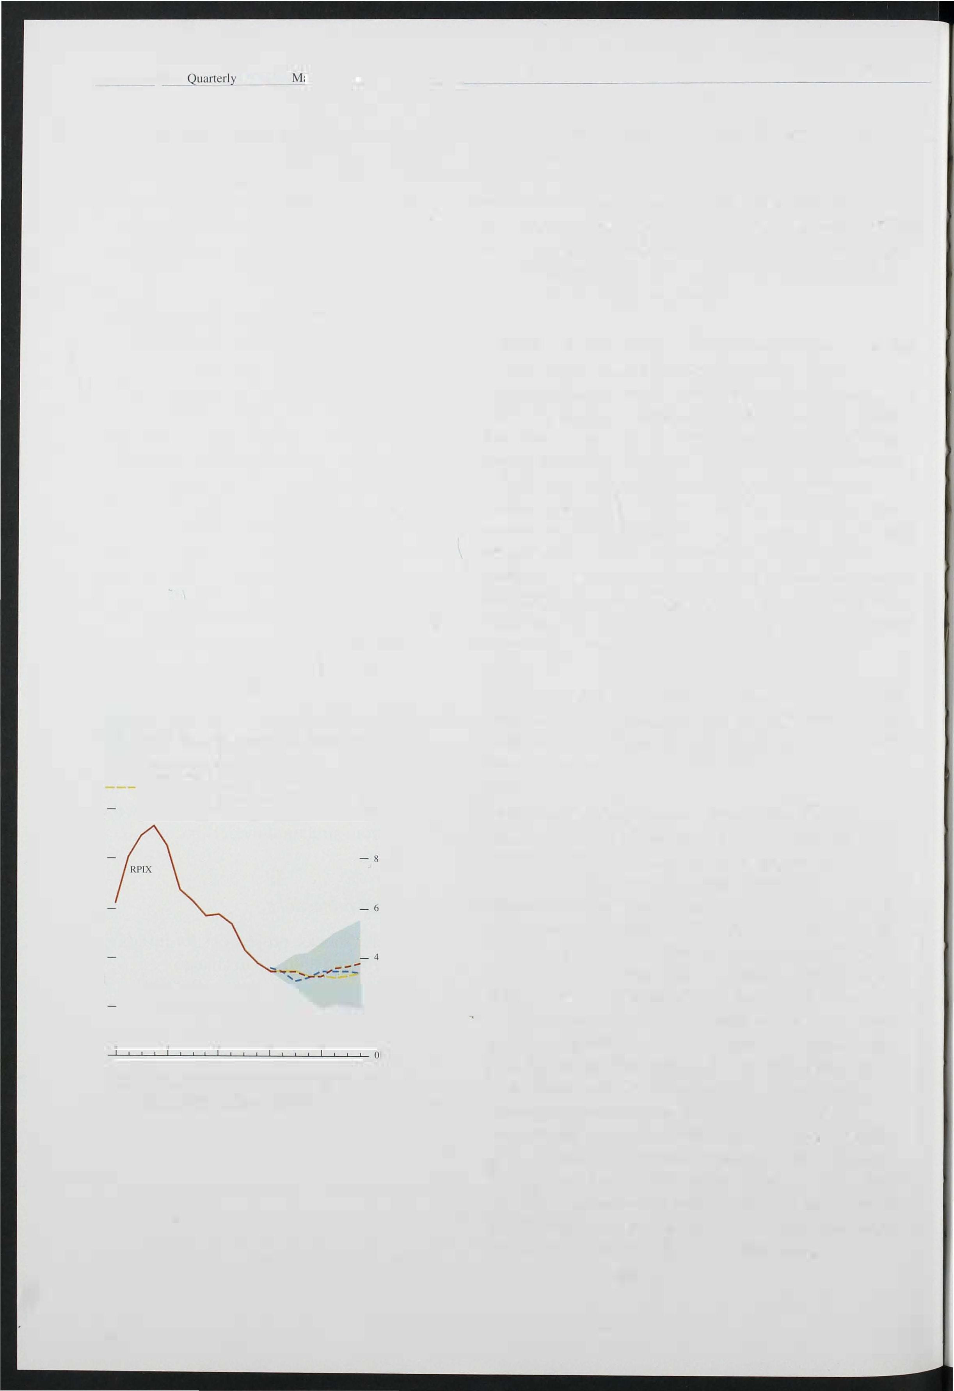

Chart 5.9

RPIX inflation projections and outturns

* - _ . Previous Inflation /?eporr
* - _ . Current projections

Current projections excluding VAT effect

Increase in prices on a year earli� 10

- 2

1 990 91 92 93 94

The range is defined as the central projection plus or minu, the absolute

?vcrnge error on consumer price innUlion projecliolls since 1985. The projection I� based on bro;'ldly unchanged policy, with the exchange rate in the second quaner of 1993 sel aI 8 1 .0 (£ ERI), DM 2.49 and $1 .57.

1 86

The third factor is the impact of the extension of VAT announced in the Budget. The 8% VAT rate for domestic fuel and power is likely to add around 0.4% to the headline RPI from April 1 994.

Taking all of these factors together, the central projection for RPIX inflation is shown in Chart 5.9. Inflation is l ikely to fall during the remainder of this year, as the i mpact of the earlier depreci ation is partly offset by the subsequent recovery in sterling, and the disinflationary impact of the output gap persists. But as recovery gathers pace this disinflationary effect will diminish. At the same time, headline RPI inflation is likely to rise around the turn of the year as interest rate cuts drop out of the twelve-month comparisons, and the reduction in MIRAS will add a further 1 /4 percentage point to the headline rate in the second quarter of next year. These may feed into the rate at which wage settlements and earnings rise. Nevertheless,

'underlying' inflation (RPIX inflation *excluding* the impact of the VAT extension) will probably remain broadly flat during 1 994, at just over 3%. Allowing for

the VAT extension, however, RPIX inflation is likely to rise from the second quarter of next year-although it is still likely to remain within the target range.

On balance, the changes since the last *Inflation Report* have lowered slightly both the expected inflation rate and the probability of breaching the 4% limit during the course of this year. The impact next year of the Budget measures, together with the uncertainties surrounding the rate at which the output gap is likely to narrow, suggest that the probability of breaching the target next year may be a li ttle greater than previously envisaged, but the Bank's central expectation still is that the target will be met. Any further increase (decrease) in the exchange rate would lower (raise) the probability of breaching the target.



1 87



# Conclusions

Inflation, as measured by RPIX, has remained within the target range throughout the period since the February *Report.* During that period new information about the likely course of future inflation has been of three main kinds. First, real activity is rising more rapidly than had been expected three months ago. Most of the indicators relating to the real economy, including output, retail sales and employment, point to increasing levels of activity.

Second, the exchange rate, as measured by the sterling effective exchange rate index, is some 5% higher than at the time of the February *Report.* Third, in the March Budget the Chancellor announced increases in indirect taxes, to take effect both this year and next, which will raise the measured rate of underlying inflation. The rise in the exchange rate is not independent of the news ab ut activity, indeed in large part it fol lows from it. This

increase in the exchange rate has lowered somewhat the risk of breaching the top of the target range towards the end of this year and the early part of next. In the very short run, there is likely to be a further fall in underlying inflation as the Council Tax enters the index to replace the Community Charge. But this effect is likely to be short-lived. Nevertheless, apart from changes in indirect taxes, the outlook to the end of 1 994 is no worse, and probably slightly better, than it was at the time of the February *Report.*

The principal reason for our judgment that RPIX inflation is l ikely to remain in the 3 %-4% range over the

. next eighteen months or so is that the inflation rate for domestically produced goods is likely to remain low.

The output gap will probably remain negative for some time to come, exerting downward pressure on inflation.

The upward pressure on prices comes from the continuing pass-through of depreciation to domestic

prices and broader VAT coverage as announced in the March Budget. In the absence of any change in indirect taxes, inflation would probably be roughly constant over the next year or so. B roader VAT means that underlying inflation as conventionally measured may rise in 1 994.

As discussed in the February *Report,* it is evident that

expectations of inflation are not yet consistent with the target range for inflation of 1 %-4%. Both direct surveys

of expectations and also the indirect evidence from implied forward market interest rates suggest that many

1 88

people have yet to be convinced that the target will be met in the long run. But the longer underlying inflation remains within the target range the more credibility will grow over time.

Looking to the end of 1 994 and beyond, the principal uncertainty concerns the response of domestic factor costs-wages and profits-to the loss of purchasing power resulting from depreciation of the currency. If total profits and wages rise because of a *volume* effect, rather than an increase in profit margins per unit of output or earnings per head, then the increase in nominal demand consistent with the monetary stance will lead to rising real activity and continuing low inflation. A continuing determination on the part of the authorities to meet the inflation target will help to ensure that increases in wages and profits are real increases, reflecting higher output and productivity, rather than nominal increases reflecting only higher unit costs. It is vital in this context that the inflation target be seen as a framework for policy over a long period, and that monetary and fiscal policy should be consistent with

achieving the target on a sustained basis.

189